**Getting started with the RAMP GameSheets mobile app**

**Installing and logging on to the RAMP GameSheets app**

* Download and install the app from the App/Play Store to your mobile device.
  + A fast way to find the app is to search for **RAMP GameSheets** within the App/Play Store.
* Once the app is installed you need to log in. The login screen looks like this:

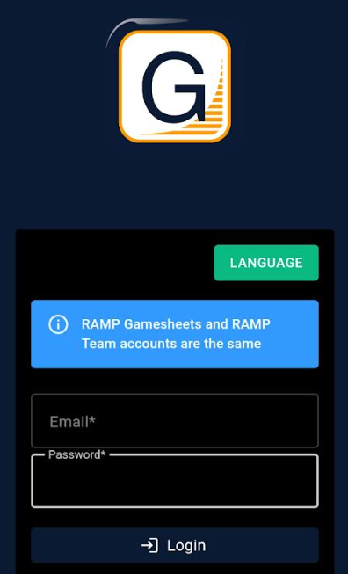

* **Important!** You will need to use the same user ID (email address) and password that you use for the RAMP Team mobile app. There is even a message in blue on the login screen reminding you of this.
* If you don’t already have a login for the RAMP Team app, you will need to create a new account.

**Downloading all your games for the season to the RAMP GameSheet app**

* Once you are signed in, the easiest way to download all your games for the season is to use your **Team Code** which you can get from the SSDSA RAMP Content Management System (CMS) page for your team.
  + You should have received a login ID and password from either your club president or the SSDSA scheduler (Alexa) directly.
  + Open a web browser and type this URL in the Address bar: <https://admin.rampcms.com/login>

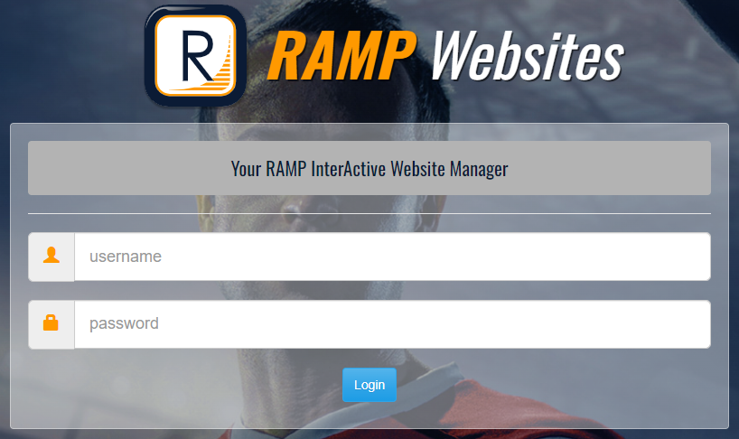

* + Use the User ID and password provided to you from SSDSA. **Note:** You are logging into the SSDSA RAMP CMS page for your team **not** your local club RAMP CMS.
  + Once you are logged into the SSDSA RAMP CMS page you can find your Team Code on the **Dashboard** home page. You will see it in big letters right in the middle of the page. Note: the actual Team Code has been hidden here (yellow paint mark), as this is a real SSDSA CMS team page for Chester United.

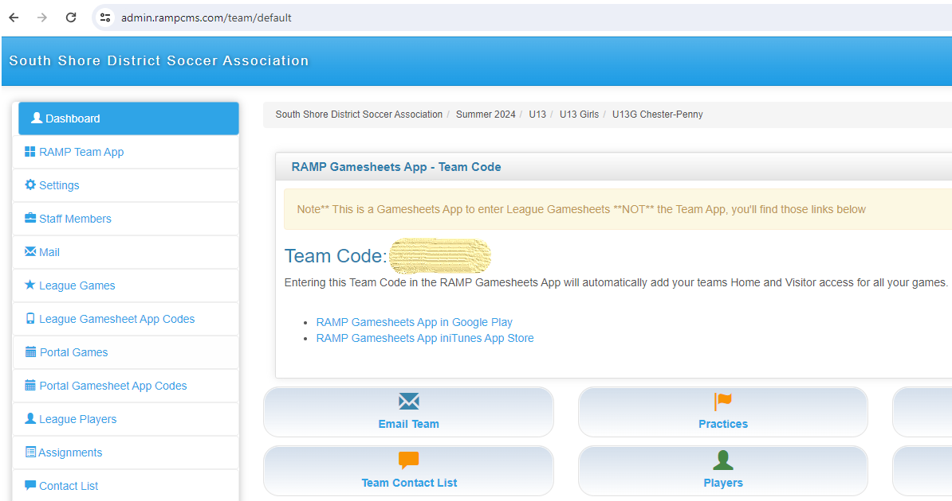

* + Once you know your Team Code (you may want to write it down), you need to switch back to the RAMP GameSheets app on your phone.
  + At the top of the screen on your phone you need to tap the 3 bars menu icon on the far right

|  |  |  |
| --- | --- | --- |
|  |  | **Tap the 3 bars for the menu** |

* + Next, you will see a menu like this:

|  |  |  |
| --- | --- | --- |
|  |  | Tap the **Team Accounts** menu item |

* + The screen will refresh and you should see something like this:

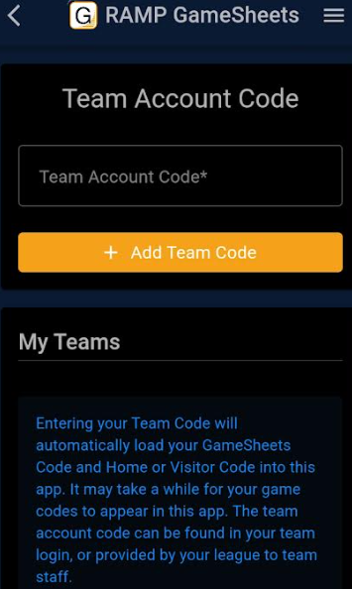

* + This is where you enter the 8-digit (4 digits a dash and another 4 digits) Team Code you found from the Dashboard home page on the SSDSA RAMP CMS site for your team in the previous step.
  + Once you have entered your team code you need to tap the **+ Add Team Code** button
  + 
  + You will see a confirmation message like this one:



* + It will probably take up to several minutes for all your games for the season to be loaded into the app. While the app is loading data you will see a spinning icon.
  + Once the data is finished loading you should see all your games in the app, to check on your games you need to access the menu (3 bars) at the top of the screen.
  + Choose the **Games** menu item.

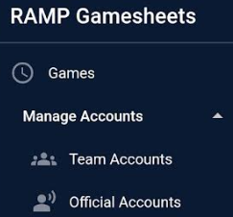

**Navigating Games within the app**

* Now that you have entered your Team Code, downloaded your games and returned to the Games screen in the app; you will need to know how to navigate and enter information.
* You should see a listing of your games now in the app, just like the example below:

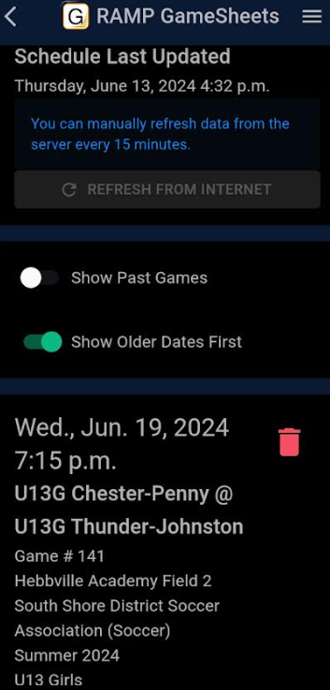

* As you can see the game schedule refreshes itself every 15 minutes or so.
* There are a few settings you can turn on and off on the Games screen as well, these are:
  + **Show Past Games** – these are games that have already happened. If you need to refer to any previous games your team has played, this slide button needs to be turned on. Otherwise, you can leave it turned off if you like.
  + **Show Older Dates First -** mostpeople will want this feature turned on, as it sorts your games on the screen from oldest to newest.
* To navigate to the various games on the Games screen you simply need to scroll up and down the page like you would for any other app on your phone.

**Entering game information and submitting to the SSDSA**

* To begin entering the score from your completed game you need to tap the **Gamesheet Access** button for the game that corresponds to the date/time of the game you just played.



* You will be asked if you want to use **Offline Mode** or **Online Mode** for your Game Mode while editing the information.

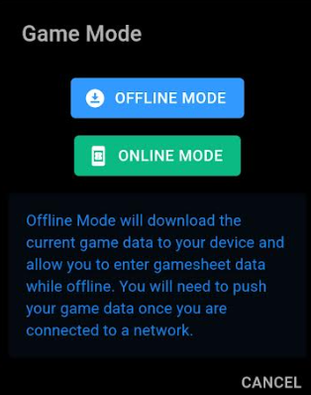

* You can use **Offline Mode** if you think the cell coverage at your game location may be spotty. **Important!** Don’t forget to log back into the app and submit your information later if you chose **Offline Mode**.
* However, you should be fine to use **Online Mode** most of the time when using the app.
* Once you have picked your **Game Mode** you can begin entering information.
* The screen will refresh and you will see a message saying: **“Please wait while Game Data is being downloaded”**

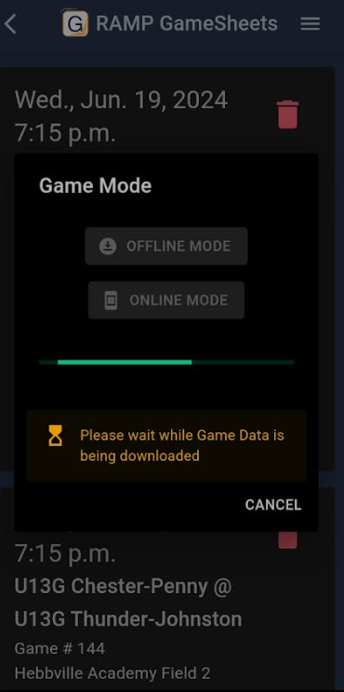

* Now you will be able to enter details about the game you just finished.

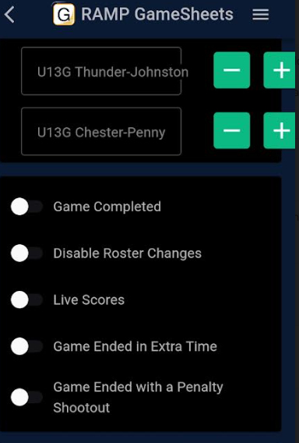

* The most important three items on this screen is the **Number of goals for each team (the fields are labeled by team name with the plus and minus buttons)** and the radio button to indicate the **Game Completed**
* Use the other radio buttons as necessary. For example: if the ended with extra time or a penalty shootout.
* Now a question coaches will have is: **Who should enter this data?**
  + Ideally the officials should submit this data, however after speaking with our League Scheduler (Alexa) she told me the following:
  + The winning team’s coaching staff (Head Coach or Assistant) should enter the scores and submit the game data from the app to the SSDSA.
  + In the case of a tie the Home team coaching staff (Head Coach or Assistant) should enter the scores and submit to the SSDSA from the app.
  + **Important!** A best practice would be to have the lead official and a coach from each team observe the data entered just before submitting so everyone agrees on the final score submitted from the app.
* When you are done entering your game data you will need to tap the **Sign Digitally** button



* A smaller screen will pop up like the one you see below:

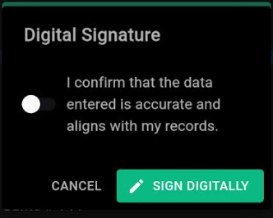

* Tap the **Sign Digitally** button once more and you’re done!
* The scores from the game will be automatically sent via the app to the SSDSA CMS site and scores will be updated there and on your local club’s team page, provided you have already completed the League Tie-In with the District CMS site.