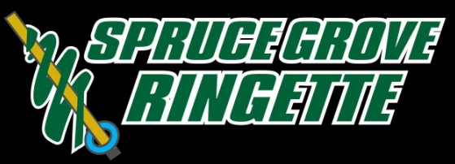

Spruce Grove Ringette Association
Annual General Meeting
Wednesday, May 22th, 2019 at 7:00 p.m.
Border Paving Athletic Centre – Jen Col/Zender Ford Rooms

- WELCOME AND CALL TO ORDER

- CREDENTIALS REPORT – Establish Quorum

- ADOPTION OF AGENDA FROM PREVIOUS AGM – SGRA Minutes May 23, 2018

- ADOPTION OF MINUTES – AGM Agenda May 22, 2019

- RULES OF ORDER AND AGM PROCESS

- ADOPTION OF UPDATED BYLAWS

- FINANCIAL REPORT

- ELECTIONS – 1st Call of Nominations for Executive & Committee Positions

- PRESIDENT AND EXECUTIVES REPORTS – see attached

- ELECTIONS – 2nd Call of Nominations for Executive & Committee Positions

- RINGETTE ALBERTA & BLACK GOLD LEAGUE UPDATES

- ELECTIONS – 3rd & Final Call of Nominations for Executive & Committee Positions

- ANNOUNCEMENTS

- 2019 – 2020 Player Registration Fees
- Sweetheart Tournament

- PRIZE DRAW

- ADJOURNMENT

