Steinbach Ringette’s New Registration Process

Registration Link: steinbachringette.rampregistrations.com

If you are new to RAMP registration you will need to create a new account.
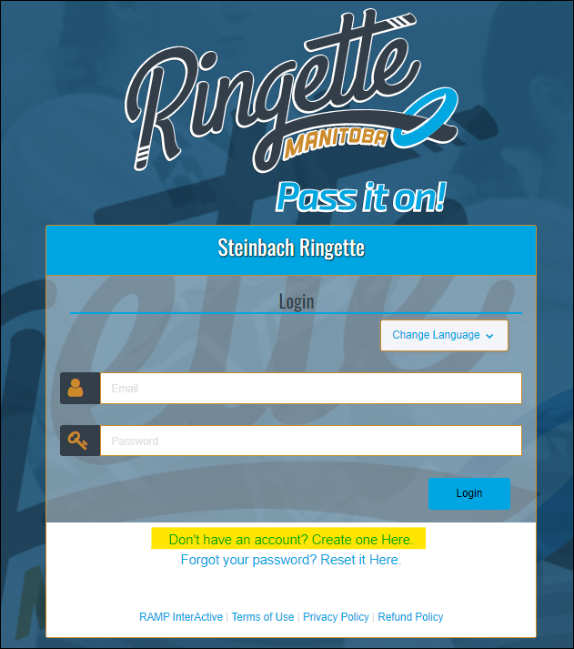
Once your account is created, add family members, and start your registration.
* If you add all family members that will either be a participant, volunteering, or a guardian, it will speed up your registration.

Please have your Respect In Sport and NCCP numbers handy when setting up your family members. If this is not completed, you will be asked to add it before the season starts.

Select Register and then participant to start.
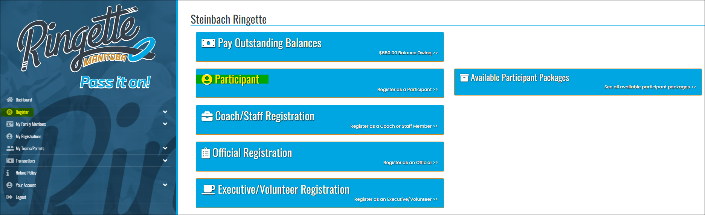

Enter the requested information and choose the age-appropriate Division.

There will be 2 options/packages to select.
1 - The Registration package is required and is automatically selected.
2 - The Optional Volunteer Fee can be selected if you are unable to volunteer during the season and wish to pay the volunteer fee instead.
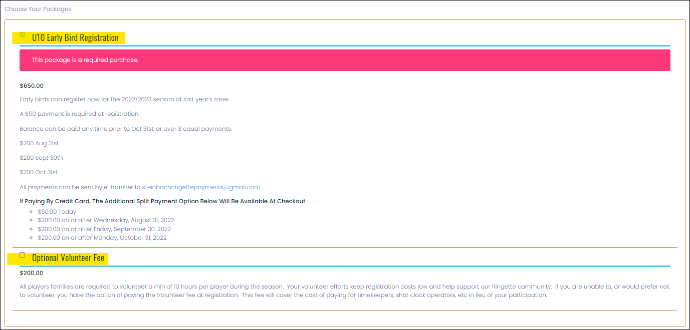

Continue through the screens answering questions and signing the waivers.

The Volunteer page will tell you 10 hours/points of volunteering is required to complete the registration. You only need to indicate how you intend to complete the 10 volunteer hours during the season. It can be a combination of several items and can change as the year progresses. This will help your coach and manager organize the year and is not set in stone.
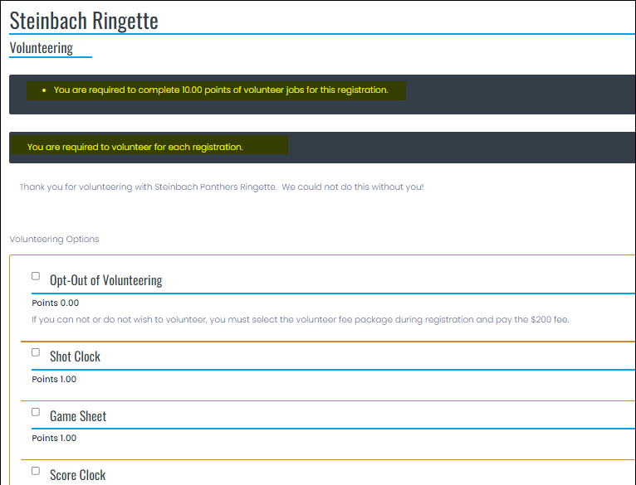

A confirmation email will be sent to you including all the information you see on the confirmation page.

We are only accepting payments by e-transfers at this time. If this will be an issue, please contact SteinbachRingette@gmail.com to discuss alternative arrangements.

STAFF REGISTRATION:
If you indicated you are willing to volunteer as a Coach or Manager, you must also complete a Staff Registration. The registration should be in the name of the person volunteering (ie the parent or guardian), not the players name. This can be done through the same RAMP account as the player registration. Once teams have been determined the SRA Board will contact you to discuss team staffing options.

If you have questions about the registration process, please contact SteinbachRingette@gmail.com.

If you have technical issues with the website, please contact RAMP at support@rampinteractive.com.

