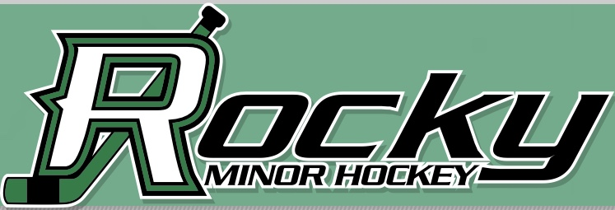
We are excited to invite teams to our RMHA Initiation Jamboree happening MARCH 7, 2020 here in Rocky Mountain House at the Christenson Sports and Wellness centre.

Cost: $400.00 / team

GAMES:
- Guaranteed 4 games 30 mins each on ½ ice

- Game play will be 4 on 4 with a goalie (No Equipment)

- We are looking for learn to play teams, teams with mostly first year initiation players for one division and combined first- and second-year initiation teams in another division to form even games with similar ability.

Extras:
- Heart & hustle and MVP awards will be handed out to each team

- Goodie bags and player gifts will be awarded to all participants.

- Expect Raffle Table, 50/50 draws and fun games

Please see the registration form below to get your spot in our Jamboree!!!!

* 3 Game Guarantee * Fun Skills Competition
* Swag Bags * Raffle Table *50/50 Tickets
Cost: $400.00 per team
Tournament applications are to be received by November 22, 2019 and selected teams will be notified by December 6, 2019. Selected teams are required to submit a tournament fee by December 13, 2019. For questions or for further information, please contact Rikki Park @ 1(250) 321-1144 rooshkin@hotmail.com
- Full Team Name: _____________________________________________

- What league do you currently play in? ________________________________

- Which ‘tier/ group’ are you applying to participate in?
Options are: (mostly 1st year) ________, (mostly 2nd year) ________

- How many players are on your team? __________

5. Please confirm you can submit the $400 payment by to December 6, 2019 if your team is selected to participate in this tournament? Yes ____or No _____

