SMRA Shot Clock Set Up Sheet

- Ensure ‘game clock’ is on and set up with game time (sheets for that should already be in box) but if not;
  - Click ‘game time’ button and then put in the number of minutes per period (15) and then enter-enter to input should look like photo below (photo 1) but with 15:00:00 in the time slot
- Then need to click ‘play timer set’
- Then play timer select until in the right side of screen says reset ‘B’ like shown below (photo 2)
- Set A should be 0, set B should be 30 and set C should be 0
- Then enter
- Screen should go back into the ‘main screen’
- Plug shot clock into remote 2
- Once the shot clock is on and reset, should run automatically with clock

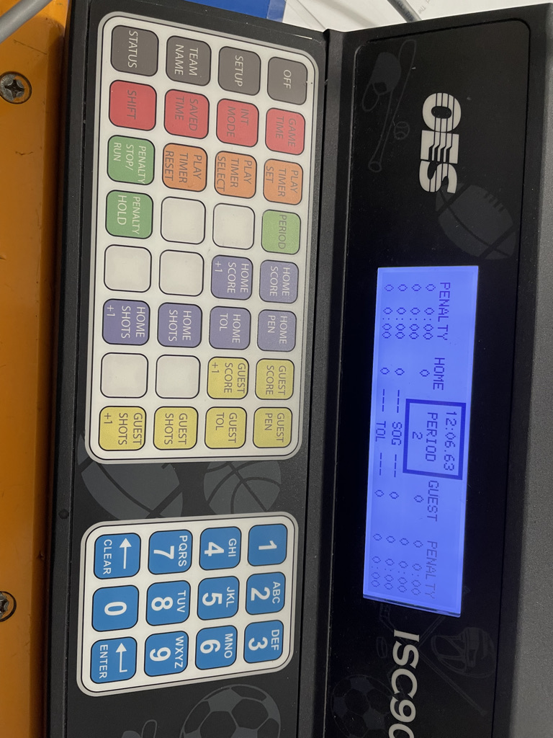 Photo 1

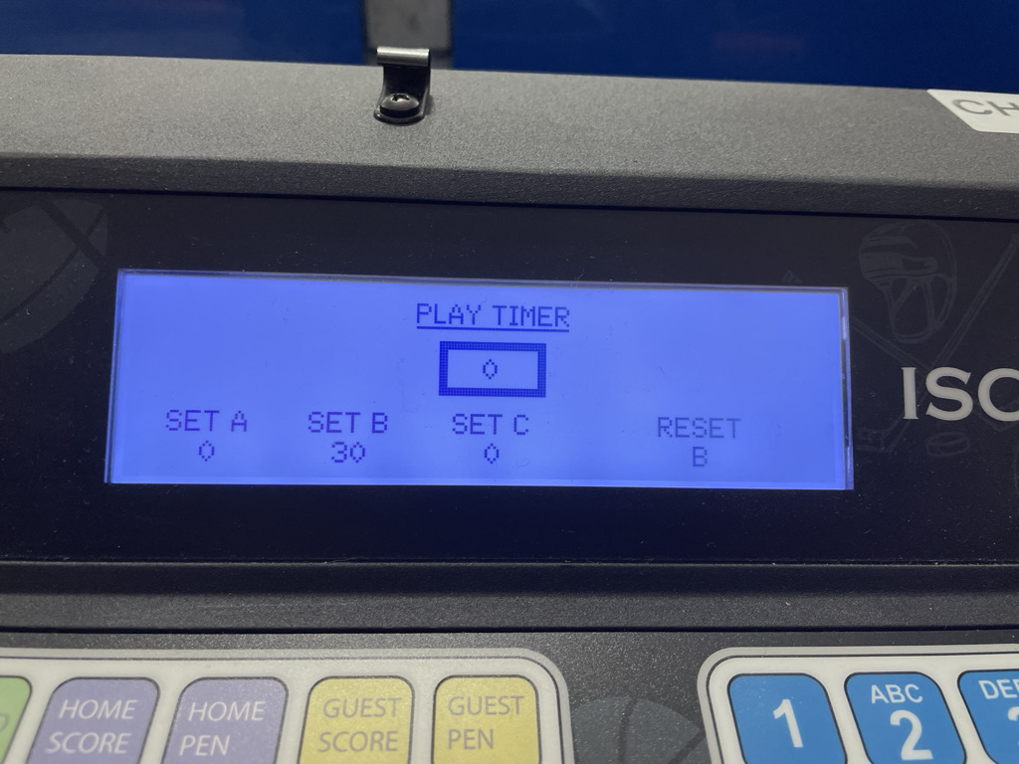 Photo 2
Shot Clock Cheat Sheet

- Anytime the goalie stops a shot or touches the ring RESET
- When a penalty is called but play is still going (delayed penalty) RESET
- Ref will signal by holding up a hand and drawing a circle in air if you have missed a reset while also saying reset
- Shot clock will automatically stop and start with the game clock
- If less than 30 seconds in game and a reset occurs the shot clock will shut off, do not panic it is just because there is less than 30 left in the period/game so no more resets are necessary

