Players- Runners - will need to have the equipment below. Most items can be found at local Sporting Goods stores.
If your player is a Goalie, the SBLA will supply them with the equipment they will need, minus a helmet, cup, and gloves. This equipment will need to be sized to ensure your Goalie is fitted properly. Once fitted a $300.00 post dated cheque is required as a deposit, to ensure the equipment is returned at the end of the season.
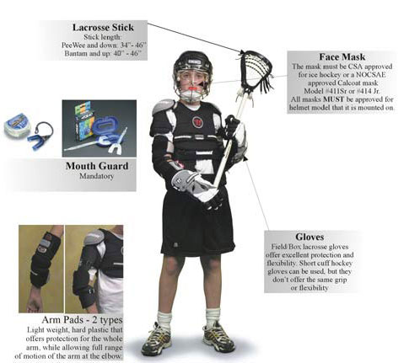

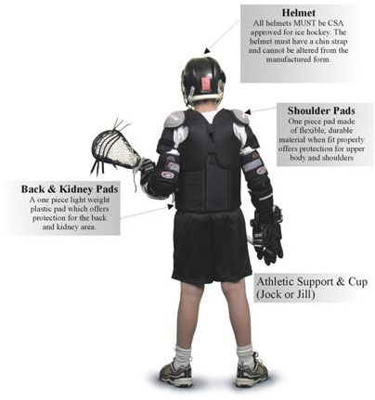
Registration Information
2020 Registration information can be found under the link below. Days of play, divisions and costing is all located on this page.
http://stoonboxlax.com/content/registration-information

