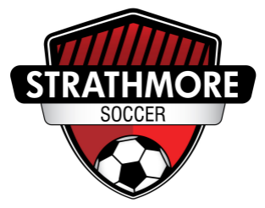

Technical Lead

District League

Role Description

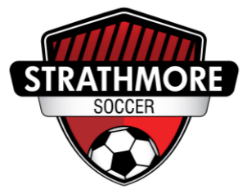**Technical Lead District League**

**Role Description - Volunteer Position**

**Overview:**

The District League Technical Lead (DTL) will be accountable for the development, implementation and supervision of player and coach development programs for District League. The DTL shall provide leadership, guidance and mentorship to all coaches. The DTL will be responsible for the District League Program, working collaboratively with the CMSA Technical Lead, Administrator, and under the direction of the Board of Directors.

This is a volunteer role, dedicated to supporting the club's District League program and contributing to a positive and safe sport environment.

**Time Commitment**

The District League program includes one practice night and one game day per week. Estimated time commitment is approximately 4-6 hours per week, subject to seasonal variation and special events.

All indoor practices and games are held in Strathmore, while the outdoor season games alternate between Strathmore and Chestermere.

**Qualifications:**

Must have completed a minimum of 1 year (2 seasons) in a coaching capacity/Coach management capacity.

* RCMP Clearance
* Required Courses:
  + NCCP Community Stream Coaching program for which they will be designing programming.
  + Making Headway in Sports
  + Making Ethical Decisions
  + Respect In Sport for Community Leaders
  + Safe Sport
  + Rule of 2 Module
  + Emergency Action Plan
* C Diploma and/or Youth License is an asset

**District League Technical Lead Responsibilities:**

* Develop the District League program, in collaboration with the CMSA Technical Lead, in alignment with the SSA and current licensing requirements
* Review the District League technical program with the board prior to each season
* Assist with recruiting, retaining and assigning District League coaches
* Provide leadership, guidance, and mentorship to all coaches involved in the District League program by:
  + Building and implementing a development plan for the District League Program (currently completed)
  + Support coaches in managing challenges and be a main point of contact for coaches, redirecting to the appropriate avenues, as needed
  + Maintaining a log of coach interventions, ensuring a 2:1 support ratio is upheld
  + Ensure incident reports for injuries or serious behavioral concerns are completed and submitted promptly to the Administrator
* With the administrative assistant's help, prepare coach binders/manuals with seasonal program information
* Co-host a parent meeting once each season to provide updates, address questions, and promote open communication between the coaching staff and families
* Represent the club in all matters related to CMSA technical programming by attending aligning and Club Connect meetings, while upholding high standards of sportsmanship and professionalism.
* Foster a fun, welcoming, and inclusive environment for all players and coaches