PREGAME: LOCATION ________________ Date: _____________ VS ________________

GAME OBJECTIVES 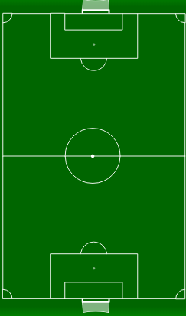

FORMATION & POSITIONS
KEEPERS
DEFENDERS MIDFIELDERS ATTACK

