Valley United Soccer Club
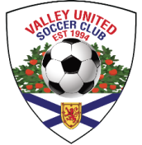
For Winter 2023-24, all apparel can be purchased through the Soccer Shop in New Minas (9323 Commercial Street) . Stop in to see Randall about viewing samples, trying sizes and checking availability before ordering.
Orders can be dropped off at the store or e-mailed to randall@thesoccershop.ca
The 2023-24 Winter order will be placed on November 6.
The following Adidas items will be available for purchase.
Any personalization can be done for $5 per item
All prices below are before tax.

(1) Hoodie - Crested price - $60
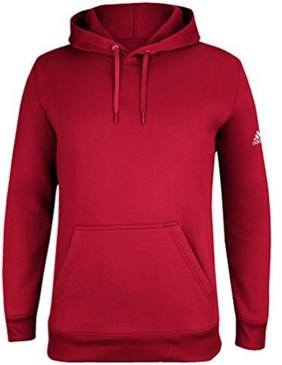

(2) Training Jackets (Full Zip) → Crested price - $70
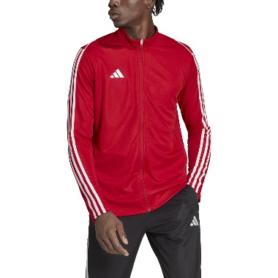
(3) Training Pants → Price - $50
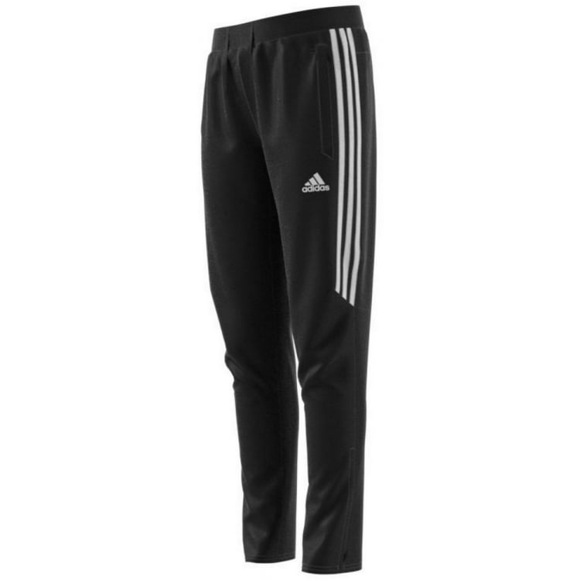

(4) Stadium Parka → Crested Price - $195
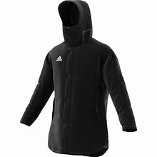

(5) CON22 Winter Jacket → Crested Price - $165
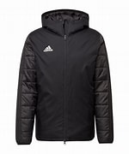
(6) Backpack → Crested Price - $65
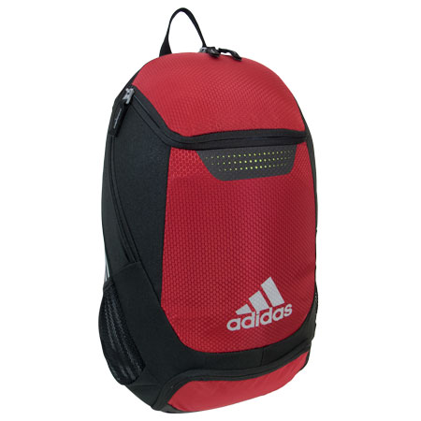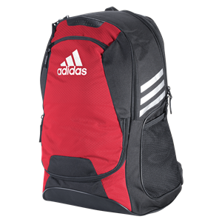

(7) Duffelbag - Crested Price - $50
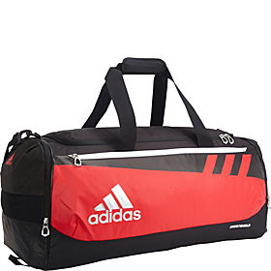

(8) Sackpack - Crested Price - $30
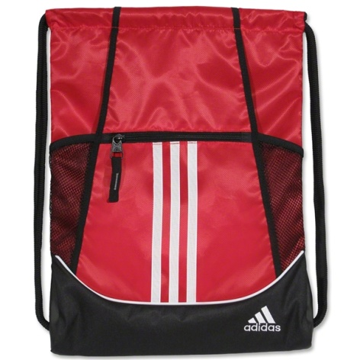

(9) Long-sleeved Training Shirt – (red, white or black) – Only adult sizes - $40
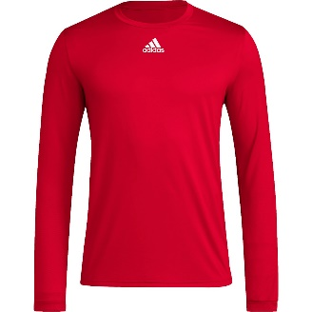

(10) Warm-Up/Training Tees (red, white or black) – Only adult sizes - $30
