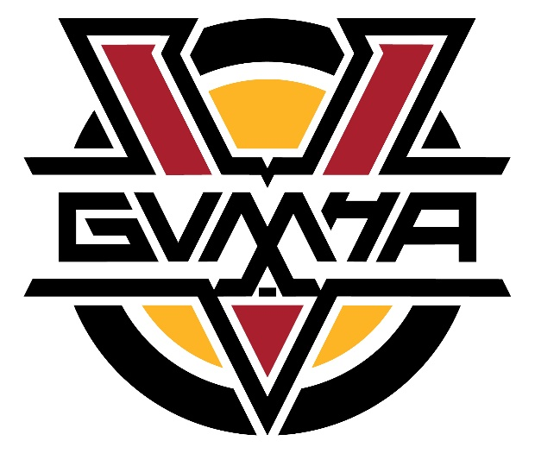
GVMHA Board Meeting Minutes
February 21st, 2024
Kal Tire Place North, 7:00pm
Present: Chris, Kevin, Curt, Cheryl, Bryan, Trevor, Nik, Jesse, Lynn, Jodi, Brendon, Gord
Absent: Erik
1. Approval of Agenda
Motion to approve agenda by Cheryl; seconded by Bryan.
2. Approval of Minutes
Motion to approve minutes by Curt; seconded by Cheryl.
3. Financials by Jodi Peshko
- Ice rental costs does not include January.
- We are over our budgeted amount in ice rental fees, but it makes sense because we have more teams.
- We are still forecasting a surplus.
- All rep jerseys need to be replaced from U11 Development to U18 Tier 2. When we replace them, we should have them with the same colours and look.
- Rebranding is being considered by GVMHA for new jerseys.
- Financials are good for this time of the year.
Motion to approve financials by Nik; seconded by Bryan.
4. Updates by Executive Director of Hockey Operations, Kevin Bathurst
- Event Connect is the app that we have been using to manage hotel contracts for tournaments and help with scheduling and logistics of tournaments. It has been a great partnership. Our revenue from the hotels from October to December was $8540. Rep tournaments create more revenue because there are usually more travelling teams than Rec tournaments. We get $10 for every room that is booked. For every 20 rooms booked and paid by a team, we get complimentary rooms given to us that go back to the teams/managers. Teams were happy.
● House Playoff Rules: Kevin can send the rules to whoever needs them.
- Super League: There are 4 Super Leagues: South, Central, North and Kamloops. North Super League includes Salmon Arm, Winfield, Revelstoke, Sicamous, Lumby and Vernon. We have had an amazing volunteer, Gene, who has been doing the management of the League for many years. The North Super League will continue to use OMAHA rules and work on having better structure and communication. There were some issues this year with how points were given if a team forfeited a game which, in turn, affected standings. This should have been set at the beginning of the season. How do we want to run the recreation league next year? There is a group working on how the recreation league will be run next season. This committee will see where to go from here. For example, if there should be cross over games to other zones.
● Recreation Awards at GVMHA Banquet
- Jesse and Kevin met with three Rec coaches and decided that the Rec awards will mirror the U11 Development Awards: Most Dedicated, Most Sportsmanship and Most Improved. There will be 36 additional plaques from last year.
- Brian Martin will be the MC for the GVMHA Banquet.
5. Updates by Interim Registrar, Chris Collard
- We are still waiting for two families to pay their registration fees. GVMHA Board will set a date when registration monies need to be paid by. We do not want to deny any player access to playing this season, but GVMHA will let families know that if they do not pay, they can’t register their player next year.
6. Mandatory Mid-season Coaching Reviews by Trevor
- If we make the mid-season coaching reviews mandatory for every family to fill out before their child goes on the ice after Christmas Break, we will be able to get a true picture of the coaching and hopefully deal with any problems. There were some issues this season but families did not take part in the reviews so GVMHA office were not aware of the issues. Mandator Coaching Reviews also helps to build a file on the coaches. It also would help to see the whole picture because often the families who fill out the reviews are families who have issues, not the families that are happy. We want to keep our coaches and we would like to see the whole picture. It also gives insight for mentorship for GVMHA coaches. Team managers need to address this at their Team meetings at the beginning of the season. Feedback is good.
7. Mandatory Team Meeting by Coaches by Trevor
- To give clarity for all families, there needs to be a mandatory team meeting at the beginning of every season for every team.
8. Cage Hang by Trevor
- Players will get a minor penalty if they have cage hang as it is illegal equipment. Coaches/safety people need to ensure players do not have cage hang. If a player gets a penalty, their coach will be suspended for a game.
9. Two Minute Updates by Board Members
a. Jesse: Jesse has a relationship with the Scorehawks and wants to support them. A small group of the Mustangs are going out to volunteer this Saturday with the Scorehawks’ players and head coach. GVMHA will continue to support the Scorehawks and would like to invite them to the GVMHA Awards Banquet next year. We will keep the communication open with them to see if and how best we can support them.
b. Bryan: Bryan would like to schedule a date for strategic planning that we would all be required to attend. The suggestion is to get Sam Mowat to help before the end of April. GVMHA AGM is at the end of May so this timeline would give Sam a month to compile our Strategic Plan.
c. Brendon: We have officially committed to a U18 Rec Female team in Vernon for next season.
Motion to end meeting by Lynn; seconded by Bryan.

