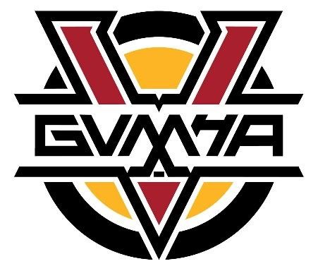
GVMHA Board Meeting Minutes
June 28th, 2023

Present: Gord, Jesse, Jodi, Lynn, Erik, Kevin, Dwight, Nik, Trevor
Absent: Cheryl, Curt, Bryan

Call meeting to order.

1.Approval of Agenda
Motion to approve agenda by Erik; seconded by Brendon.

2. Approval of Minutes
Motion to approve minutes by Brendon; seconded by Jesse.

Financials by Jodi Peshko
- Budget is approved but a couple of changes were made because of the ID camps and development clinics.
Motion to approve amendments to budget by Nik; seconded by Brendon.

Motion brought forward by Trevor and seconded by Nik that the Accountant, Treasurer,
President and Executive members are ineligible to win the progressive GVMHA 50/50.

- Jodi will research through licensing to see if other board members are eligible to win.
- We have had registration monies come in with 319 registrations and 84 in progress.
- Hockey school registration has slowed down but is looking great overall with 150 kids registered at this point.
Motion to approve financials by Lynn; seconded by Trevor.

Sponsorship Document (see attached) by Kevin Bathurst
• The sponsorship document has been updated from last year. See attached. We sold 3 platinum sponsors: Boston Pizza, Training House, and Rink. Trevor will update this document into a one-page document that Kevin will be able to drop off at local businesses.

OMAHA Update, Female Zone Program by Kevin Bathurst
- Discussions are ongoing regarding zones and how they are structured.
- There may be changes to what associations are a part of each zone. Winfield currently comes north to Vernon but Kelowna may need more players so Winfield or West Kelowna may end up moving to Central Zone but that will be determined after ID skates.

6.OMAHA Update-U9 Program by Kevin Bathurst
• More associations are starting to tier U9. This allows the associations to group kids based on skills.

7. Strategic plan by Kevin Bathurst
- Kevin presented information from Michael Butler, who can help us with GVMHA’s strategic plan. Michael is a former BC Hockey office staff member, who worked in grassroots development and has a great background in hockey. It would take approximately a year. Kevin needs to get costs.
- Gord discussed the importance of having a simple strategic plan that we can work on for the next 5-6 years with clear goals. We need short term strategic goals that we can work on and communicate to the membership. We need to look at costs if we are going to consider hiring a consultant.

Motion to end meeting by Lynn; seconded by Brendon.

