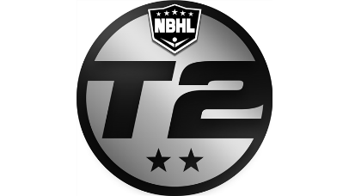 |  | 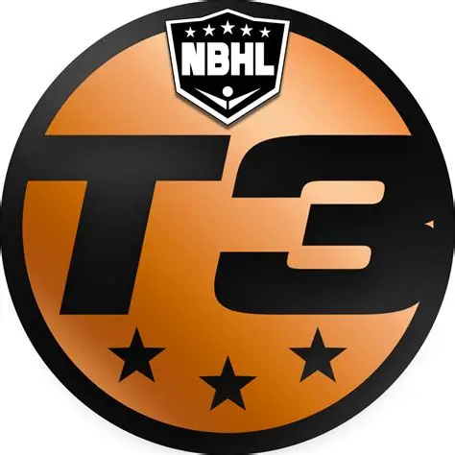 | NBHL – BC  Game incident report (GIR)

Dated: | 10 April 2026

INCIDENT REPORTED: | Major – Boarding/Bodychecking

Rule #1: | USABH Rule #64(A & B), Page 48 – Boarding/Bodychecking
Rule #2: | If required
Rule #3: | If required

Officials:

Jim Jones | High Official | Made the Call | JJofficial@gmail.com | 778-555-1212
Tom Smith | Low Official |  | TSmith@gmail.com | 250-222-1515

Time: | 2:00 pm (PT)
Date: | Saturday, 11 April 2026
Location: | Eagle Ridge, Victoria, BC

Teams:

Home: | Vancouver Island Mountaineers (Blue Jerseys)
Visitors: | Victoria Jaguars (White Jerseys)

Player(s) Involved:

#1 | Mountaineers | Phil Davis (13) | Subject of Incident
#2 | Jaguars | Ted Stevens (55) | Victim and/or Injured in Incident
#3 | If required
#4 | If required

INCIDENT REPORT

Incident:

At the 2:24 mark of the first period, the play was deep in the Jaguars zone, with the play in behind and just to the right of the net. At that time Stevens (Jaguars #55) was defending and in possession of the ball. He was about one (1) foot plus from the boards. It was here that Davis (Mountaineers #13) was forechecking and was attempting to box in Stevens. However, he was approaching quite quickly and failed to hold up in time, thus hitting Stevens in the back area into the boards face/headfirst, resulting in Stevens immediately falling to the floor and not move.
From the position of the official Jim Jones, who was about 15 feet away and had an unobstructed view of the incident, the initial impact appeared minimal, in that it appeared to cause Stevens to lose his balance and go headfirst into the boards.

Stevens stayed on the ground for a few moments and had to be assisted off the floor.
Both officials conversed and believed there was no intention of the body check outside of the fact that Davis is a hefty player and could not stop in time, misjudging his speed and distance.

Davis was escorted to the Pentalty Box, where it was relayed, he would be receiving a Major for Boarding/Bodychecking – causing injury, and the automatic Game Misconduct. He was then escorted off the floor after apologizing profusely to Stevens several times that he was sorry, it was an accident and he had no intentions of hurting or checking him.

As a result of the play, resulting in an injury (Stevens, after some time at the bench and walking around to clear his head, tried to come back and play one shift and felt he could not do so.) He then stayed off the floor and out of the game until the handshake and then departed.

Notes/Info to include and think about

- We need the full story (Who, What, When, Where, Why, & How)
- What happened leading up to the incident?
- What happened after the incident?
- Was there anything happening prior to the incident which may have resulted in it occurring?
- Tell the FULL story in detail so that it is understood and can be used to visualise the story.
- If injury was sustained on the play, then provide as many details available, such as what type, if the player returned to the game, needed first aid/ambulance, or when they returned to the game.

Video/Streaming

Upon review of the Video Stream, you can see the incident at the 12:40 mark.
There is no volume on this video

Note: If no video streaming is available state such

Breakdown of the USABH Rules

- USABH Rule #64(A & B), Page 48 – Boarding/Bodychecking
- If more than one offence

Rule #64(A)

States; “A Minor Penalty or, at the discretion of the Referee, a Major Penalty and a Game Misconduct Penalty, based upon the degree of violence of the impact with the boards, shall be assessed to any player who body checks an opponent in such a manner that causes the opponent to be thrown violently into the boards.”

Rule #64(B)

States; “A Minor penalty or, at the discretion of the Referee, a Major penalty and a Game
Misconduct penalty shall be assessed any player who, in the opinion of the Referee,
intentionally body checks, bumps, shoves or pushes any opposing player.”

Questions/comments/concerns may be addressed to the undersigned.

Jim Jones
//Signed//
Jim Jones
NBHL-BC Referee
JJofficial@gmail.com
778-555-1212

