Vancouver Island Minor Lacrosse Commission
Regular Meeting Minutes
January 5, 2026

Attendees
Voting Executive
Chair Andy Stuart
Vice Chair Scott Barillaro
Secretary Krista Gregory
Treasurer Michelle Vecqueray
Zone 6 Representative Adam Gow
Web Master/Scheduler Liaison Jeremy Penzin
Female Coordinator Kate Blass

VIMLC Executive
BCLOA Representative Sarah Dmytruk
Indigenous Development Bryan Baxter (absent)
BCLCA Representative Kelly Fines (absent)
Other Attendees

Association Representatives
Alberni Valley Jeremy Penzin
Campbell River Sarah Thomas
Comox Valley Chad Robinson
Cowichan Valley Janice Parmar
Juan de Fuca Kyla Pedlow, Curtis Morwick, Nikila Cyr
Nanaimo Bryan Norby, Jesse Kemp, Shawn Swanson, Cathy Coulson
Oceanside Ryan Minty
Peninsula Rod Senior, Terry Hall, Simon Upshon
Saanich Scott Barillaro, Katherine Dyrland
Victoria Esquimalt Kate Blass

- Call Meeting to Order at 7:05 pm
Land Acknowledgement

- Adoption of Previous Minutes
Motion made by Jesse Kemp, seconded by Scott Barillaro, Carried

- Additions and Adoption of Agenda
Motion made by Kyla Pedlow, seconded by Michelle Vecqueray, Carried

- Business Arising from the Minutes none

- Financial Report: Michelle Vecqueray

Included are the Bank reconciliations for November & December 2025. Current Bank balance is $22,312.85 and there is 1 outstanding payment for an adjusted book balance of $22,072.85
I will have the 2026 Budget prepared and able to present for the February meeting. No other updates at this time.

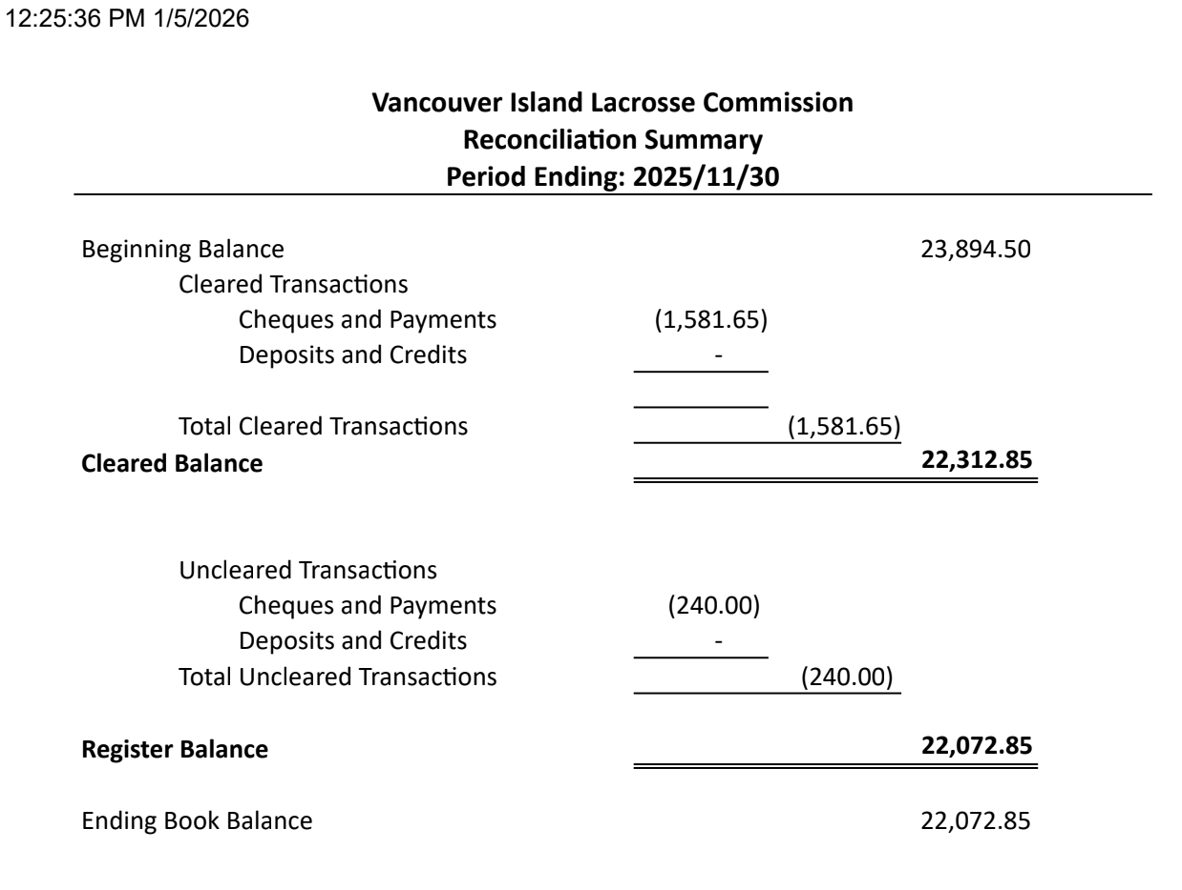

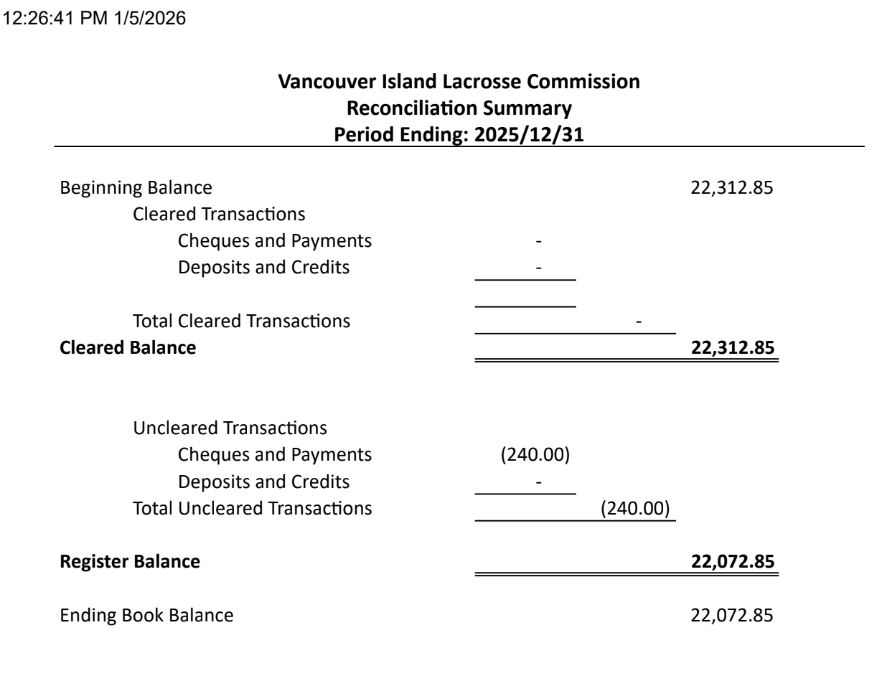

- Zone 6 Reports
- Chair Andy Stuart
VIMLC executive have had a couple preliminary meetings to understand our roles and the role of the commission. There may be some streamlining of VIMLC bylaws and policies so that these documents become more of a guidebook which references BCLA policy.
Looking to have good discussion at meetings to foster collaboration and sharing of ideas and solutions.

- Minor Directorate Rep Adam Gow
MD wants to make sure anyone hosting tournaments with teams from the USA to ensure the teams have their own insurance. The teams/players are not covered by the BCLA policy, same goes if any teams travel to the US.
As presidents know the provincials are very different this year due to FIFA. It was suggested by the Shuswap zone rep that hotels be secured early, I believe this is a topic on the agenda tonight.
The Commissioner meeting is planned this year for March 12 and possibly March 26.
Important reminder U9 games are 3v3 until end of season, June 1. After the season exhibition games can be scheduled and teams can agree to play 5v5.
If any associations have not completed their membership renewal with the BCLA they are asked to complete soon.

- Vice Chair Scott Barillaro
Not much to report on the Vice Chair front. I am responsible for two items on the agenda tonight: business rules and key dates (which are from the business rules). We will share information with associations and ask for feedback. I will then finalize the documents in time for our February meeting.

- BCLCA Rep Kelly Fines nothing to report

- BCLOA Rep Sarah Dmytruk nothing to report

- Indigenous Development Coordinator Bryan Baxter nothing to report

- Female Coordinator Kate Blass nothing to report

- Web Master Jeremy Penzin
Boundary maps were emailed to presidents on January 3, please reply with any possible edits with rationale before the February VIMLC meeting. After this the maps will be uploaded to the VIMLC website.

- Association Reports
- Alberni Valley
We've had some executive board changes with lacrosse in the Alberni Valley. We have a new revamped lacrosse website with RAMP to help with minimizing admin work and make it easier to register. Registrations are slow so far which is normal for us. Try-it sessions begin week and will run through February to help boost registration numbers.

We also switched to credit card and e-transfer payments only for registration. Limited floor time remains an issue as both rinks hold ice for nine months of the year. Due to low player numbers expected in certain divisions, we will look at the possibility of combination teams with Oceanside in early February.

- Campbell River
With the news of our arena phase 2 upgrades being approved in November. We are uncertain at this moment when they plan to start. March 2026 has been thrown out as an option however some user groups have proposed a lot of discussion and they are unsure when they plan to start and there still might be dry floor this season.

With this we have delayed our registration opening. We have our board meeting tomorrow to go over more options and come up with a decision for our season

Our board is mixed currently with wanting to push for a season for our younger divisions with the usage of our outdoor box and as always release our competitive divisions elsewhere. Since we are a small association it’s not a big burden as we don’t have a lot of displacement and it will put extra players in other associations if there’s space.

I’d love to hear from anyone who has gotten through an arena upgrade or how to navigate home games in a different arena perhaps? As we don’t have any other dry floors in our area. And I believe our outdoor box is not regulation size to host full court games. Any ideas to bring forward to my board would be appreciated as we navigate another tough year in the north island

- Comox Valley
Registration will open on January 15.
We have learn to play sessions scheduled over the next few weeks in partnership with the school district. We will see kids from grades K-4 during their PE classes on Fridays. This has been successful in the past and we are hoping it helps to attract kids in the U7/U9 age groups, our numbers were low there last season.
Drop in sessions for returning and new players will start at the end of this month

- Cowichan Valley no report

- Juan de Fuca
The biggest change for JDF this year has been our board structure change that was voted in at our AGM in November. We are now following a Governance model that has our elected directors focusing on strategic planning, and our appointed positions focusing on operations. Obviously, there will be overlap between the two, but with the size of our organization, we are looking forward to this new structure and to having a more equal workload amongst our board.

Season planning is well underway. This year we have moved away from Assessments for U13-U17 and moved back to Tryouts instead. The amount of players we needed to assess in those age groups was huge, and we started to notice some inconsistency in assessment quality.

Tryouts for our competitive divisions begin tomorrow night, and coaches for those teams have been selected and announced. We anticipate all of our U13-U17 teams will be formed by early February. U7-U11 will follow, with a goal of having those teams formed by early March. We anticipate having teams practicing in early March.

Current registration is at 280 players, however we do expect that number to grow. Similar to Saanich, we have switched to credit card only payments this season. We will still accept etransfers for those that don’t have credit cards, but this change has made things significantly easier for our registrar and treasurer.

- Nanaimo
Registration is open and we are filling up fast. We have “try lacrosse” and “drops ins” for coed and female scheduled for January.
Looking forward to the season.

- Oceanside
We have also had some executive board changes for Oceanside minor lacrosse. Our registration is open at 26 so far. Drop ins starting Jan 12.
We have an accepted release of a Jordain Hassey. Hopefully Krista has received paperwork so that can go through.

We are having our outdoor lacrosse box redone. Which is fantastic but it might in our box lacrosse season. They are not giving us dates but very much Hoping the ice is out at that time so we can play. Ice is out April 13th - June 17.

- Peninsula
Registration opened in December and we currently have 90 registered to this point.

We are starting some back to the box sessions this week and very happy to be using the newly covered Centennial box. Unfortunately securing time at the new box has been a task and a half due to everyone and their dog wanting time there. As it’s our only outdoor box we are working hard to continue to get priority.

We are in planning to introduce lacrosse to all classes at Sidney Elementary School at the end of January.

- Saanich
Registration started a bit slowly but picked up over the past week. We will start our U11 and U13 evaluations this coming weekend. We also have a Skills and Drills/Icebreaker session scheduled for Sunday night. The U15 and U17 evaluations will start later in January. Coaching applications closed prior to the holidays and we're in the process of finalizing selections for the season. Other various pre-season activities are underway as well.

On an administrative note, we linked the RAMP registration system to the Sportspay merchant account embedded in the platform. We can now process credit card payments and have virtually eliminated manually processing etransfers. We intend to use the merchant account to set up a Team Store in our RAMP website to help manage clothing/swag sales this year as well. It will reduce a lot of admin work for volunteers going forward.

- Victoria Esquimalt
Back to the Box sessions started last weekend. We saw a great turnout for both coed and female. It's bittersweet because we won't have Archie Browning this season due to renovations which limits how many teams we can host.
We've been working to make arrangements for our coed players this season and it's been going better than expected. I am incredibly thankful for the support we've received from our neighbor associations and the commission as we navigate this situation. We will continue to host drop ins for all ages and work to build female and non-competitive numbers through school visits.

- Commissioner Reports: no reports at this time

- New Business
- Season Key Dates
The VIMLC website will soon have a list of dates related to the Vancouver Island League. Note that because Provincials are not organized by age group this year the schedule will need to reflect season ending deadlines in a different way (so that playdowns are finished 8 days prior to the corresponding Provincials date)

- 2026 League Business Rules Scott Barillaro
The document will be sent to everyone for review, and then there will be discussion at the February meeting. After the major rewrite which occurred 2 years ago there has not been a need for other substantial changes. There is a new paragraph regarding teams booking playdown games closer to home if both associations agree. Scott will liaise with the scheduler once the Business Rules are adopted.

- Commissioner Nominees
Every association is required to nominate a commissioner volunteer by February 1. Please email Krista Gregory with the name and email address of your nominee, as well as any potential age group conflicts they may have.
Please remember that the role of commissioner can be time consuming, and it requires level-headed, organized, capable individuals. Adam Gow will act as a mentor for all commissioners this year.

- U11 Tiering
Presentations and discussion from several individuals on the successes and challenges of the U11 tiering pilot which ran in the 2025 season.
Highlights:
-more even competition for both A and B teams, including smaller associations, allowing for increased ball touches, more players felt successful and new leaders emerged on teams
-scheduling exhibition games was challenging as most floor time was already allocated and lower mainland teams wanted to come for double headers
-feedback from players and parents was positive
-young referees sometimes felt intimidated by the intensity of A team parents, will need support from mentors, and associations need to remind parents of appropriate spectator behaviour
-self scheduling exhibition games (vs league games) sometimes lead to lack of communication with referees
-request that smaller associations be allowed to remain in B and not retiered to A if they are winning games. Note for the Declaration meeting: please try to place teams in all divisions in the appropriate tier as best you can, considering the best interest of the league and the players

Motion made by Jesse Kemp, seconded by Bryan Norby, To allow tiering at the U11 division on the island including the creation of a league Carried

- U9/U11 Player Recruitment Strategies Jesse Kemp
Suggestions for Female player recruitment:
-Create a board position which focuses on recruitment
-Focus on a single age category, U11
-Partner with school district or other sports groups, host “try lacrosse” or “bring a friend” sessions.
-Nanaimo and Vela are happy to send groups of U17 players to other associations to participate in drop ins.

- Hotel Bookings for Provincials Adam Gow
Because FIFA games will be played on Vancouver this year, hotel prices and availability will be a challenge for any teams attending Provincials or other tournaments in the Lower Mainland. It is suggested that blocks of rooms be booked now, and hopefully shared with successful teams if those who booked them don’t qualify for Provincials. Island teams may also want to explore other opportunities like travelling to Calgary or hosting a tournament on the Island.

- Next Meeting: Monday, February 2 at 7 pm Preliminary Team Declarations

- Motion to Adjourn made at 8:34 pm made by Jesse Kemp, seconded by Jeremy Penzin, Carried

