Vancouver Island Minor Lacrosse Commission
Annual General Meeting Minutes
November 15, 2021
Via Microsoft Teams

ATTENDEES
Voting Executive
Chair Tim Frost
Vice-Chair Ryan Hyland
Secretary Krista Gregory
Treasurer Christine Mavin (absent)
Zone 6 Representative Doug Kampen
Web Master/Scheduler Liaison Dylan Taylor (absent)
Female Coordinator Stephanie Hopkins

VIMLC Executive
BCLOA Rep Tyler Boyer
Indigenous Development Bryan Baxter
BCLCA Rep Vacant
Mini-tyke Phil DiBattista
Tyke Cam Miller (absent)
Novice Adam Gow
Pee Wee Kandace Dunning (absent)
Bantam Teri Zunti (absent)
U16 Allison Logan
Female Brande Terris

Association Representatives
Alberni Valley Kelly Fines
Campbell River Philip Kountouris
Comox Geoff Garbutt
Cowichan Valley absent
Juan de Fuca Ryan Hyland, Liz Hyland
Nanaimo Brande Terris, Lonny Sullivan
Oceanside Jason Hassey
Peninsula Phil DiBattista
Saanich James Scott, Nancy Passfield
Victoria-Esquimalt Kate Blass, Mike Lavender

1. Call Meeting to Order: 7:06 pm

2. Adoption of Previous Minutes:
Motion made by Ryan Hyland, seconded by James Scott Carried
Motion to adopt additions & adoption of Agenda made by Ryan Hyland, seconded by James Scott Carried

3. Additions and Adoptions of Agenda:

4. Business arising from old minutes: none

5. Correspondence and Handouts: none

6. Financial Report:
Motion to adopt financials as presented by Christine Mavin made by Kelly Fines, seconded by Ryan Hyland Carried

I have attached a copy of the Summary Balance Sheet, Detail Balance Sheet and the Bank statement from August 2021 (our year end is August 31). We currently have $10,502.77 in our account which is pretty good considering we have not collected any dues in 2 years. We are going to need to be careful of any money we spend this upcoming year until we have invoiced the first half of fees and received that money in. We also need to be mindful of the fact that the # 's we use to base our fees could be lower than in years past which could affect our money to spend later on things like playoffs, any clinics we may want to hold and travel fees we pay for referees. I have not received any #s from BCLA regarding last year’s #'s so that is something we need to be mindful of. If anyone has any questions please let me know.

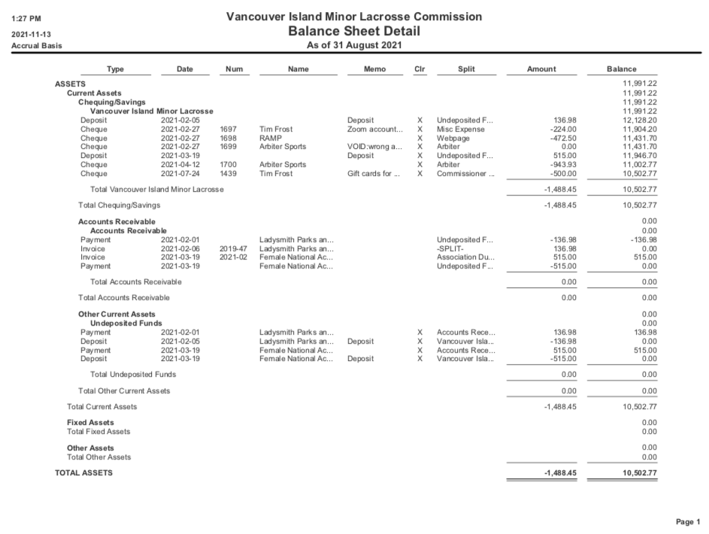
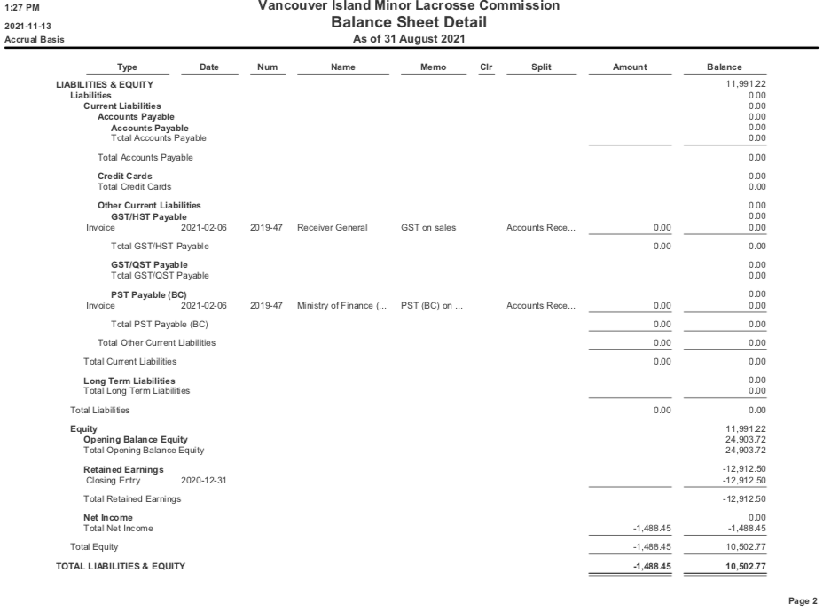
7. Zone 6 Reports: no reports at this time, no lacrosse activity since our last meeting

8. Commissioner Reports: no reports at this time, no lacrosse activity since our last meeting

9. Association Reports:

A. Alberni Valley: Alberni has had their Agm. Our head ref (Tyler Boyer) has stepped down to take the head ref position with the island. Our registrar (Lindsay Hodgson- one year remaining) stepped down and our past registrar (Carrie Johannesson) has stepped in for the remaining year. I am back for another term. We are working hard to recruit new members due to most of our members kids age out this year. I have set up a meeting with the city for Tuesday to discuss floor times for next year. We may lose one dry floor, with them adding a second junior hockey team. We have also put together a small committee to discuss ways to promote our 20th anniversary in 2022.

B. Campbell River: AGM is scheduled for the 17th. We are expecting some movement on our Executive, in addition to implementing long overdue changes to our internal policies to increase parent involvement, fundraising efforts and raising the overall bar for the CRMLA. I will officially take office as President on the 17th and will be pushing for accountability this season from our Executive Committee.

C. Comox Valley: Comox Valley AGM is later this week and we will have two new executive members following two retirements

D. Cowichan Valley: no report

E. Juan de Fuca: JDF has not had our AGM it will be in January. We have officially amalgamated with Victoria Titans Field lacrosse which is now call JDF Field lacrosse. Nothing else to report.

F. Nanaimo: Our AGM was held October 24. No one else would step up as President so I am back for 2 more years. We have a new secretary, Jesse Kemp and New head coach, Shawn Swanson. No other changes to the executive at this time. We will be opening registration on December 15th.

G. Oceanside: I have stepped down as president at our AGM and Jason Hassey has taken over as president.

H. Peninsula: We held our AGM on November 8th we have a new registrar and two new directors that filled positions that were vacant last season which is great. We plan to open registration on Dec 1st. Since we are expecting a regular season, we will plan to host our Midget Tournament in early May and Mini-tyke in June

I. Saanich: We held our AGM on October 24. I have one more year on my term as President. All other current elected executive members were elected for another year. We are looking to open registration in early December.

J. Victoria/Esquimalt: VELA had our AGM on November 4th. We have a new president: Kate Blass
We also have a new treasurer, VP3 and Registrar.

10. New Business:

A. Election of Officers:
i. Chairperson: James Scott nominated Tim Frost, no other nominations, one ballot cast for Tim Frost
ii. Secretary: Tim Frost nominated Krista Gregory, no other nominations, one ballot cast for Krista Gregory
iii. Female Rep: no nominations, position is vacant
iv. Webmaster: no nominations, position is vacant

11. Next meeting: January 10, 2021 at 7 pm. This may be altered depending on Minor Directorate deadlines and schedules.

12. Motion to adjourn at 7:32 pm made by Doug Kampen, seconded by Krista Gregory Carried

