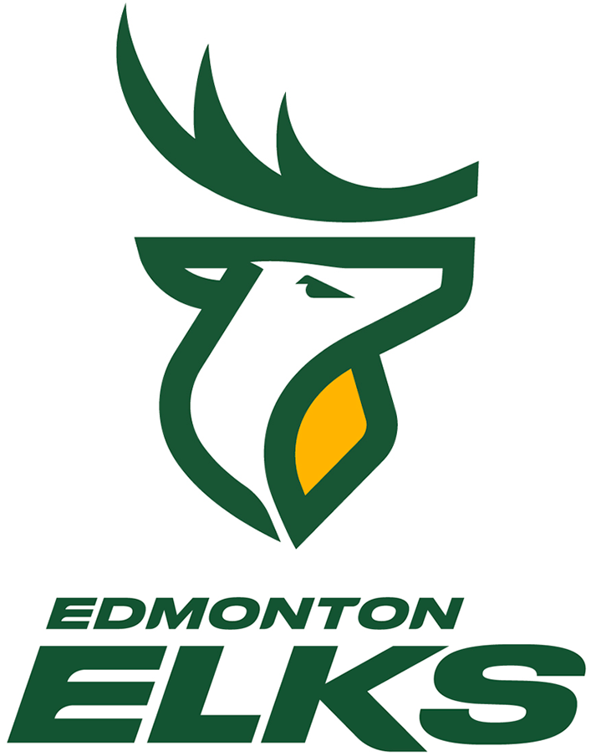
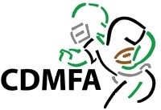
Edmonton Elks Game Day
October 15, 2022
Capital District Minor Football Association
Member’s Event

On October 15, the Edmonton Elks will be saluting the minor football players and their families. Our CDMFA members will be honoured and recognized and there will be fun and football for everyone.
October 14 – Skills and Drills Party
This event is open to all CDMFA members of all ages. Come join in some hands-on drills directed by Elks Alumni. Have fun participating in these activities and get some inside tips from those who have played professional football. Special treats will be provided for participants. Bring your camera and a pen, as there will be an opportunity for pictures and autographs with the players. See attached for more details.
October 15: Green & Gold Double-Header Game Day
Elks Toes on the Turf – All CDMFA ticket Holders
A great opportunity to watch the players warm up from field level. This is open to all CDMFA members. Be there early for a chance to see your favourite player practicing and warming up for the big game; at least 45 minutes prior to Elks kick-off. (See attached for more details).
PeeWees Run with the Herd
PeeWee players, enter your name for a chance to be one of the players selected to run onto the field as part of the Elks Herd and stand at field level for the National Anthem. (See attached for more details). Deadline to enter is October 10.
Bantams Fan Tunnel
Bantam players, enter your name for a chance to be one of the players selected to be the fan tunnel on field and cheer for the players as they enter the field for the Elks game. (See attached for more details). Deadline to enter is October 10.
Coin Toss – MVP Draw – Open to all players/ages
A chance to acknowledge the heart and passion of our athletes … coaches are invited to nominate any player from any of your teams/programs for a chance to stand center field for the coin toss and be recognized at the Edmonton Elks Football Club Salute to Minor Football. Deadline to enter is October 10/22. See attached for more details.
O’Canada – Officials
Our new Junior Officials will be a part of the CFL Officials’ Pre-Game routine and stand along-side them during O’Canada to start the Elks game. (See attached for more details).
Half-Time Show
Teams entered their names at the Atoms Festival. Eight teams have been selected to participate in the Elks Half-Time Game. (See attached for more details) Congratulations to the winners of this great experience:
- Beaumont Bears – Navy
- Camrose Buffaloes – Navy
- Millwoods Grizzlies
- Fort Saskatchewan Falcons – Black
- SCMFA Wolverines – Blue
- SAMFA Fury
- SGDMFA Cougars – Blue
- Edmonton Seahawks - Blue

CDMFA Member Tickets: 2 Games for the Price of One … In the Lower Bowl!
It’s a “Green & Gold Double-Header!” Game 1 the UofA Golden Bears, Game 2 your Edmonton Elks.
One ticket for 2 Games and a whole lot of minor football fun…
Seats have been reserved for all our CDMFA teams and families in the lower bowl. We will have quick access to field activities and will be up close to all the action.
CDMFA Member Prices: $37 for Adults and $19 for Youth (players 12 and under can still qualify for free tickets) *Everyone will require a ticket for entry into the facility (even those participating on the field).
It is recommended that to try to guarantee your team will all sit together, that tickets be ordered in bulk. See attached for details.

Win an Elks VIP Experience – “A Day with the Herd”
Would your club want the chance to spend a day with the heard? Come spend a practice day with the team; tour behind the scenes, take part in a “Coach Talk,” and have pictures and autographs with the players.
The Club that sells the most tickets to the October 15 game, will win this exciting hands-on experience with the Elks. (tickets for the “under 12 and free” will not count towards the contest). See attached for complete details. Deadline for ticket sales to count towards the competition is October 10, 2022.

Tips for an enjoyable day of Football for all:
- Parking
- CDMFA will not be able to arrange transportation or parking for our members at this event. Clubs are welcome to arrange this for their individual teams. Otherwise, please share information on park & ride options to your families. Football Park & Ride | City of Edmonton
- Or they can arrange their own taxi or Uber services.
- Guidelines for Admission … visit the website for complete details https://www.goelks.com/health-safety-guidelines/
- Mobile Tickets … tickets must be scannable on your mobile device
- Clear Bag Policy … applies to all fans
  - **See section 1 for instructions for players/coaches with equipment**
- Represent the Best about Football
- We ask all CDMFA members to wear their team jerseys/team colours through out all the activities on that day. We want to represent our league in all the photos, jumbo-tron shots …. And who knows how many may even be seen on national television!!! (Parents should set their PVRs!)
- Wear your club colours and represent them well.
  - The media, jumbo-tron, and all the other fans in the stadium (and on television?) will be watching us. Let’s make everyone aware that youth football is here, and while we are passionate about the sport, we are well-mannered, good sports who are respectful of each other, our fans, and the volunteers who make all this possible.
- Coaches & parents, not only do we need to be respectful of the season seat holders and other cash customers, we need to keep the safety of everyone as our number one priority
  - Everyone, but specifically players, should remain seated when the game is in play
  - No one should be sitting on the stairways, or running up & down the stairways (last year we had two accidents on stairs)
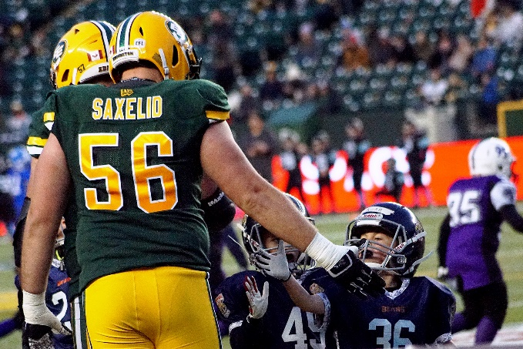
  - When possible please have a “buddy system” or “rule of 2” when players are out of their seats (last year we had a youngster who left for the bathroom and then couldn’t find his way back to his respective seat)
Let’s make this a fun and memorable event for everyone!
Tracy Kociuba
CDMFA, President
tkociuba@telusplanet.net

Questions about tickets, contest entries, please contact:
steve.andrusiak@goelks.com

