West Ottawa Ringette Drill Manual (FUNdamentals to Recreational U12)

Objective of the Manual
- To provide guidance for first time coaches, coaches new to ringette, or coaches new to coaching novice players
- To provide a resource for all coaches to make it easier to plan practices and communicate with assistants and parents
- The first part of the manual outlines suggested coaching approach, practice plan recommendations and skills to be taught
- The second section of the manual details suggested drills and coaching tips
- The last part of the manual outlines fundamentals of positional play and set plays like goalie ring and free passes. Each team can tweak these, but it is important that the same message be conveyed to the players from all coaches
- There is a sample practice plan on the last page of the document

Coaching Approach
- The main objective is to teach basic Ringette skills in a fun environment that will keep the Players engaged and excited. If successful in achieving these objectives, it will translate to success in games
- Try to minimize standing around
- Have the Players and assistant coaches gather in a semi-circle while explaining a skill or a drill
- The Players should ‘take a knee’; try to ensure they are paying attention before starting to speak
- When teaching a skill, explain and demonstrate each element of the skill
- Speak loud, slow and clear, using age and skill appropriate language. Remember, new players won’t understand terms like ‘check’, ‘cover her’, ‘open ice’, ‘forehand’, ‘backhand’ etc
- Always demonstrate the skill, drill or game after explaining it
- When executing a drill, it is sometimes necessary to physically maneuver the Players until they ‘get it’
- All coaches should continue to coach the Players as much as possible as they execute the drills; “Show where you want the pass!” during a passing drill for example
- Use a constant stream of positive feedback, “Look at you, you’re doing great!”

Practice Plan Recommendations
- Recruit as many parents as possible to be assistant coaches or ‘helpers’
- Complete a practice plan and distribute to the assistant coaches a day or two before each practice
- Keep the drills simple. Maximize movement and skill execution, while ensuring all Players have an equal chance to participate
- Split the ice into separate areas and run separate stations in each area
- Plans should include a slot at the beginning of practice to warm up & split the Players into groups based on skill level. See Warmups, Getting Organized
- Appoint an assistant coach (or yourself) to be responsible for each drill and tell the other assistants which drills they are assigned to
- Tell the assistants when they volunteer and repeat with each practice plan, that they are responsible for learning the drill(s) for that station, BEFORE the practice
- Practice plans should identify the skill to be practiced, the name of the drill to be executed at each station, the page number in the manual where the skill and drill are described, the time allotment for each component and the name of the coaches responsible for each station
- Assign the young player helpers to the stations at the beginning of the practice. The responsible coach at each station tells them what they can do to help: demonstrate skills and drills and help execute the drills. Every effort should be made to ensure these young people make meaningful contributions to the practices
- Plans should include a fun game or scrimmage at the end of each practice
- Try to organize practices so players of similar skill execute drills and play games together
  - This allows for more directed coaching, depending on the skill level of the players executing the drills. It is also less intimidating for the less experience players
  - Requires some planning to determine how to split up the ice. And remember the goalie!
- In Fun 1 & 2, keep first time skaters together and modify drills at each station to accommodate them
- If the folks using the ice directly before you don’t chew up the ice, you can ask the Zamboni driver not to flood. This will give you an extra 10 minutes. Of course, this works better if you know in advance and tell the parents to come early
- Include a cheer at the end of each practice. Wait for the Zamboni Horn
- You can burn a lot of practice time working on positional play and set plays with very little payback. The objective at this level is skill development, so it is far more important to practice fundamentals. Think about giving the players simple instructions on positional play and set plays to bring home, along with fun quizzes. You can coach the heck out of it during scrimmages & games.
- Note: Most of the drills in this document are designed for ½ ice practices
- See the last page of the manual below for a sample practice plan

Skills to Teach
- Balance: Getting comfortable on the ice
- Skating: finding edges, power strides
  - Forward, backward, stopping, cross overs
- Basic shooting and passing
- Stabbing the ring
- Carrying the ring
- Checking/avoiding being checked
- Passing/receiving a pass
- Shooting
- Goalie
- Rules
- Positional play and set plays
Skills --> | Page | Balance | Skating | Shooting | Passing | Stabbing Ring | Carrying Ring | Checking | Goalie | Rules | Positional Play & Set Plays
Drills (All except * can be used or modified for Fun 1 & 2)
Warm Up/Getting Organized | 4 | ✔ | ✔
Basic Balance & Skating | 4 | ✔ | ✔
Sub Stations | 5 | ✔ | ✔ | ✔ |  |  | ✔
Simon Says/Ring Around the Rosie | 5 | ✔ | ✔ | ✔ |  |  | ✔
Power strides | 6 | ✔ | ✔
Power glides | 6 | ✔ | ✔
Hard Skating & Stopping | 6 |  | ✔ |  |  |  | ✔
Lightning Drill | 7 |  | ✔ |  |  |  | ✔
Around the Free Play Circles | 7 |  | ✔ |  |  |  | ✔
Basic Passing & Shooting | 8 |  |  | ✔ | ✔
Pepper Passing Drills | 8
Shooting Pylons | 9 |  |  | ✔ | ✔
Shooting on Goal | 9 |  | ✔ | ✔ | ✔ |  | ✔ |  | ✔ | ✔
Circle Passing | 10 |  | ✔ |  | ✔ |  | ✔
Cross Ice Passing | 11 |  | ✔ |  | ✔ |  | ✔
Pass Across Blue Line Skill | 12 |  | ✔ |  | ✔ |  | ✔ |  |  | ✔
Pass Across the Blue Line 1 | 12 |  | ✔ |  | ✔ |  | ✔ |  |  | ✔
Pass Across the Blue Line 2* | 13 |  | ✔ | ✔ | ✔ |  | ✔ | ✔ | ✔ | ✔
Pass Across the Blue Line 3a* | 14 |  | ✔ | ✔ | ✔ |  | ✔ | ✔ | ✔ | ✔
Pass Across the Blue Line 3b* | 15 |  | ✔ | ✔ | ✔ |  | ✔ | ✔ | ✔ | ✔
1/2 Butterfly Drill | 16 |  | ✔ | ✔ | ✔ |  | ✔ |  | ✔
Ring Stabbing | 17 |  | ✔ |  |  | ✔ | ✔
Checking Skill | 18 |  | ✔ |  |  | ✔ | ✔
Scramble Checking | 18 |  | ✔ |  |  |  | ✔ | ✔
Keep Away/Checking Tag | 18 |  | ✔ |  | ✔ |  | ✔ | ✔
Goalie Skills | 19 | ✔ | ✔ |  |  |  |  |  | ✔ | ✔
Goalie Ring Drill | 20 |  | ✔ |  | ✔ | ✔ | ✔ |  | ✔ |  | ✔
British Bulldog | 21 |  | ✔ |  |  |  | ✔ | ✔
Toilette Tag | 21 | ✔ | ✔
Turtle Tag | 21 | ✔ | ✔
Kwazy Wabbits | 21 |  | ✔ |  |  |  | ✔ | ✔
Here Comes the Wolf | 21 |  | ✔ |  |  |  | ✔ | ✔
Soccer/HandBall | 21 | ✔ | ✔
Scrimmages | 22 | ✔ | ✔ | ✔ | ✔ | ✔ | ✔ | ✔ | ✔ | ✔ | ✔
Positional Play/Sets Plays | 22 |  |  |  |  |  |  |  |  | ✔ | ✔
Sample Practice Plan | 27 |  |  |  |  |  |  |  |  | ✔ | ✔
Rules | See ‘A Ringette Story’ |  |  |  |  |  |  |  |  | ✔ | ✔

Warmup, Getting Organized:
- Line up all the Players on the goal line. Make sure they spread out
- Have some coaches and helpers line up in front the Players to demo the positions and a few behind the Players to help as required
- Encourage the Players to go into the Ringette stance. Demonstrate the stance: bend knees, arms in front, two hands on the stick, head and shoulders lined up over feet, looking straight ahead.
- Have the Players bend their knees and bounce up and down a little. Have them pretend they are sitting down on a bench and getting back up. Repeat several times
- Have them bend over and touch their knees several times; touch their feet several times; reach for the sky several times; twist several times. Each time, encourage them to return to the Ringette stance
- Demonstrate how to get up from the ice. Have them fall to their knees and get back up, going back into the Ringette stance. Repeat several times
- Demonstrate marching on the spot & making snow while in the Ringette stance
- March to the Ringette line and back to the goal line
- Tell them when you blow the whistle, they should skate across the ice as fast as they can, and when you blow the whistle twice, they should all freeze
- Have the coaches get ready in their stations to grab Players of similar speed
- Blow the whistle to get them started. When the first Player nears the centre red line (1/2 ice) or far ringette line (full ice), blow the whistle twice for them to stop
- Split the Players into groups based on their position on the ice. This will ensure Players of similar skating skill will be in the same groups
- Note: If you can split the team into groups of similar skill without executing this last maneuver, then do so

BASIC BALANCE & SKATING SKILLS
Coaching Focus
- Ringette stance, knees bent
- Getting comfortable; balance, falling down & getting up
- Finding their edges

Basic Balance & Skating Skills (Fun 1 & 2)
- Demonstrate the Ringette stance. Bend knees, arms in front, two hands on the stick, head and shoulders lined up over feet, looking straight ahead. Have the Players bend their knees and bounce up and down a little. Have them pretend they are sitting down on a bench and getting back up. Repeat several times
- Demonstrate how to get up from the ice. Have them fall to their knees to show it doesn’t hurt and get back up, going back into the Ringette stance. Repeat several times
- Demonstrate marching in short strides, lifting the feet and maintaining the Ringette stance. Have the Players march across the ice, lifting their feet
- Demonstrate 360’s. Have the Players march on the spot turning completely around, while maintaining the Ringette stance. Have them repeat in the opposite direction.
- Demonstrate side steps, maintaining the Ringette stance and lifting the feet with each sidestep. Have the Players sidestep across the ice. Make sure they are all facing in the same direction. Have them pretend they are monkeys, grunting ‘Oo-Oo-Oo!” Repeat in the opposite direction
Sub Stations (Fun 1, 2)
- Set up sub stations like the ones below and have the players march through and execute the skills in each station. Requires a number of helpers

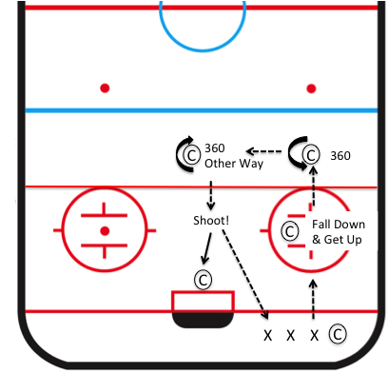

Simon Says and Ring Around the Rosie (Fun 1 & 2)
- Have the Players form a circle around 1, 2 or 3 coaches
- Ensure the Players are spread out, each Player has a ring
- Tell them to start skating around the coaches
- Play Simon Says: March! Fall down and get up! Turn in a circle! Turn the other way! Make Snow! Ringette stance! etc, etc
- Have them turn around, skate the other way and repeat
- Play ring around the Rosie: “Ring around the Rosie, a pocket full of posies, Husha, Husha, we all shoot at the coaches!”
- The Players all try to hit the coaches with shots
- Repeat with “Ring around the Rosie, a pocket full of posies, Husha, Husha, we all get our rings back!”
- The Players retrieve their rings and return to the circle
- Have them turn around and skate in the opposite direction and repeat
- This will get the Players to shoot with forehand and backhand

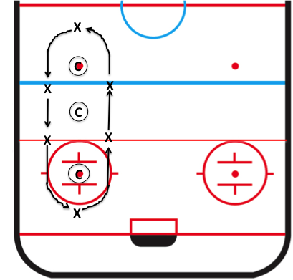

POWER Strides
- Demonstrate Ringette stance with sideways strides, scraping the ice and making snow
- For new skaters, have the Players drop their sticks, turn around, hold the boards for support and pretend to push the boards backwards. Tell them to try and make scraping sounds with their skates. You may have to physically grab their feet to demonstrate the sideways scraping motion. Have them do one leg several times, then the other, then alternate
- Have the Players push the coaches across the ice, making snow. Hold your stick and their stick in front of you to give them something to hold onto. Coaches are facing backward
- If there are too many Players for the assistant coaches, they may have to take turns pushing the assistant coaches, or two Players of similar skill push each coach
- Once they are able, try repeating with the Players pulling the coaches across the ice
- For U10 and U12 recreational, repeat with the players pulling the coaches while skating backwards. Demonstrate ‘making big C’s’
- Eventually, try these drills with the Players forming pairs and pushing and pulling each other

POWER Glides
- Demonstrate power glides: Players pretend they are riding a scooter: Ringette stance, hands out front holding the stick like handlebars, one foot stationary like it’s on the scooter, other foot pushes sideways and back to push the scooter. Exaggerate the push
- With each stride, encourage the Players to glide and stay in the Ringette stance
- Have the Players glide to the red line, turn around, switch feet and glide back
- Have the Players skate to the blue line & back, alternating glides
- You can have the players try to execute this skill on the ‘Around the Free Play Circles Drill’ below. It is the first element of crossovers

Hard Skating and Stopping
- Demonstrate hard skating with power strides and stopping on the left and right
- Have the players practice stopping on their left and right by taking a few steps in one direction and stopping, then a few steps in the other direction and stopping, scraping the ice each way
- Repeat the skill several times until they’ve found the inside edge on their outer skate at minimum and hopefully, the outside edge on their inner skate, in both directions
- See lightening drill on following page

Lightning Drill
- See hard skating and stopping on previous page
- Spread players out along the goal line, no rings
- Depending on the number of players, you may have to form two lines
- Players skate to the blue line, back to the Ringette line and up to the red line
- Repeat in the opposite direction: Ringette line, blue line, goal line
- Every time they stop, they should be facing the dressing rooms. This will force them to stop on both their strong and their weak sides
- For U10 and U12, repeat with the players skating the second (or first and third) sections backwards
- Repeat the drill in both directions carrying rings
- Note: You can run this drill with two lines on either side of the ice, one for experienced players and one for inexperienced players

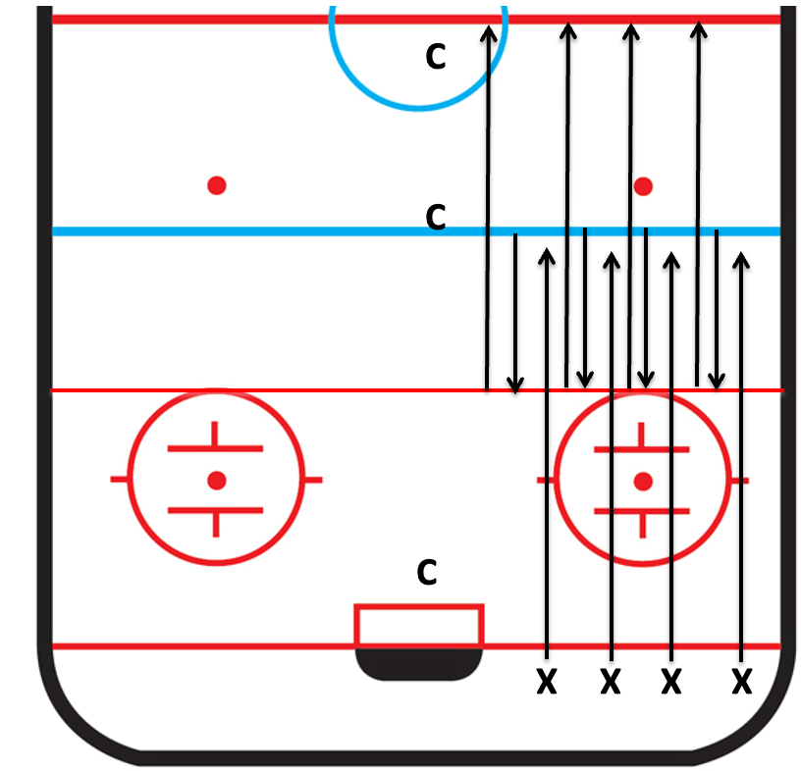

Around the Free Play Circles
- Experienced player should attempt crossovers
- 2 to 3 players go at once. Faster players can pass slower players
- Repeat several times
- Execute the drill with rings; repeat several times
- When the players are more experienced, have them try doing it backwards and doing half forward and half backwards

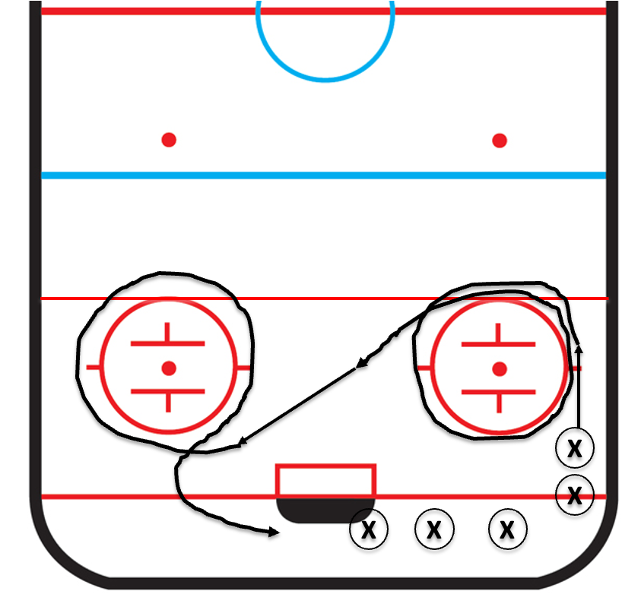

Basic Passing and Shooting
- Demonstrate the proper grip of the stick, both hands on the stick, thumbs pointing down, lower hand a third of the way down the stick
- Demonstrate sweeping the ring and following through so the stick is pointing at the target at the end of the sweeping motion
  - Have Fun 1, Fun 2 and any players new to ringette try the sweeping motion left and right to see which they are more comfortable with
- For receiving passes, demonstrate looking at the passer, using the stick to show where you want the pass, and stabbing the ring by keeping your eyes on the ring and guiding the stick into the centre of the ring

Pepper Passing Drills
- Divide the Players into as many small groups as there are coaches
Option 1 (Below Left):
- The coaches line up about 5-6 meters from their Players and take turns passing to and from each Player, encouraging them to execute the skills correctly: follow through and pointing at the target for passing, looking at the passer and showing where they want the ring for receiving
- Demonstrate turning sideways to the target and using the backhand to “sweep” a pass along the ice. Make sure they are not changing their hand position on their sticks
Option 2 (Below Middle)
- Players face each other about 5-6 meters apart
- Player 1 passes to 2 who passes to 3, who passes to 1 and so on
- After a minute, have them change the direction from clockwise to counter clockwise
- Coach encourages proper execution of the skills from a few meters away
Option 3 (Below Right)
- Players line up in a row, about 5-6 meters apart. They should all face the end board so they are passing sideways
- Coaches fill in as required
- Player 1 passes to 2, who passes to 3, who passes back to 2 who passes to 1 and so on
- Have them change the direction of the passes so they will be practicing their forehand and backhand
- Coach encourages proper execution of the skills from a few meters away

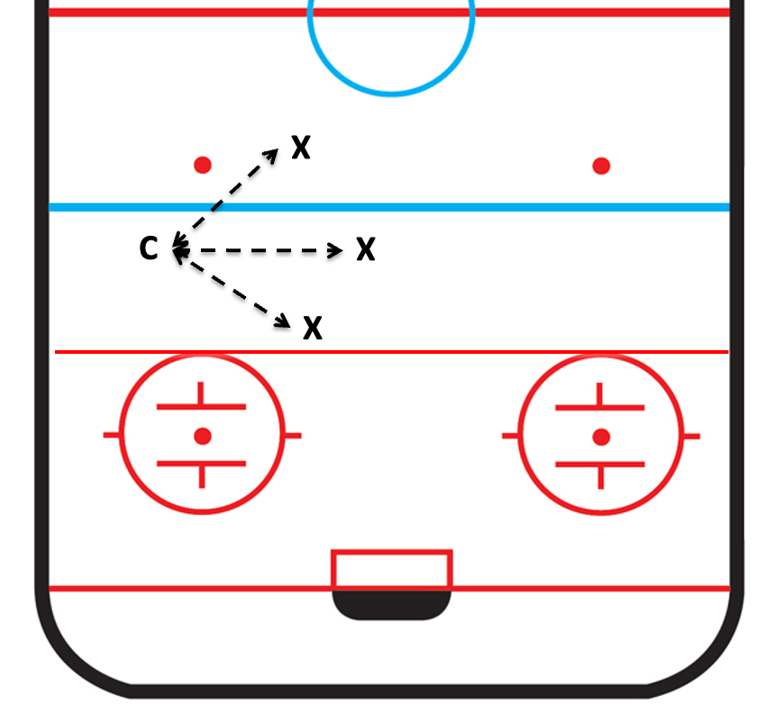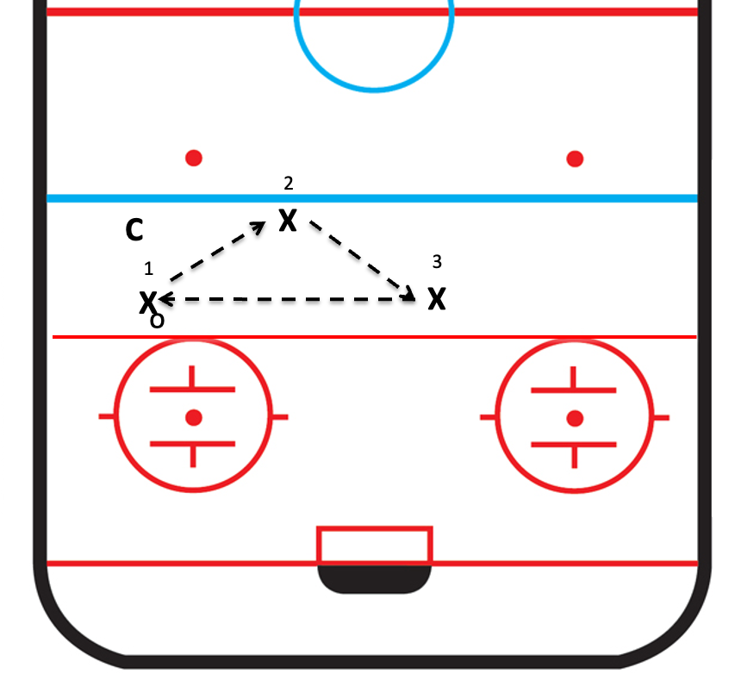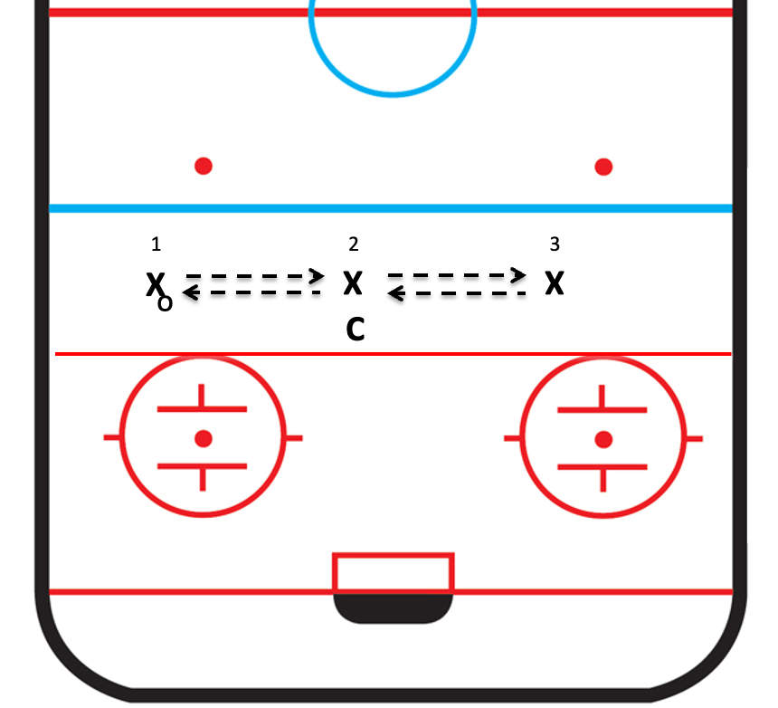

Note: These are good drills to add to the warmup of every practice for a few minutes, and even as a pre-game warm up
Basic Passing and Shooting Continued
Shooting Pylons (Fun 1 & 2)
- Line Players up half way between the ringette line and the goal line
- Place a line of pylons opposite the Players, just inside the goal line
- Have the Players shoot rings at the pylons and try to hit them
- One or two coaches behind the shooters, correcting their shooting motions
- One or two coaches behind the pylons, replacing the pylons and passing the rings back to the Players
- Options:
  - Have the players carry the ring from the blue line before shooting

Backhand Flip Shot (Against the Boards). Demonstrate turning sideways to target and using a stick to “shovel snow”. Enforce not raising the stick over their shoulders

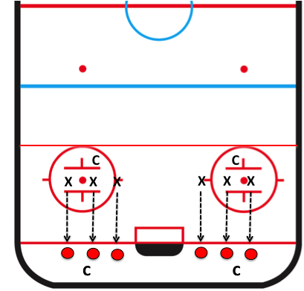

Shooting on Goal (Fun 1 & 2)
- Line Players up in front of the goal (not too close)
- Explain that no Players except the goalie are allowed in the crease. Also, if the ring is in the crease, the only Player allowed to touch it is the goalie
- Each Player should have a ring
- Each Player shoots on net; encourage the Players to sweep and point at the target
- Each Player gets a turn to be goalie, with a coach to give them pointers: play near the edge of the crease, knees bent, goal stick blade flat on the ice
- Also, the goalie should try picking the ring and throwing it back to the shooters like a frisbee

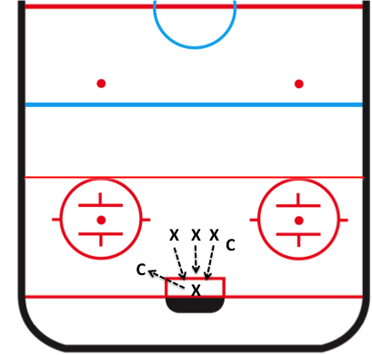

Circle Passing Drill
- Have the Players spread out evenly around the circles as pictured below left and start skating around the circle. Each Player has a ring
- Coaches are inside the circle
- Coaches pass to the Players as they skate around the circle and the Players pass back
- Encourage the Players to:
  - Sweep the ring and point to the target when passing
  - Use their sticks to show where they want the ring when receiving passes
- After a few minutes, have the Players stop and go in the opposite direction. This will force them to pass on their forehand and backhand
- Note: You can run this drill with two lines, one on either side of the ice, one for experienced players and one for inexperienced players
- Options:
- Expand the circle. Have the coaches stand further apart as pictured below right or bottom. Players skate around the coaches and execute the drill as described above
- Players are inside the circle making the passes. Have them work on passing where the player is going, not where they are. Passes are firm, but not too hard

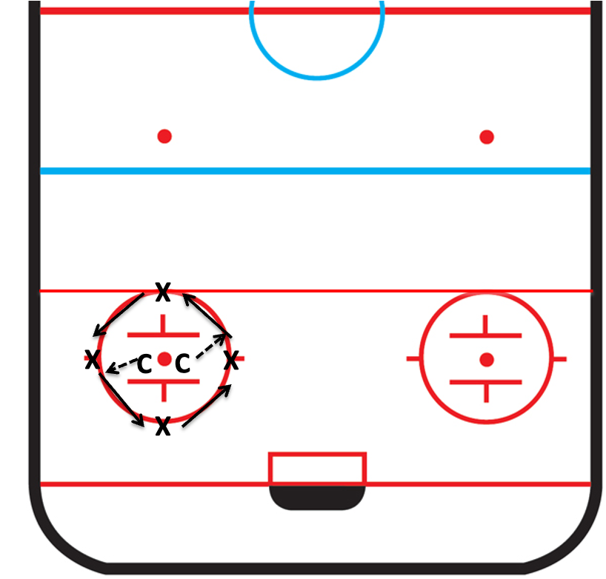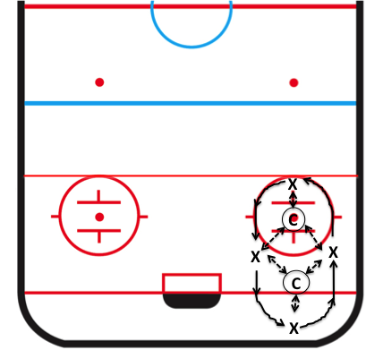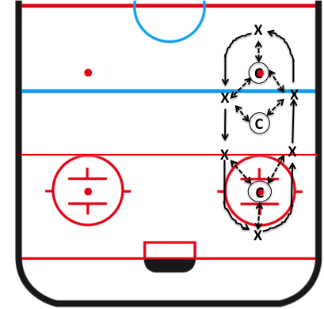

Cross Ice Passing Drills
- Form multiple lines, as pictured, below left
  - 2-3 players on one side of the ice, both with rings, one behind the other
  - 2-3 players on the opposite side of the ice, with no rings
- Two Players start skating towards one another
- The Player with the ring passes to the other Player and they each take up position on the opposite side from where they started
- Encourage the Players to:
  - Sweep the ring and point to the target when passing
  - Use their sticks to show where they want the ring when receiving passes
  - Pass where the target is going; firm passes, but not too hard
- Note: You can run this drill with two lines, one for experienced players and one for inexperienced players

Option 2:
- All players line up on one side of the ice
- All the players have rings except the first one in line
- The first player start skating, looks back for a pass and shows her teammate where she wants the ring
- The next player starts skating, passes to her teammate and looks back for a pass and so on
- Each player passes to the player in front of them and receives a pass from the player behind them
- After receiving their pass, the player finishes skating across the ice, around a pylon and back to the end of the line
- Note the players should start skating before passing. Do not pass while standing still
- The coach should encourage execution of proper passing skills as outline above

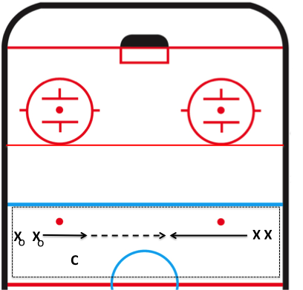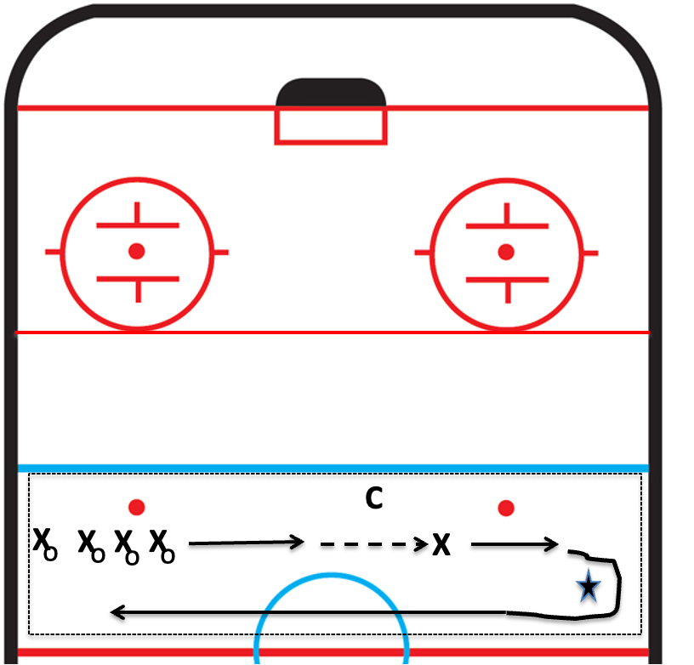

Pass Across Blue Line Skill
- Explain that in ringette, you can’t skate across the blue line with the ring, you have to PASS across the blue line. That means that if you don’t have the ring, you should skate across the blue line, so your teammate will have someone to pass to
- Demonstrate skating across the blue line, looking to see where the defenders are, moving to open ice looking over your shoulder for the pass and showing where you want the ring. Don’t turn around and stop – KEEP SKATING!!
- Demonstrate passing to where your teammate is pointing, not where they are

Pass Across Blue Line Drill (Fun 1, 2)
- Players form a line as pictured below
- One Coach stands just across the blue line to keep the line organized. Make sure Players are well back from the blue line & keep the line moving. Don’t wait for each Player to complete the whole drill before sending the next Player
- The other coach stands just inside the ringette line
- The first Player skates across the blue line, receives a pass from the coach, passes to the second coach, skates around the second coach, recieves a return pass, passes across the blue line to the last Player in line, and skates to the end of the line
- Encourage players to execute the passing skills described above: skating across the blue line, looking to see where the defenders are, moving to open ice and looking over your shoulder for the pass and showing where you want the ring. Don’t turn around and stop – KEEP SKATING!!

Options, Depending on Time, and How Well They Understand the Drill:
- Each Player takes a turn being the passer. In this option, one coach focuses on teaching the passer to pass where their teammate is going, not where they are. The other coach(es) focuses on having the Players use their sticks to show where they want the pass, and to keep skating. Don’t cross the blue line, stop and turn around
- Change direction of the drill so the Players can practice looking over their left shoulder and right shoulders

Note: You can run this drill with two lines, one for experienced players and one for inexperienced players

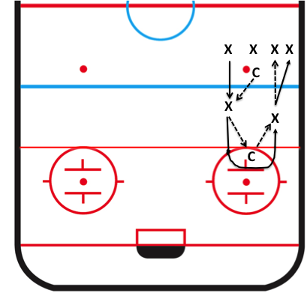

Pass Across Blue Line Drill 2
- Before starting the drill, tell the players (and demonstrate) that if they cross the blue line, turn around and stop, they can’t see the defenders. Also, if they receive a pass, they are easy to check because they are standing still
- When they cross the blue line they should look ahead at the defenders, move away from them and then turn to look for the pass
- Players line up near the centre red line as pictured
- All players have rings except the first one on line
- First player skates across the blue line towards the coach. As she nears the coach, she gives a little head fake and moves cross ice to receive a pass, showing where she wants the ring
- As the first player approaches the blue line, the second player in line starts skating towards the blue line, passes to the first player and continues to skate towards the coach. She also gives the coach a little head fake and moves cross ice for a pass, showing where she wants the ring
- All subsequent players pass to the player in front of her and receive a pass from the player behind her
- After receiving the pass, players shoot on goal (no deking), skate around the free pass circle, receive a pass from a coach and returns to the end of the line
- The blue line coach keeps the line moving quickly. They make it look like they are going to cover each player coming across the blue line, and encourage all players to execute the skills as taught : cross the blue line, look for defenders, move to open ice, look over their shoulder for the pass and show where you want the pass. Passers pass where their teammate is headed, not where they are. Passes are firm, but not to hard
- Second coach passes rings back to each player as they return to the end of the line
- Third coach coaches the goalie
- Players should start skating before passing. Do not pass while standing still
- After a minute or two change sides on the ice so players can practice looking over both shoulders
- Note: You can run this drill with two lines, one on either side of the ice, one for experienced players and one for inexperienced players

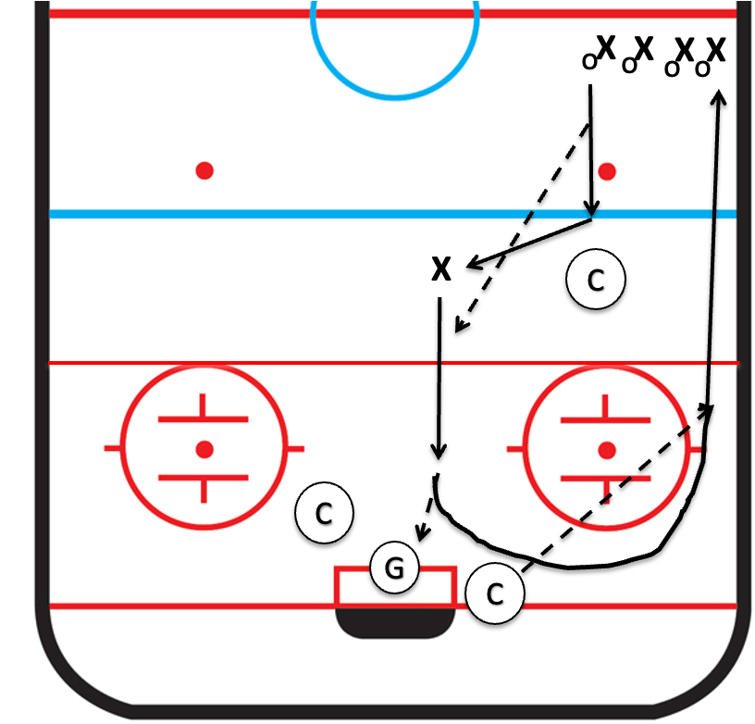

Pass Across Blue Line Drill 3a
- Before starting the drill, tell the players (and demonstrate) that if they cross the blue line, turn around and stop, they can’t see the defenders. Also, if they receive a pass, they are easy to check because they are standing still
- The drill is designed to teach the players to keep their head up while crossing the blue line for a pass so they can see the defender, then turn away from the defender for a pass
- Players form two lines as pictured below (left). All players have a ring except for the first player in the line on the left. She skates hard towards the pilon, gives a little head fake and skates cross ice looking for a pass, showing where she wants the ring to go
- The first player in the other line starts skating towards the other pylon with a ring when her teammate reaches the blue line. She makes the pass to her teammate, taking care to pass where her teammate is going, and to make the pass firm, but not too hard. After the pass, she skates hard towards the pylon, gives a little head fake and skates cross ice looking for a pass, showing where she wants the ring to go
- And so on, and so on, and scooby dooby dooby do
- After receiving the pass, each player shoots on goal (no deking) and returns along the boards to the other line
- One coach stands just outside the blue line to keep the lines organized, directing traffic and coaching the girls
  - Pass firmly, but not too hard. Pass where the target is going, not where she is
  - Receivers cross the blue line, look for the pass and show where you want the ring
  - Don’t turn around and stop – KEEP SKATING!!
- Two other coaches retrieve the rings and pass them to the players returning to the lines
- If you have a fourth coach, he/she encourages the goalie to practice her goalie skills; otherwise one of the other two other coaches will have to do so

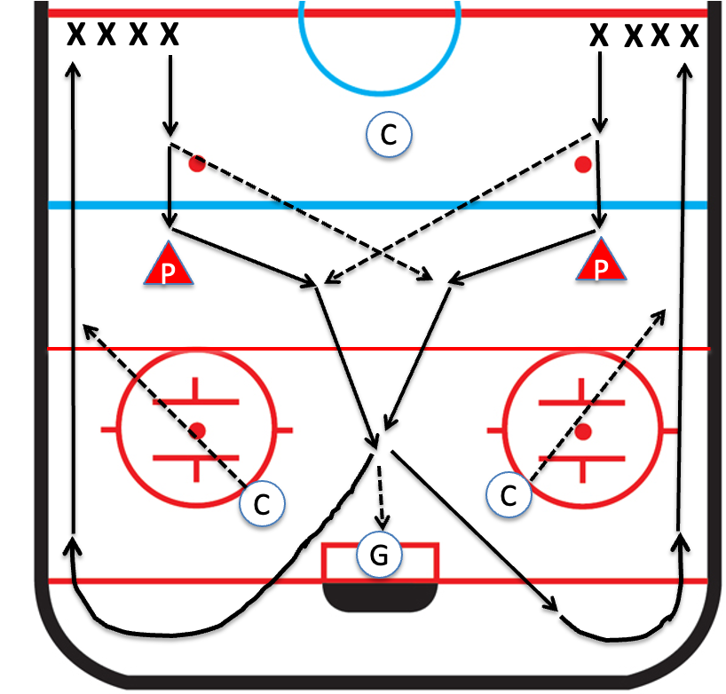

Pass Across Blue Line Drill 3b
- Modify 3a on the previous page to incorporate checking
- Line the players up as shown below
- The line near the centre red line has rings. The line near the blue line doesn’t
- First players in each line start skating towards the blue line
- The one without the ring crosses first and looks for a pass
- The ring carrier passess to her teammate
- The player receiving the pass skates in and shoots on goal (no deking)
- The player who made the pass tries to catch the other player and check her before she shoots.
- Don’t wait for each pair to complete the whole drill before sending the next players
- Make sure the passing line doesn’t start inching towards the blue line. The receiver line should have a head start

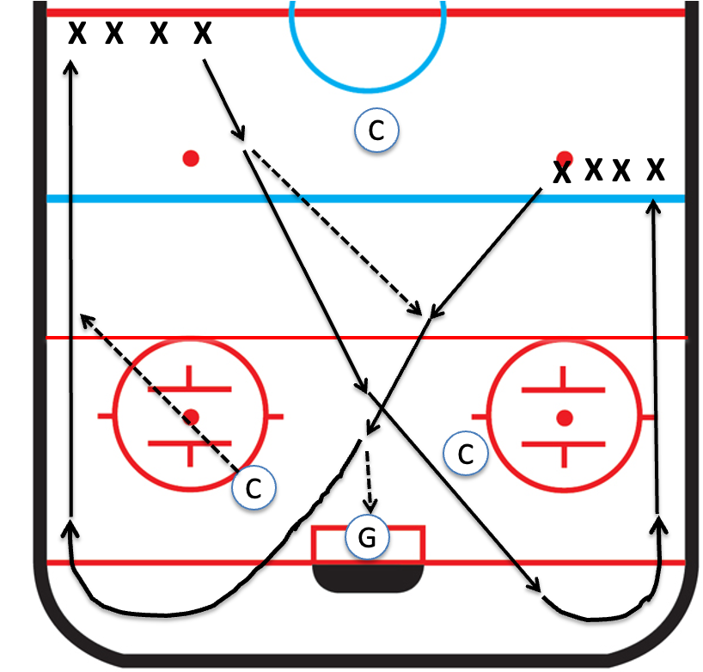

½ Butterfly Drill
- Players form a line along the goal line
- 1 coach in the free pass circle, 1 just outside the blue line and 1 near the goal
- Players skate towards blue line, pass to the first coach, get a return pass, pass to the coach across the blue line, skate around the coach and across the blue line again, looking for a return pass
- The blue line coach passes back over the blue line to the Player
- The Player receives the return pass, shoots on net and joins the end of the line
- The coach in the free pass circle directs traffic.
  - Each Player starts after the previous player has made their first pass and received the return pass
  - Make sure the Players stay on or behind the goal line
- Coaches should encourage Players to:
  - Skate HARD! Do not stop to wait for a pass
  - Sweep the ring and point at the target when passing
  - Look at the passer and use their sticks to show where they want the ring when receiving a pass
- The coach in front of the goal coaches the goalie, gently tries to check each skater, and feeds the rings back to the line
- Options
- Use the shorter version pictured on the right for more inexperienced Players. Pretend the Ringette line is the blue line
- For Players who can’t skate well, shrink the butterfly even more. Have them pass to and skate around a coach on the face off dot. The coach passes back to them before they shoot on goal. Have the 3rd coach skate with each Player to help and encourage them

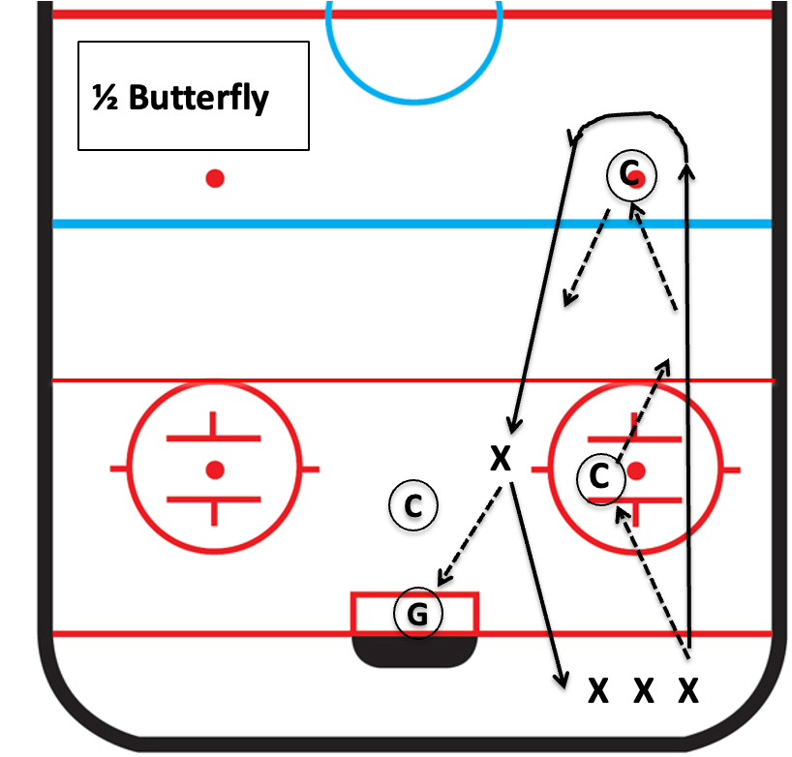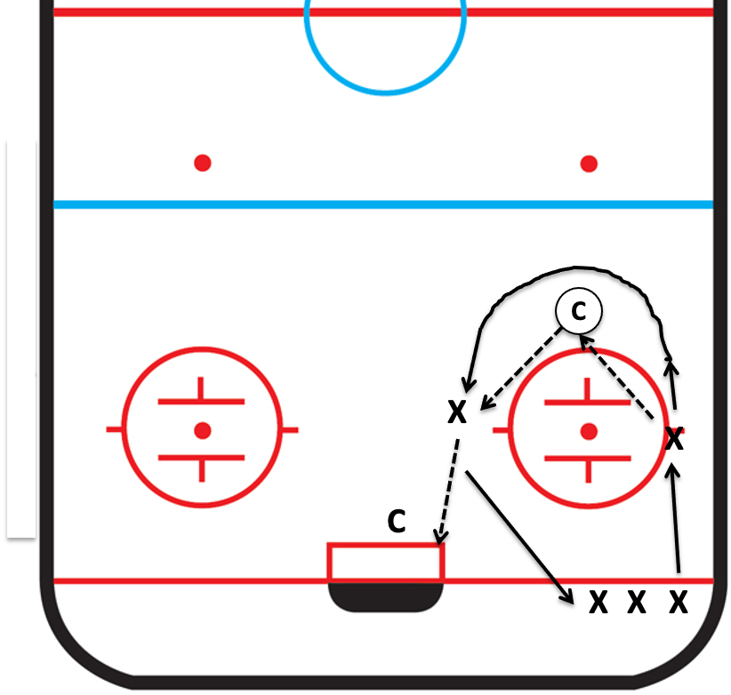

Ring Stabbing Skill
Coaching Focus
- Encourage Players to point their sticks at the ring and follow the end of the stick into the middle of the ring
- Encourage the Players not to slow down or stop when they are stabbing the ring or dropping the ring; they should skate THROUGH HARD
- Demonstrate the skill

Ring Stabbing Drill (Goal Line to Centre Red Line)
- Remember to demo the drill
- Line the Players up along the goal line
- Have a line of rings at Ringette line (one for each Player)
- When you say go, the Players skate to the Ringette line, stab the ring, drop the ring at the blue line, skate to the red line and stop
- When you say go, the Players skate to the blue line, stab the ring, drop the ring at the Ringette line, skate to the goal line and stop
- Split the drill in two. Less Experienced players on one side of the ice and Experienced players on the other side

Options
- Goal Line to Blue Line
  - Same as above except:
  - The Players skate to the Ringette line, stab the ring, skate to the blue line and stop
  - On the return trip, the Players skate to the Ringette line, drop the ring and skate to the goal line
  - See diagram below right
- Here Comes the Wolf!
  - Same as above except the coaches line up behind the Players
  - Once the first Player stabs their ring, the coaches yell, “Here come the wolf!” and chase after them
  - The objective is to get to drop the ring at the blue line without being checked
  - Repeat in the opposite direction

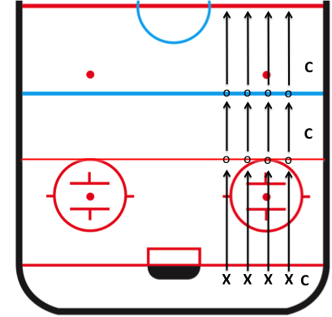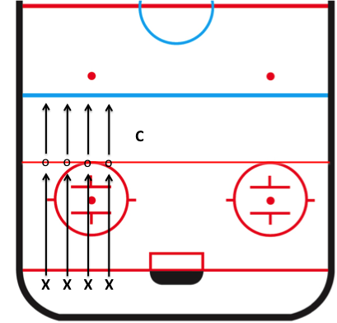

Checking Skill
Coaching Focus
- Demonstrate proper checking technique
  - Show the Players the sweeping motion (not hitting up, to avoid hitting hands)
  - Demonstrate skill by having the assistant coaches check each Player
- Demonstrate how to avoid being checked
  - Focus on lower hand 1/3 down the stick and pressing down
  - Demonstrate the skill by having the Players check the assistant coaches
  - Have the Players put their hands close together and demonstrate how easy it is to check them, then have them move their lower hand further down the stick and demonstrate how it is more difficult to check them
- Explain they should skate hard when being checked – KEEP FEET MOVING

Scramble Checking Drill
- Split the Players into as many groups as there are assistant coaches
- Each assistant coach to find a section of the ice separate from the other groups
- Players and coaches are 10 metres from the boards
- When ready, the coach passes the ring to the boards. Depending on the size of the group, 2-3 Players go after the ring. First Player to the ring is the ring carrier, following Players are checkers
- The ring carrier tries to get back to the assistant coach without being checked
- Give the first Player in each rush a head start
- Coaches try to ensure each Player gets at least 1-2 head starts
- Give each trio 10-15 seconds to get back in line. If they are still messing about, tell them to stop checking and come back
- Encourage the Players to keep skating hard when they are being checked and to dig in hard when checking

Keep Away/Checking Tag
- Split Players into 2 groups, 1 or 2 coaches per group
- One group in each of the free pass circles
- If there is a 3rd group, put them between the blue line and the centre red line
- Each Player has a ring. Coaches and assistant coach check the Players, encouraging them to have their hands in the proper position, pressing down on their sticks AND SKATING HARD
- Repeat with the coaches and assistant coaches having rings and the Players trying to check them
- Repeat with the Players checking each other. Players take turns being the ring carrier and being checked by 2 other players

Goalie Skills
- Try to have a coach dedicated to coaching the goalie for the duration of the practice
- The goalie should participate in the warmup and some (if not all) skating drills planned in the practice. Have the goalie skate with the newer players so she can keep up while wearing goalie pads. If the goalie is struggling with the skating drills, consider moving her to a separate area to practice simplified skating skills, and/or removing her pads for the skating drills
- The goalie should also participate in any drills that involve shooting on goal
- Skills to learn:
  - Learn the rules:
    - Show them the ringette crease
    - Explain that no other players can skate through the crease or reach into the crease to get the ring. Also, if any part of the ring is touching the crease, it is considered to be in the crease
    - Once the ring is in the crease, the goalie has 5 seconds to pick it up and pass it to a teammate
    - The goalie is not permitted to pick up the ring or touch it with her hand if it is outside the crease
    - The goalie can pull the ring into the crease with her goalie stick
  - Goalie stance: knees bent, feet shoulder width apart, blade of goal stick flat on the ice, catching hand ready
    - Demonstrate the stance and have the goalie try it
    - Have the goalie fall to her knees, get up and go into the goalie stance as quickly as possible. Repeat several times.
    - Have the goalie sidestep to the left and right while staying in the goalie stance. Repeat several times
  - Playing the angles
    - Explain that playing goal is all about giving the other team less to shoot at
    - Show the goalie how playing on the edge of the crease gives the other team less to shoot at than playing on the goal line
    - Show her how looking down at the crease gives an idea of position in relation to the shooter and the goal. She can also tap the goal post with her stick
    - Have the goalie sidestep around the front of the crease while maintaining the goalie stance. Have her move in relation to your position on the ice
    - Shoot at the goalie from different angles to have her practice stopping the ring with her stick and her pads
  - Passing
    - Demonstrate passing the ring like a frisbee
    - Have the goalie try it several times
    - Start shooting as before, but with each save, have the goalie pick up the ring and pass it back to you
    - Count 5 steamboats loudly from the time she makes the save, so she will get a feel for how much time she has
    - Practice passing to a moving target
- If possible, at least some of the individual coaching should be with the actual nets and crease.

Goalie Ring Drill
- This drill practices 3 skills: goalie passes, staying off the boards as you try to leave the defensive zone and passing across the blue line
- Line the players up as pictured below
- The player closest to the goalie pushes the ring into the crease, waits for the goalie to pick it up and quickly skates around the net as pictured
- The goalie slides across the crease and lays a soft pass behind the goal line, frisbee style. If possible, have her practice this skill earlier in the practice
- As the ring carrier moves across the goal line, the coach moves towards her as if to check her
- The ring carrier makes it look like she’s going to push between the coach and boards, but turns sharply inside, towards open ice
- The player on the blue line has her back to the boards so she can see the ring carrier and the defenders with a quick turn of her head. As the ring carrier approaches the ringette line, she takes one stride along the boards, then skates cross ice for a pass
- As she crosses the ringette line, the ring carrier passes to the player who is skating across ice
- After the pass is executed, the two players join the end of the other line

Skills to Stress
- The Coach closest to the goalie:
  - Coaches the goalie on sliding across the crease and making a nice flat easy pass
  - Counts steamboats out loud, so the goalie knows how much time she has
  - Ensures the skaters don’t start until the goalie has picked up the ring
- The Coach in the free pass:
  - Coaches the ring carrier on cutting over sharply
  - Using her body and stick position to protect the ring
  - Not waiting too long before making the pass
  - Leading the target – “Pass where she’s going!”
- The Coach near the blue line:
  - Ensures the first player that’s in line is near the blue line with her back to the boards
  - That she waits until the ring carrier approaches the ringette line
  - That she uses her stick to show where she wants the pass
  - Ensure the players go to the correct lines after the pass
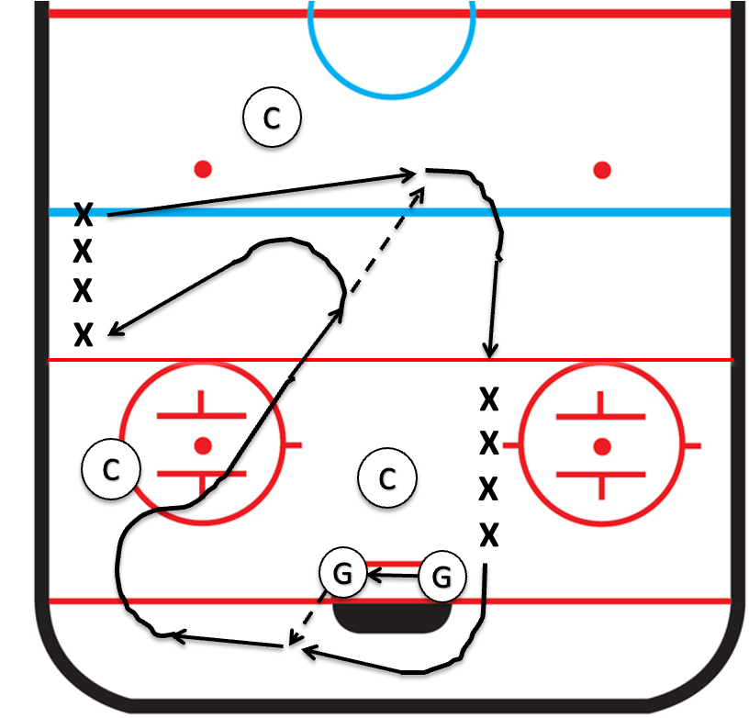

GAMES
British Bulldog
- All Players are behind the goal line with rings. Get them to spread out
- The coaches are bulldogs. They line up at the ringette line
- When the coaches yell British Bulldog, the Players attempt to skate to the blue line without being checked
- If they are checked, they become Bulldogs
- Repeat in the opposite direction
- Option: The Players are bulldogs and check the coaches, or split the Players into two groups and have them check each other

Toilette Tag (no sticks)
- The coaches are ‘IT’
- When they yell “GO!”, the Players try to avoid being tagged
- If they are tagged, they become toilettes with their arms stretched out, parallel to the ice
- The other Players can free them by flushing the toilet

Turtle Tag (no sticks)
- The coaches are ‘IT’
- When they yell “GO!”, the Players try to avoid being tagged by ‘turtling’ on the ice
- If they are tagged before they turtle, they are it too
- Last Player standing wins the game

Kwazy Wabbits
- Have all the Players spread out across the ice, behind the goal line
- Pick 4 or 5 Players to be wabbits, and give them each a ring
- When the coaches yell “Go Zwazy Wabbits!”, the wabbits try to reach the far Ringette line without being checked by the other Players
- Give the wabbits a head start
- Repeat until all the Players have had a chance to be wabbits

Here Comes the Wolf!
- Have all the Players spread out across the ice, behind the goal line, each with a ring
- The coaches all line up behind them. They are the wolves
- When the coaches yell “Here come the wolves”, the Players try to reach the far Ringette line without being checked by the wolves
- Give the Players a head start
- Repeat in the other direction
- Repeat with the Players being the wolves

Soccer/Handball (No Sticks)
- The Players play a modified soccer by using their hands to punch a ball cross ice to score
- Each team must make at least 1 pass before shooting on net
- Encourage the Players to maintain the Ringette stance
- Use pylons for nets if required
- Try to have Players of similar skill play each other

Scrimmages
- If full ice, think about using pylons to divide the ice in two (lengthwise) and run two games
  - 3-4 players on each team
  - If possible, have Players of similar skill play each other
- Options for ½ Ice:
- Use the ringette line as the blue line
- Organize two cross ice games with only 2-3 skaters. Strong vs strong and weak vs weak. Each team must make at least 2 passes before shooting on net
- Use pylons for nets as required
- Scrimmages are not productive unless they are used as teaching opportunities. Stress the following:
  - Skate hard, never give up
  - Keep your head up. Be aware of more than just the ring
  - Go to open ice to avoid defenders when going for a pass
  - Show where you want the pass
  - Pass away from defenders
  - Pass where your teammate is going, not where they’ve been
  - Keep your feet moving when being checked
  - Stay between the goal and the ring when playing defense

Positional Play and Set Plays
Notes:
- See “A Ringette Story” for basic rules
- Keep in mind that many (if not most) of the positional play and set play principles outlined below are too advanced for Fun 1 and 2.
  - Experienced U10 and U12 players should “get it”, but players with limited or no experience will take time to grasp them
- The suggestions below are based on my experience. Coaches can tweak them based on their own experience and the skills of the players they are coaching. The important thing is to decide on the principles you want to shoot for, and to ensure that all coaches and helpers communicate the same messages to the players.
- Finally, you can burn a lot of practice time working on positional play and set plays with very little payback. The objective at this level is skill development, so it is far more important to practice fundamentals. However, there ARE three areas you should cover in practice:
  - Free passes
  - The triangle
  - Goalie ring/goalie makes a save. This happens a lot, so it makes sense to practice the skills required to breakout of the defensive zone after a save, as well as a simple set play (see below)
- The secret is not to get too hung up on creating and practicing set plays and/or explaining positional play. There would be way too much time spent standing around, and most of the kids won’t get it anyway. They will soak it up as the season progresses
- Think about having a dryland training session (combined with a pizza party perhaps?) and giving them simple instructions to bring home, along with fun quizzes. Then you can coach the heck out of it during scrimmages and games.

Positional Play
General
- Defense:
  - Play from the end boards in the defensive zone to the ringette line in the offensive zone
  - Their role is to protect the goal, prevent the other team from scoring, help regain possession in the defensive zone, move the ring into the neutral zone
  - The defense can help move the ring into the offensive zone and even score but protecting their goalie in the event of a turnover should always be top of mind.
  - As a rule, the defense should ensure there are no opposing players between them and the goalie, even when we have possession of the ring
  - If a defense has the ring, her partner should be cross ice and behind her
- Centre:
  - Plays from the area between the ringette line and the goal line in the defensive zone to the end boards in the offensive zone
  - When we have possession of the ring, the centre takes on the role of a forward
  - When we lose possession, the centre immediately reverts to defense
- Forward:
  - Play from the ringette line in the defensive zone to the end boards in the offensive zone
  - When we have possession of the ring, forwards help to move the ring from the defensive to offensive zone and to score
  - When we lose possession, the role of forwards is to hound and check the ring carrier. SKATE HARD, NEVER GIVE UP, CHECK, CHECK, CHECK!!

Defensive Zone
- When the other team has possession:
  - The centre and both defense should be in the triangle (see set plays below)
  - Forwards should be just outside the ringette line so they can check the ring carrier if she drifts outside the ringette line, or pick up a loose ring that drifts outside the ringette line
    - Note: In some cases (for example, a defense or centre falls in the neutral zone and can’t get back fast enough), a forward can move into the triangle to help her teammate. The principle is “first three in”. If that happens, it is the responsibility of the player who fell to stay out of the zone.
- When we regain possession of the ring
  - The player who gains possession should skate hard for open ice, even if they have to move back towards their own goal line. Once they have a little room to maneuver, they should look for a teammate to pass to across the blue line. The player should not stop or glide; they should keep their feet moving and stay hard on the ring!
    - Note: It is better for the ring carrier to shoot the ring out of the zone blindly than to lose possession in the defensive zone, so we should celebrate those plays, especially when the player is new or inexperienced. Just encourage her to hang on to the ring a little longer next time
  - If possession is regained by a defense, the other defense and the centre should make sure there are no opposing players between them and the goalie, until the ring clears the zone. However, if it is clear the goalie is safe, the centre can join the rush
  - If possession is regained by the centre or a forward, both defenses should play defensively by making sure there are no opposing players between them and the goalie until the ring clears the zone. If it is clear the goalie is safe, the more experienced defense can join the rush
  - If possession is regained by the centre or forwards, the others (centre and forward or both forwards) should move across the blueline quickly to give the ring carrier someone to pass to
Neutral Zone, We Have the Ring
- Once we have possession in the neutral zone, the ring carrier should skate hard to avoid being checked, and look for a teammate to pass to, across the other team’s blue line
- The other attacking players should move quickly across the offensive blue line to give the ring carrier someone to pass to
- Note: If at least one of our defense is between our goalie and all the other team’s players, it is OK for the other defense to join the rush
Offensive Zone
- Once we gain possession of the ring in the offensive zone, the ring carrier should move quickly to take a shot on goal. Don’t wait for the other team to form their triangle, try to take a shot early! Aim just inside either post.
- If the ring carrier is a defense, it is the centre’s responsibility to stay outside the ringette line and play defense. The defense should return to her position quickly, after taking a shot or losing possession.
- If the triangle is formed, the ring carrier should skate hard around the triangle, looking for an opening to shoot or pass.
- The other two attacking players should avoid congesting the front of the net and be ready to pounce on a loose ring
- The defense should be between the other team’s forwards and our goal (‘man to man’ coverage)
- Options:
  - The attacking players who don’t have the ring follow the ring carrier at 6-foot intervals, or position themselves near the goal line on either side of the net, 4-5 feet from the crease
  - The defense can do a switch with the ring carrier
- When we lose possession, the objective is to stop the other team from crossing their blue line:
  - The two forwards immediately attack the ring carrier and check, check, check!!
  - The centre moves quickly to the middle of the ice, between the blue line and the ringette line to cut off passing lanes and cover their centre as she crosses the blue line
  - The defense should be between the other team’s forwards and our goal (‘man to man’ coverage)
Neutral Zone, They Have the Ring
- If the other team gains possession in the neutral zone:
  - The forwards continue to attack the ring carrier and check, check, check!
  - The defense moves back to our zone quickly to get into the triangle
  - The centre moves just inside our blue line and attempts to break up their entry into the defensive zone. If she fails, she moves quickly into the triangle

Set Plays
Triangle
- The objective of the triangle is to force the ring carrier away from the net and harass and check her along the way. The centre works in tandem with one of the defense, while the other defense protects the goalie
- The focus for U10 and new U12 players should be shifting the position of the triangle based on the position of the ring carrier

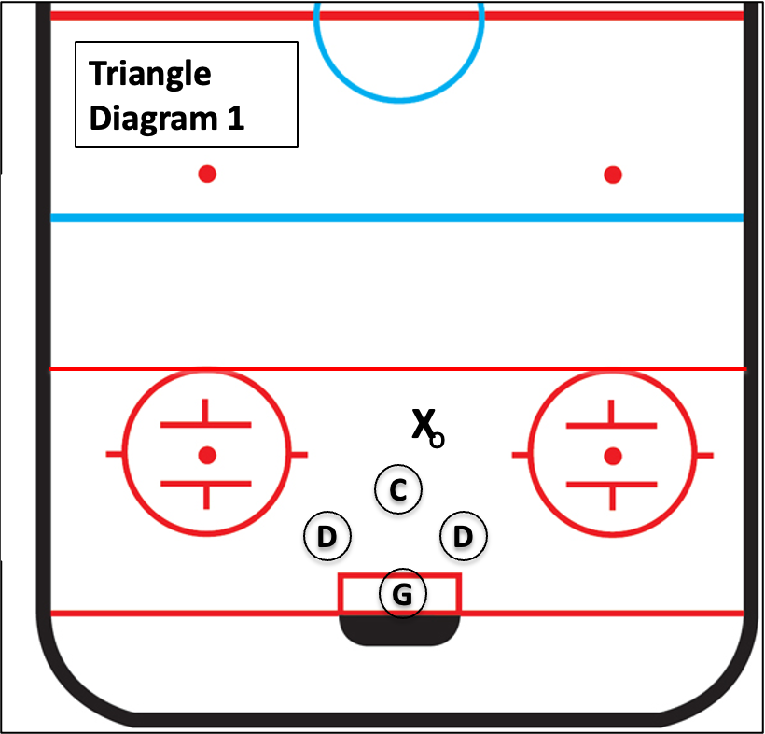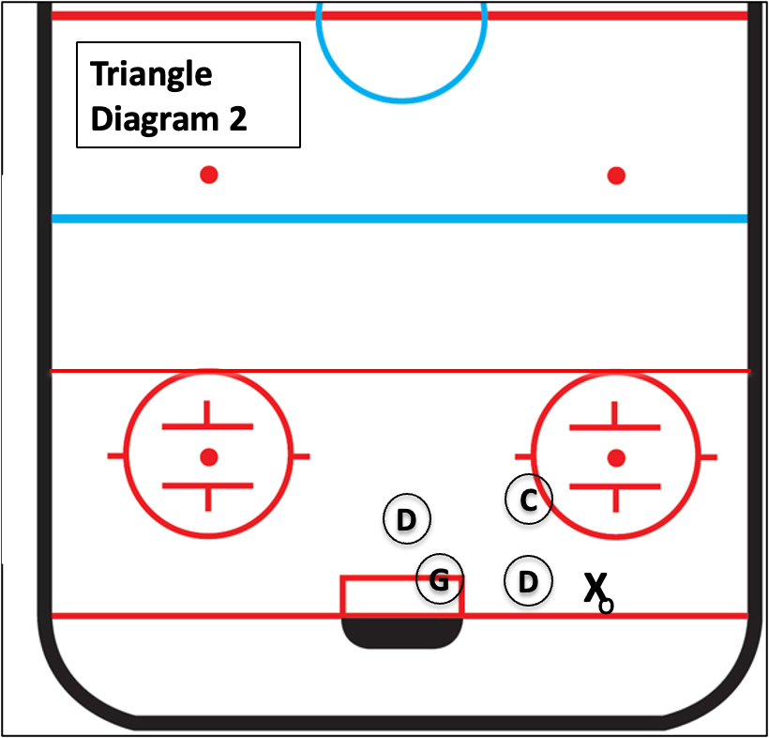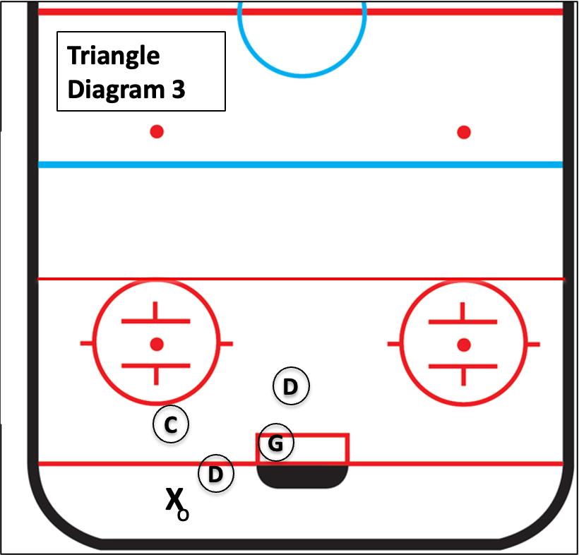

Goalie Ring, Goalie Makes a Save
- When the goalie makes a save or the referee awards a goalie ring in the defensive zone, it is wise to have a simple breakout play like the one below (or design your own)
- Most goalies will be passing the ring with their left hand, so the breakout should be to the left.
- At least one defensive player should remain in front of the net until the ring clears the defensive zone

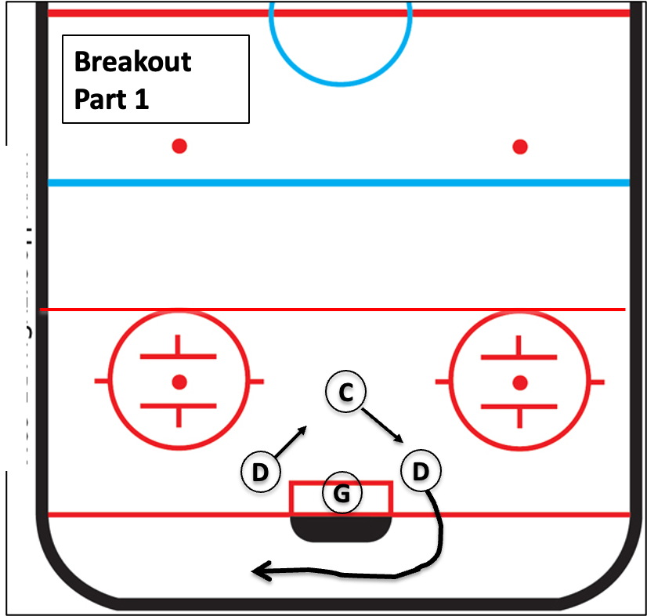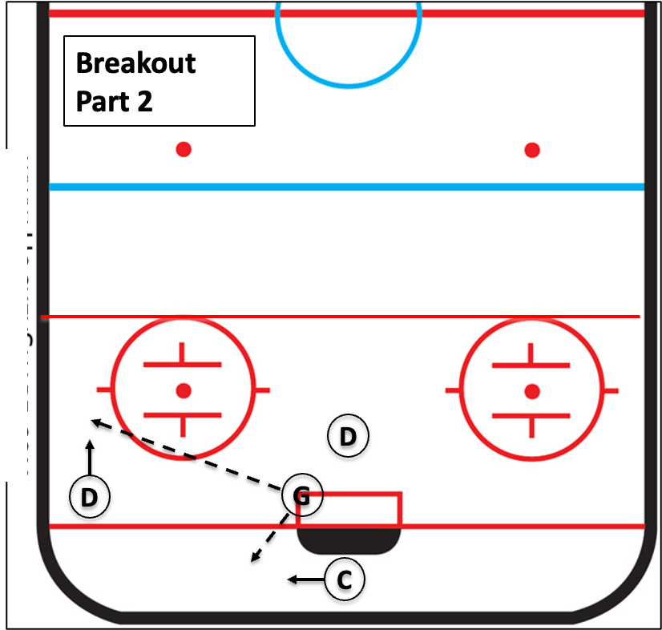
Free Pass Defensive Zone
- This rarely happens, so I wouldn’t waste time designing a set play

Free Pass Neutral Zone
- This happens often at this level, so it is worthwhile having a simple play like the one below. You can design your own, but keep it simple
- After making the pass, the passer should move back to the defensive blue line in case we lose possession in the neutral zone
- Have the least experienced Defense take the pass; a chance for her to contribute. Don’t give up on her if she isn’t successful at first. Praise her effort regardless. This will pay dividends with her confidence and her skill will improve
- Think about having the forwards move towards the ringette line or even the goal line. If they are being covered, it will reduce congestion at the blue line. If they aren’t covered, then they’ll be a good target

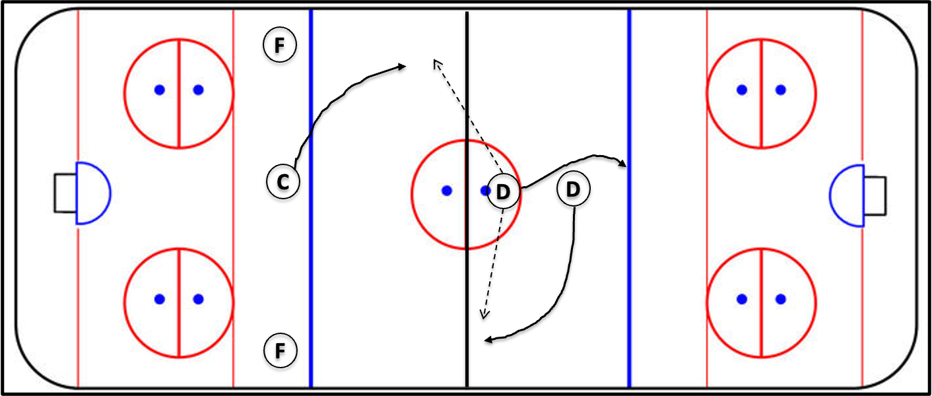

Free Pass Offensive Zone
- Usually, the other team is in the triangle, so this free pass is pretty simple
- If they are covering man to man, it shouldn’t be too hard for the centre and forward to give their checkers the slip.
- Have the least experienced forward take the pass; a chance for her to contribute. Don’t give up on her if she isn’t successful at first. Praise her effort regardless. This will pay dividends with her confidence and her skill will improve

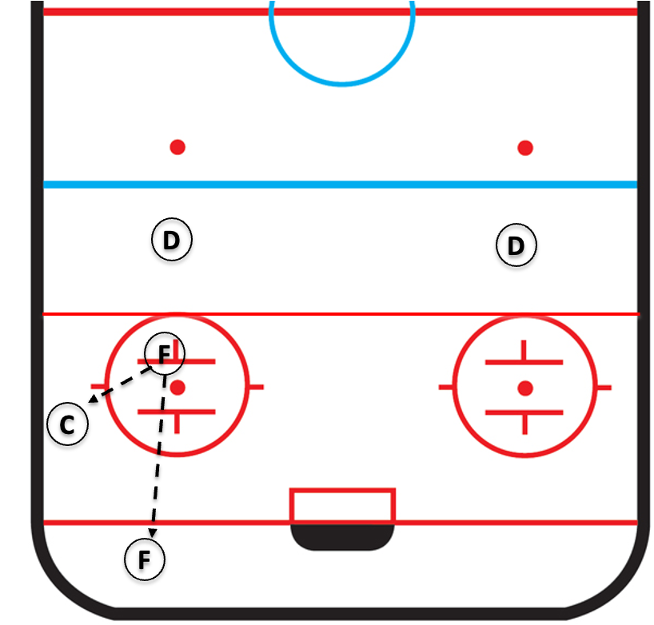

Defending Against the Other Team’s Free Passes and Goalie Ring
- On free passes, we have 5 players to cover 4:
  - The forwards and defense each cover an opposing player
  - On neutral zone free passes, the centre should be at the blue line, directly opposite the passer, ready to intercept passes or check the player who receives the first pass
  - On defensive zone free passes, the centre should team up with the goalie to block any attempts by the passer to shoot on net
- On goalie rings, the centre, defense and forwards should try to cover ‘man to man’

Sample Practice Plan
- Warm up, getting organized (all players, including goalie): 5 minutes
  - Tom, with help from everyone
  - Page 4
- Skating: 15 minutes
  - Station 1 (New Players and Goalie)
    - Dick
    - Power Strides and Power Glides (p 6)
  - Station 2 (Experienced Players)
    - Harry
    - Hard Skating and Stopping (p 6), Lightning Drill (p 7)
- Passing: 12 Minutes
  - Station 1 (Goalie)
    - Tom
    - Goalie Skills (p 19)
  - Station 2 (New Players)
    - Dick
    - Pepper Passing (p 8)
    - Circle Passing (p 10)
  - Station 3 (Experienced Players)
    - Harry
    - Pepper Passing (P8)
    - ½ Butterfly (p 13)
- Water Break: 3 minutes
- Passing Across the Blue Line: 10 Minutes
  - Station 1 (All players, including the goalie)
    - Tom, with help from everyone
    - Pass across the blue line drill 2 (p 13)
- British Bulldog: 5 Minutes (p 21)
- Cheer!

For Fun 1 and Fun 2, Split the Ice into Stations (See Example Below)
