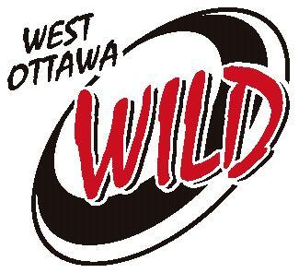
Team Sponsorship Request

We are seeking your sponsorship for our team this season. Your contribution would assist the team in paying for tournaments, ice time, and other operating costs.
Your involvement in West Ottawa Ringette can be financially rewarding for your business. A modest investment in a team sponsorship can:
- Increase business traffic
- Provide a low-cost form of advertising (sponsorship receipt provided)
- Demonstrate your interest in the community and help West Ottawa region youth participate in an organized sport

In return for your generosity, your business name/logo will appear on the Association website with a link to your website or Facebook page and you will receive recognition at our year end banquet. In addition, the following advertising is available:

Sponsorships $500 or greater | Options include  Business name on jersey bar(s)  [Business name on team banner to be displayed at home and away tournaments  and Provincial Event]  Recognition plaque for display at your business location  Business name on Association Website (as noted above)
Sponsorships $250 – 499 | Options include  [Business name/logo on team banner to be displayed at home and away  tournaments and Provincial Event]  Recognition plaque for display at your business location  Business name on Association Website
Sponsorships $175 – 249 | Recognition plaque for display at your business location  Business name on Association Website
Sponsorships less than $175 | Business name on Association Website

We will display our sponsors’ names proudly and we will be a credit to your establishment by always showing good sportsmanship, dedication and commitment to ringette and to our community.

Thank you for your support!

[WEST OTTAWA TEAM NAME]
[Name]
[Position]
[Email address]

