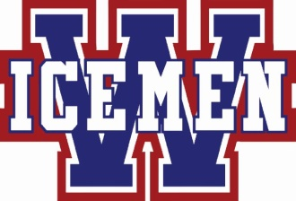 Provincial
Special Ticket
Package Offer
Name ____________________________________________
Phone # __________________________________________
E-Mail ___________________________________________
Special Minor Hockey Price if paid in full by March 1, 2019
Family Pass – Adult _______ Youth/Child ____________ Maximum of three children $100.00
Icemen Fan Special Adult Pass - ______ $40.00 + 2 free playoff tickets
Weekend Pass Prices
Adult Pass - _____________ $ 40.00
Senior / Youth / Child (5 – 17) Pass - ____________ $ 30.00
Family Pass – Adult__________ Youth/Child____________ Maximum of three children $ 125.00
Method of payment - Cheque or Cash _______________
Cheques payable to - Wetaskiwin Icemen
Please return to Icemen office in mail slot in office door or in person on game days.
Tickets can be picked up on next game day or can be held till Provincial event. Check below.
Game Day _______
Provincial Event _______

