BRONCOS BASEBALL CLOTHING
PLAYERS CLOTHING
Please note: Bronco Baseball hats are mandatory and will be available for purchase at our Broncos clothing nights as well as evaluation nights (cash/cheque only).
Cooling towels with the Broncos logo will also be available for purchase for $15.
*Prices include Broncos logo. Names, numbers and tax are extra*

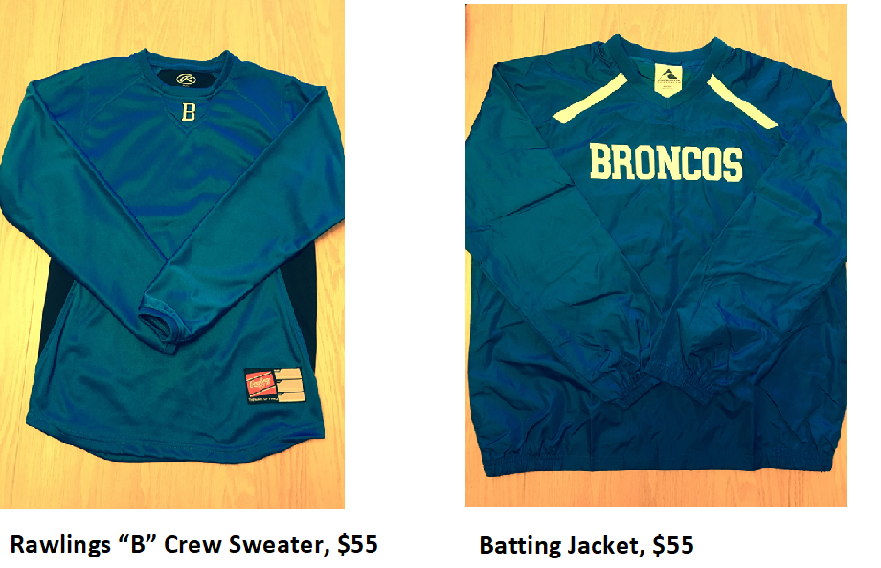
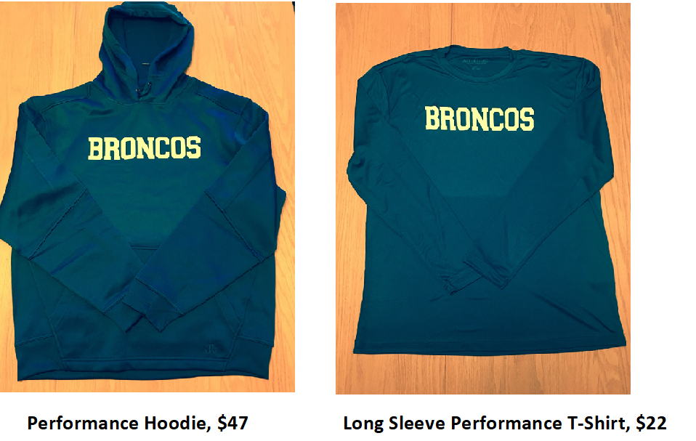

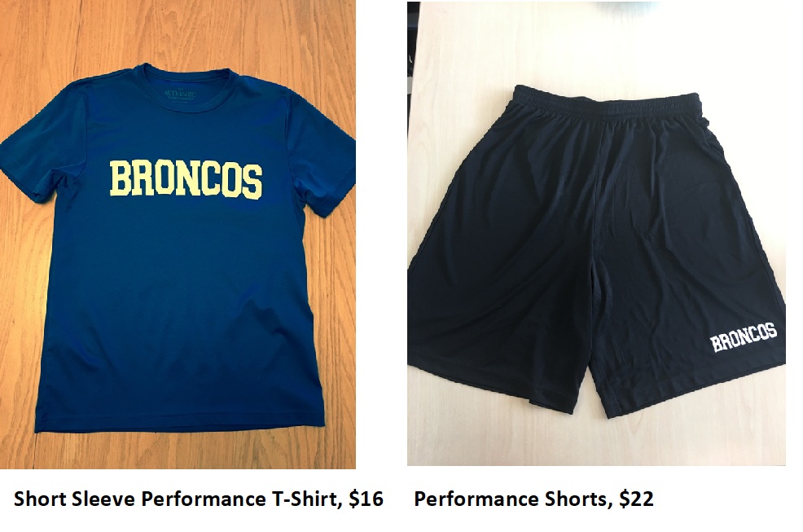
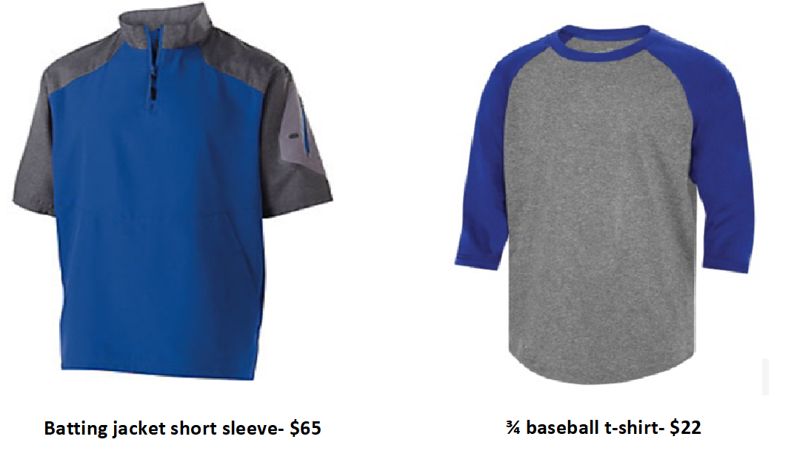

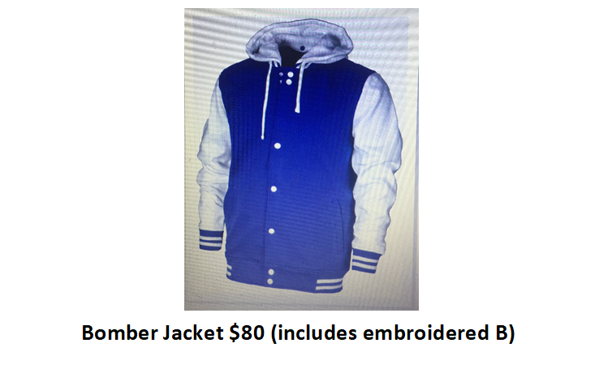

For the Fans (Adult Sizes Only)

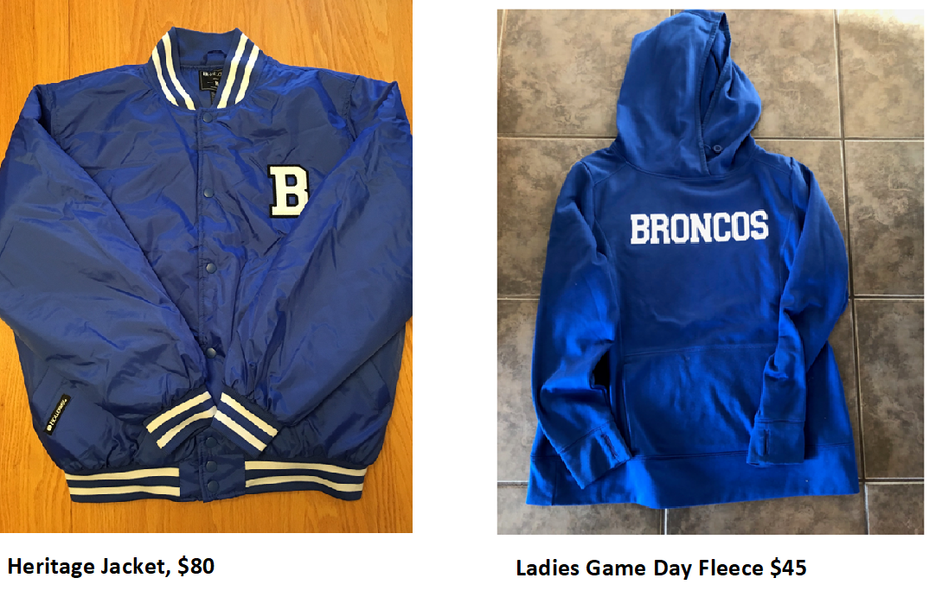

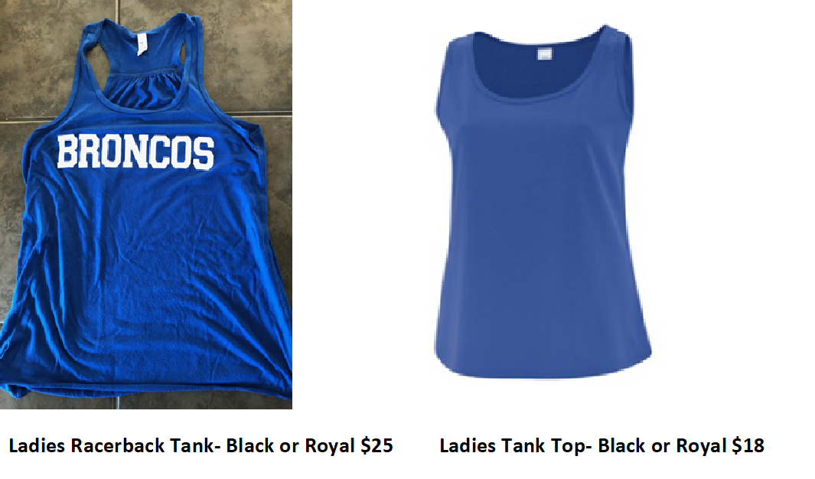
For the Cold Nights

