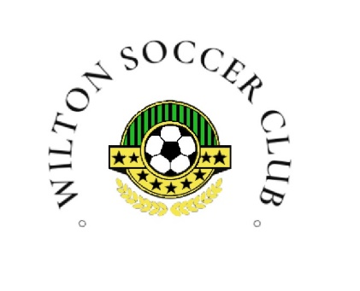 | Wilton Soccer Club | No. | 2025-01
 | CONCUSSION MANAGEMENT POLICY | Effective Date
 | CONCUSSION MANAGEMENT POLICY | Revision Letter
 | CONCUSSION MANAGEMENT POLICY | FINAL APPROVAL | Resolution

- PURPOSE
1.1 The purpose of this policy is to establish guidelines for the identification, management, and return-to-play procedures for concussions within WSC

2.0 DEPARTMENT(S) AFFECTED (SCOPE)
2.1 Department(s) Affected: WILTON SOCCER CLUB

3.0 POLICY
3.1 General Guidelines:
- Concussions can result from a direct blow to the head or an impact to the body causing rapid head movement
- Correct management is crucial, as incorrect management can lead to further injury
- All concussions are considered potentially serious

3.2 Immediate Action:
- Anyone displaying concussion symptoms must be immediately removed from playing or training
- Concussions must be diagnosed and managed by healthcare professionals within their scope of practice
- Physical and brain rest is required until symptoms resolve

3.3 Assessment and Evaluation:
- Initial Assessment: A coach or staff member will perform an initial assessment of the suspected concussion. If concussion is suspected play is halted immediately and directed to a healthcare professional

3.4 Interaction:
- Notification of policy and procedures are corresponded with the responsible party or legal guardian

3.5 Return-to-Play Protocol:
- Graduated Return-to-Play: Players diagnosed with a concussion will follow a gradual, stepwise return-to-play protocol as laid out on the Soccer Canada website, supervised by a healthcare professional

3.6 Medical Clearance:
- Players must obtain written clearance from a qualified healthcare professional within their scope of practice before returning to full participation

3.7 Communication:
- Parents, coaches, and board members will be informed of the concussion diagnosis, management plan, and return-to-play progress

4.0 DEFINITIONS
4.1 Concussions: A concussion is a traumatic brain injury caused by a direct or indirect force to the head resulting in functional disturbance to the brain

5.0 IMPLEMENTATION
5.1 Concussion management will be communicated to all members via the Wilton Soccer Club website

5.2 Education and Training: All coaches and staff associated with WSC will undergo mandatory concussion education and training. They will be provided with concussion recognition information documents and checklists at the start of each season

5.3 Recognition and Reporting:
- Signs and Symptoms: Players, coaches and parents will be educated on the signs and symptoms of concussions through means of training or information provided on our website
- Reporting: Any individual suspecting a concussion must immediately report it to the coach or designated team official

5.4 All concussion-related incidents will be documented, including assessment details, medical evaluations, and return-to-play progress

5.5 This policy will be reviewed on a consistent basis and revised as needed to ensure compliance with current best practices and regulations

5.6 Attachments:
- Sport concussion assessment tool
- Concussion Communication form
- Pocket Concussion Recognition tool

Document Approval
Role | Position | Name of the Approver | Date Approved
Final Approver

Revision History
Effective Date | Revision Letter | Document Author | Description of Change

