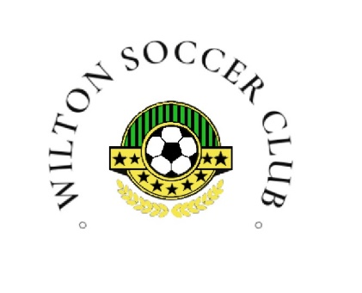 | Wilton Soccer Club | No. | 2025-10
 | REFUND POLICY | Effective Date
 | REFUND POLICY | Revision Letter
 | REFUND POLICY | FINAL APPROVAL | Resolution

1.0 PURPOSE
1.1. The purpose of this Refund Policy is to establish guidelines and procedures for the refund of fees paid to Wilton Soccer Club (WSC) for participation in soccer programs in the event that a participant withdraws from the program.

2.0 DEPARTMENT(S) AFFECTED (SCOPE)
2.1 Department(s) Affected: WILTSON SOCCER CLUB

3.0 POLICY
3.1 Refunds for program fees will be granted under specific conditions as outlined below.

4.0 DEFINITIONS
4.1 Commencement of the season: Refers to the official start date of the scheduled activities, practices, or games organized by WSCfor the respective soccer season.
4.2 SSA fee: Saskatchewan Soccer Association administration registration fee.

5.0 RESPONSIBILITIES
5.1 Participants/Parents/Guardians: Responsible for adhering to the refund request procedure, providing necessary documentation, and understanding the terms and conditions outlined in the refund policy.
5.2 WSC Board: Responsible for reviewing and evaluating refund requests, making decisions on granting refunds based on outlined criteria, and ensuring fairness and consistency in the application of the policy.

6.0 IMPLEMENTATION
6.1 Refund Period: Refunds will be provided up to the first day of commencement of the season without any penalties or deductions. The refund request form on the club website must be completed to acquire a refund. 6.2 Post-Commencement Refund Request: After the season has commenced, refund requests can be submitted through the website’s designated refund request form option.
6.3 Refund Consideration: Refund requests received post-season commencement will be reviewed by the WSC Board, which will evaluate requests based on the following criteria:
6.3.1 Medical Reason: Supported by a ceritfied doctor’s note
6.3.2 Relocation: Participant moving away from the area.
6.3.3 Other Reasons: Deemed fit by the WSC Board.
6.3.4 Jersey Kit Refund Request or other item Refund Request: Refund requests for items or jersey kits will require board approval and must be requested through designated refund request form on B.Y.S.I. website.
6.4 Refund Period Post-Season Commencement: Refunds will only be considered within a two-week period after the season begins. Refund requests beyond two-weeks will require board approval and will only be considered in extenuating circumstances.
6.5 Refund Calculation: The refund amount will be determined as the prorated fee minus the SSA fee. NOTE: WSC reserves the right to amend or modify this refund policy at its discretion

Document Approval
Role | Position | Name of the Approver | Date Approved
Final Approver

Revision History
Effective Date | Revision Letter | Document Author | Description of Change

