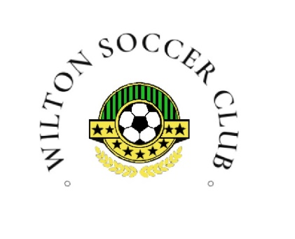 | Wilton Soccer Club | No. | 2025-03
 | CODE OF CONDUCT | Effective Date
 | CODE OF CONDUCT | Revision Letter
 | CODE OF CONDUCT | FINAL APPROVAL | Resolution

1.0 PURPOSE
1.1 The purpose of Code of Conduct is to establish and maintain a standard of behaviour for all individuals associated with Wilton Soccer Club (WSC), ensuring a safe, respectful, and positive environment for everyone involved in the organization

2.0 DEPARTMENT(S) AFFECTED (SCOPE)
2.1 Department(s) Affected: Wilton Soccer Club

3.0 POLICY
3.1 All members, including players, coaches, officials, administrators, volunteers, parents, and spectators are required to adhere to the following Code of Conduct

4.0 DEFINITIONS
4.1 The Code of Conduct sets forth guidelines for behaviour and ethical standards that must be followed by all individuals participating in WSC-affiliated activities, competitions, and events. It applies to all interactions within the organization, whether on the field, in training, during meetings, or any WSC-related gatherings

5.0 RESPONSIBILITIES
5.1 Compliance: Adhere consistently to WSC bylaws, policies, procedures, directives, and regulations

5.2 Conflict Resolution: Resolve disputes professionally and civilly, promoting respectful communication and resolution

5.3 Respect and Dignity: Treat all individuals with respect, regardless of differences including but not limited to age, ability, race, gender identity, sexual orientation, etc

5.4 Fairness and Sportsmanship: Uphold fairness, ethical conduct, and the spirit of sportsmanship in all interactions

5.5 Adherence to Rules: Follow the rules of the sport and respect the decisions made by the officials

5.6 Respect for Property: Respect others property and refrain from causing damage intentionally

5.7 No Coercion: Avoid using authority to force others into inappropriate activities

5.8 Conflict of Interest: Abide by the WSC Conflict of Interest Policy

5.9 Substance Use: Refrain from consuming alcohol, tobacco, or drugs during WSC activities or events

5.10 Promotion of Sport: Promote the sport in a positive and constructive manner

6.0 IMPLEMENTATION
6.1 The Code of Conduct will be distributed to all members upon joining WSC and should be acknowledged and agreed to annually

6.2 WSC will provide education and resources to ensure understanding and compliance with the Code of Conduct

6.3 Violations will be addressed through a disciplinary process outlined in WSC policies

Document Approval
Role | Position | Name of the Approver | Date Approved
Final Approver

Revision History
Effective Date | Revision Letter | Document Author | Description of Change

