Winkler Minor Hockey Association AGM Reports 2026

President: The greatest joy I experience when coming to the rink is watching our players, coaches, volunteers, and officials work toward their goals—achieving, building friendships, creating memories, and growing as individuals. That is what minor hockey is all about, and I believe we saw many successes again this season.
I won’t capture everything, but I’d like to highlight a few:
- Continued growth in our female program. We were able to field full-time female teams at U11 and U13, along with a double-rostered U9 female team. I’m excited to see this program continue to expand.
- A strong group of referees who continue to stay involved and give back to the game they love.
- The first recipients of the Evan Thomas Grants—an outstanding initiative by the Thomas family that helps first-year players access the game.
- First-year players experience the excitement of learning to skate, playing their first games, entering their first tournaments, and scoring their first goals.
- A number of players selected for Director’s Cup, Rising Stars, Female Stars, and POE camp this summer.
- Congratulations to U11 Silver for winning gold at Provincials and U11 Gold for capturing their league championship.
- Successfully hosting U11 AA Provincials.
- Opening and utilizing the new rink at the end of the season.
I would like to thank everyone who volunteered in any capacity this season. The amount of work required to run a successful minor hockey program is significant, and it simply would not be possible without your time and commitment.
Thank you as well to our WMH executive, who dedicated countless hours to making this program the best it can be. I also want to recognize those who are stepping away: Jordana Fehr, Craig Friesen, Derek Friesen, Brandon Friesen, Courtnie Kehl, Linda Fast, Kellin Friesen, and Bobby Matuszewski. Your contributions have made a lasting impact on our association.

Challenges This Season
This season also brought challenges.
- Delivering a quality program while operating with only one sheet of ice, balancing travel, and managing appropriate ice times. Janelle did an excellent job navigating a very difficult situation.
- Continuing to grow the booth’s capability and its impact within our community. While not perfect, we saw progress again this season. Even without realizing the full financial benefit, the booth helped offset costs for families and supported our goal of keeping hockey affordable. We also valued our partnership with Industrial Eats, ensuring that revenue supported an important local non-profit organization.

Relationship with the City of Winkler
As President, the most significant challenge I have faced has been our relationship with the City of Winkler at a senior level. I do want to acknowledge that Kelly and her staff have consistently been helpful and supportive in day-to-day operations.
However, at a broader level, my experience has been increasingly frustrating. When I stepped into this role, I believed strongly in building a collaborative partnership that would allow both the City and our association to grow together. Unfortunately, that has not been my experience.
Over the past two years, there have been several instances where communication, transparency, and follow-through have fallen short. From our perspective, this has created a relationship that lacks the level of trust, respect, and accountability that is needed for a true partnership.
The most significant example came at the end of this season, when the City informed us they would be taking over operation of the booth. While there may be differing views on that decision, the impact is clear: this removes a meaningful source of revenue that helped keep hockey affordable for our families.
At this time, we are projecting that registration fees will need to increase to offset this loss. While the City indicated they would “make us whole,” what has been presented to date does not provide the clarity or confidence needed to support that commitment.
In addition, we are seeing increases in ice costs and the introduction of new fees, with the potential for more to come. All of this places additional pressure on our association and, ultimately, on the families we serve.
To be clear, our priority is—and will remain—protecting accessibility and affordability for our players. We will continue to advocate strongly and constructively for arrangements that support the long-term health of Winkler Minor Hockey.

Looking Ahead
Looking forward, our challenge is to continue building and improving the program we offer each year—reaching more players and continuing to develop not just athletes, but strong individuals within our community.
We will continue working this summer and into next season to move the association forward in a positive direction.

Closing Remarks
As I step away from the President role and transition into the Past President position, I want to take a moment to thank everyone I’ve had the privilege of working alongside and those that took time to support me in this role. It has been an honour to serve this association and this community.
While my role is changing, I remain committed to supporting Winkler Minor Hockey and will continue to be involved—particularly in working through the ongoing matters with the City of Winkler to ensure we put our association in the best possible position moving forward.
I am grateful for the trust that was placed in me, and I sincerely hope that during my time as President, I was able to leave the association in a better place than I found it.
Thank you again to everyone who contributes to Winkler Minor Hockey. I wish you all the best this summer, and we look forward to seeing you back at the rink soon.
Ryan Friesen

RIC: We had a terrific season covering 530 assignments with 47 different officials. Over 90% of our assignments were covered by Winkler officials. There were plenty of officials that started working into the u15 age group for the first time. We also had multiple officials start working regional hockey for the first time and start to work higher level hockey which is assigned outside of WMH. There was 1 U9 tournament with 42 assignments and 41 of those assignments covered by Winkler officials. We hosted U11 Gold provincials and while we could have covered that fine with only Winkler officials there were some requirements for neutral officials so we had 32 of 38 assignments covered by Winkler officials. Next year we should have an additional 75 assignments or so with hosting tournaments again.

Treasurer: It was a great season overall considering we were down to one ice sheet for most of the year. The majority of this report will be budget focused as we project to come out slightly ahead with an explanation below as there are some things that have not yet been finalized.

Looking over the budget, I’ll cover notes on a few glaring areas:
Tournament revenue was down significantly from last year as we were only able to host a U9 and U7 tournaments this year.
Booth revenue/expenses aren’t finished to date. With a longer hockey season, Winkler Royals, our booth was still open as of last week. We expect to get the final expenses for the booth this next week. We budgeted for a profit of $15,000.00 but don’t expect to come close to that number. The year looked different with only one sheet and struggles throughout the year. We are unsure as to how the booth looks for the future.
The Fundraising revenue is slightly lower than expected but almost as high as last year which was an amazing year. Kudos to our amazing business community and Frank Loewen for his awesome job on finding supporters of Winkler Minor Hockey.
Ice expenses came in just below budget. Janelle Thiessen did a great job in her first year on the job. Budget numbers will go up next year as teams will be getting more ice with getting the second ice surface back next year.
Ref costs did come in under budget as we were able to budget more appropriately from previous years.
Fees/Dues are always completed at the end of the year and expect another $4,000-$6,000 in fees due this spring. Fees and Dues paid to Hockey Manitoba are based projections from previous year and then finalized at the end of the year.
Instruction category was under budget as player development opportunities were less than ideal with only one ice surface.
Office/Misc – Here is a breakdown of the larger categories for Office/Misc Expenses
Misc Expenses – this covers web hosting, signage, tournament fund payouts to tournament organizers, contents insurance and honorariums for the ice and ref scheduler.

I’ll wrap the report by saying we are in a good financial position heading into next season. Thanks to all the volunteers that helped make this season a success and provided our kids a safe, fun environment to learn and grow. Enjoy your summer and see you at the rink next fall.

April Booth Report.pdf
Booth Expenses April.pdf
Booth Profit April.pdf
Budget April.pdf

Registrar:
Registrar AGM Report 2025-2026.pdf

Ice Scheduler Report: During the 2025/26 season, we continued to manage with only one ice surface in Winkler due to ongoing Centennial Arena renovations. This required careful planning to ensure ice time was shared as fairly as possible across all teams. Despite this, most teams were able to practice twice per week by making full use of the available ice in Winkler, as well as additional ice in Plum Coulee from the start of the season, in Roland once it became available, and periodically in Morden for our female teams.

Teams were welcomed back to the Centennial Arena in March for fun skates, and some were able to host playoff games in the new facility.

BIG thanks to our players, families, and coaches for their flexibility in adapting to different practice locations and schedules throughout the season. Planning for ice needs and scheduling for the 2026/27 season is already underway.

Coach Committee/Player Development:

Fundraising:
The Winkler Minor Hockey Association would like to extend a sincere thank you to all of our sponsors, volunteers, and families who contributed to another successful fundraising year. We are fortunate to be part of such a strong and supportive local business community.
Our association continues to benefit from incredible partnerships within Winkler and the surrounding area. The generosity of our sponsors plays a critical role in keeping hockey accessible and affordable for our players.
We encourage all members to recognize and support the businesses that support our organization.
Looking Ahead – 2026–2027 Season
As we prepare for the upcoming season, we are reviewing ways to improve efficiency and make fundraising easier for both families and organizers.
Planned changes include:
• Transitioning from Spenst Pizza sales to Spenst Gift Cards to simplify logistics, reduce handling, and improve overall flow.
• Continuing to evaluate our fundraising structure to ensure it remains convenient, effective, and well-supported by our membership.
Our goal is to streamline the process while maintaining strong fundraising results and participation.

Fundraising Initiatives – 2025–2026 Season
This season, our primary fundraising initiatives included:
• Co-op Gift Card Fundraiser
This continued to be a reliable and well-supported program, offering families a practical and straightforward way to contribute.
• Spenst Pizza Fundraiser
Another successful initiative, with strong participation across teams.
• Raffle Tickets
Prize Sponsors & Packages:
Parkside Home Centre – Pit Boss Smoker ($1,099)
WV Cards & Collectibles – $750 Card Collection
Rona Winkler – $500 Gift Card
Arctic Spas Winkler – $250 Gift Card
Winkler Golf Course – Youth Season Pass ($150)
We are extremely grateful to these businesses for their continued support and contributions.
Booth Liaison & 50/50: We have concluded another year of operating the booth, marked by strong volunteer participation.

At the 2025 AGM, concerns were raised regarding booth hour consistency and availability for larger events. These concerns were largely addressed, with the booth maintaining more consistent hours and being open for major events throughout the season.

Volunteer commitment played a key role in this success. The majority of required booth volunteer hours were completed, allowing for dependable staffing and smoother operations. Thank you to all volunteers for your time and support.

This season also included a transition to a new booth manager in partnership with Industrial Eats. While there was an initial learning curve, improved systems for volunteer scheduling and daily operations were established, leading to steady improvements over the hockey season.

We have been advised that the City of Winkler intends to take over booth operations, meaning Winkler Minor Hockey would no longer be involved. The association does not agree with this transition and had been looking forward to operating the booth with two ice surfaces and an increased number of tournaments. As part of the proposed transition, the City has agreed to purchase the remaining non-expired inventory held by Winkler Minor Hockey.

Thank you again to all volunteers and supporters.

Equipment:

Tournaments: We hosted only two tournaments in the 25/26 season, due to the centennial renovation. They both had a good turnout and were run by great tournament committees. - See attached WMHA numbers attached for U7 and U9. We plan to host for each age group and division next season. Dates have been requested but not yet confirmed.

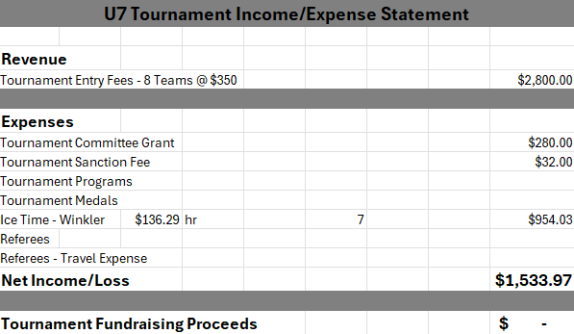
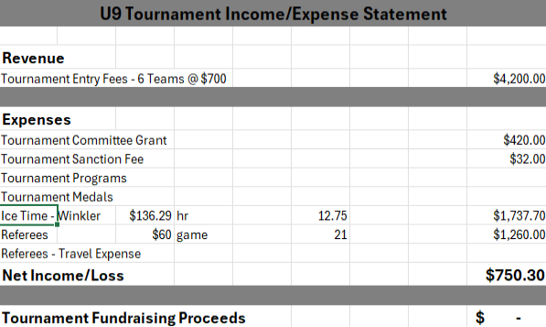

Social Media:

Female Rep: We were able to host both a U11 female and U13 female team this year. Pembina Valley had a U9 female league this year and we will have that as an option again for next year's registration (this does not mean Winkler would host the team - it would depend on the amount of registrations). We plan to host a combined U11 female and U13 female tournament next season.

