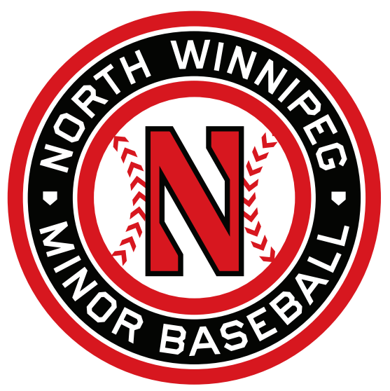

**Award Descriptions and Criteria**

**Player of the Year:  Rally Cap, Grand Slam, 11UA, 11UAA, 13UA, 13UAA, 13UAAA, 15UA, 15UAA, 15UAAA, 18UA, 18UAA, 18UAAA (14 awards)**

* The Player of the Year Awards will be awarded to the most outstanding player in each league, in their division. These players demonstrate dedication to the sport and their team, exceptional skill at their level, sportsmanship and leadership.  These players have a significant impact on the overall performance and success of their team.  The winner will have had the largest positive impact on the team on and off the field.

**Grassroots Coach of the Year; High Performance Coach of the Year (2 awards)**

* The NW Coaches of the Year go above and beyond for their team. This award will be awarded to a Coach who is a strong advocate for the game, treats his players and coaching staff with respect, and is dedicated to the development of his players.  These coaches promote sportsmanship and teamwork amongst their players and are strong ambassadors for the North Winnipeg program.

**Volunteer of the Year**

* This award winner will be an advocate for the game with support for teams and the association through exceptional volunteerism. This person gives back to the game and has a genuine love for baseball and the organization of it.  Ideally this successful nominee will show a significant impact on the association as a whole, or be a person that a team couldn’t have made it successfully through the season without their volunteerism—someone who has made North Winnipeg a better organization!

**Umpire of the Year (18+)**

* This award will recognize outstanding contributions to the Association by an umpire over the age of 21. The winner will aspire to do their best as an official, ensure the integrity of the game on a consistent basis, and conducts themselves respectfully when faced with contention.

**Youth Umpire of the Year (18U)**

* This award will recognize outstanding contributions to the Association by an umpire under 21. The winner will aspire to do their best as an official, ensures the integrity of the game on a consistent basis, and conducts themselves respectfully when faced with contention.

**Female Player of the Year**

* The NW Female Player of the Year will be awarded to a female playing at any age group in North Winnipeg, who demonstrates a love for the game, brings a unique perspective to their team and coaches and promotes teamwork and sportsmanship.

**Rally Cap Team of the Year; Grand Slam Team of the Year; Grassroots Team of the Year; High Performance Team of the Year (4 awards)**

* These award winners will represent what it really means to be a team. There is team work, player comradery, a special relationship between coaches and players, ultimate sportsmanship, and a positive exhibition of the game. These teams may have shown exemplary results over the course of the season, or be a team who came from behind and demonstrated exceptional development.

**Challenger Player of the Year**

* The Challenger Player of the Year will be awarded to a player involved in the Challenger program. He/she will enjoy the game of baseball, look forward to upcoming games, make friends with their weekly Buddies, and be a positive and enjoyable player to coach!  We see this award winner as a player with a constant smile on their face when they are at their Challenger games!