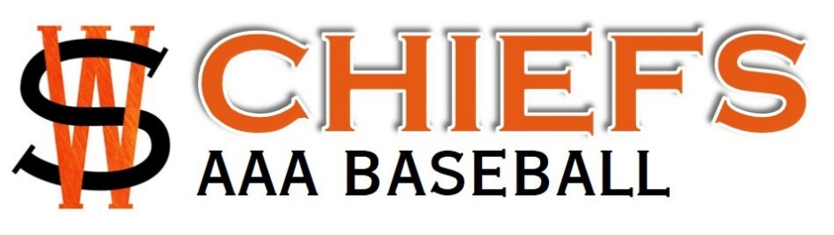
13U 2019 Season
Important Dates
- League play starts: April 30th
- St. James Tournament: June 7-9th
- Grand Forks Tournament (All Star): June 21-23
- League play ends: July 11th (approx)
- Waba Playoffs: July 20-25th (approx) (Round Robin Schedule)
- 18U AAA Provincials at Charleswood Place (Chiefs families to volunteer): July 26-28th
- Provincials**: August 2nd-4th ST. James Optimist Park
- Westerns (Provincial Champion and Finalist only): Aug 15-18th Cloverdale, BC
Tournament Hotels
ST. James Tournament
June 7-9/19
No Hotels needed

Grand Forks Domenick Palmiscno Memorial Tournament
June 21-23/19
Best Western Harvest Inn
3350 32nd Ave S, Grand Forks, ND
1-701-775-5000
$115 US$ a night before taxes
Booking Group: Winnipeg South Chiefs
Deadline to book: June 14/19
Check in Friday June 21; Check out Sunday, June 23
15 Double Queen Rooms booked; Requested away from the pool area

**Provincials Format Change for 2019:
- All AAA teams in MB will attend
- 2 tier Tournament
  - Tier 1 -- 3 WABA Teams/5 Rural Teams
  - Tier 2 – 3-5 remaining teams
- Tier Ranking based on WABA city playoffs

