Dynamic Warm-up Ideas for Baseball

Dynamic Warm-ups help prepare muscles for baseball-relevant movements. Dynamic warm-up gets hearts pumping, muscles warm and loose, while teaching agility, balance and baseball movements. Moreover, these exercises help build flexibility, quickness AND greatly reduce the chance of injury.

Dr. Joe Eisenmann of Volt Athletics recommends focusing on the following movement skills. Their website includes useful hints on teaching these skills:
https://blog.voltathletics.com/home/2018/9/11/ltad-part-3-teaching-fundamental-movement-skills

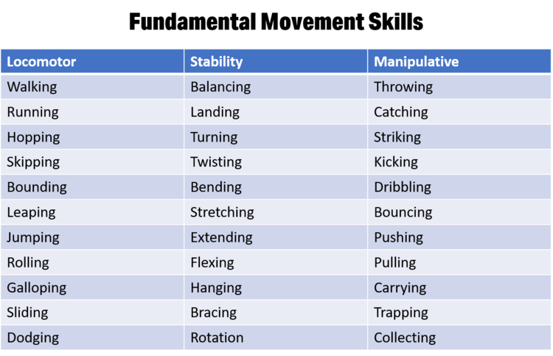

The idea is not to incorporate every movement at every practice, but build in a variety of movements each day, and vary the mix over time to expose athletes to more skills. Consider the age of your athletes too; some of the movements above will only work well with older players.

This shouldn’t take much more time than the less-effective standard of running poles and static stretching. TEN Minutes or so of dynamic warm-up at the beginning of practice or before a game can do a lot. Then another 5-10 at the end of practice for static stretching, conditioning or relaxation exercises….and you can mix these up on different days. Or you might focus on agility one day and speed another. You have many options.

One approach is to form 3 or 4 lines of players along a foul line with a cone placed 15-20yd out in the field. Run the players in small groups so the coach can observe and coach them as they move. Have players move to the line of the cone in a variety of movements called by the coach, then return to the back of their player line jogging.

An Example Sequence:
Easy jog (once or twice to begin)
Low skip
Knee pull to chest, torso upright.
Heel to butt, grab opposite foot, back straight
Kick-walking tin soldier
Heel to sky hands to ground, straight back
Lunge with rotation (arms out)
Back pedal (keep nose over toes)
Low carioca (left, then right)
High-leg carioca
High-knee skip
Shuffle left and right
Shuffle with groin stretch
Shuffle to sprint

Mix up the patterns, lines (zig zag or curve vs. straight), add in transitions for variety.
Hint: Playing tag in small groups is a fun way to encourage agility, balance and quickness.

Box cone patterns of movements are good too; change movement at each cone (e.g., jog, shuffle left, shuffle right, shuffle to sprint).

For large leg muscles, another good warm-up is to stand close to a wall or fence, with an arm up against the wall and swing your inner leg, with knee-up forward, then heel-up back. Do several times, then turn around and repeat with the other leg. The Goldeyes use this drill before every practice.

Before throwing, add in whole shoulder-capsule motions. Bands work best but you can just swing your arms too. Swing up and down forward, across the body, and up and down to the side (at least 5 each). Then arm circles in both directions. Core rotations are important too (at least 5 in each direction).

Strength and Conditioning is also important for baseball players. In our short seasons you don’t have a lot of time for this but consider how you can contribute to building well-rounded athletes. For young players, just body-weight exercises will suffice.

Basic exercises should include: squats, push-ups, pull-ups, hinge, and lunge. If you have access to lighter medicine balls these can be very useful for core rotation strengthening.
Baseball is a game of explosive sprinting for both baserunners and fielders, so players need to develop this. Any sprint/speed drills should be done near the end of practice when players are fully warmed up.

For sprinting focus on arm actions first, as the legs will follow. Think “left hand to pocket, right hand to chin, holding a potato chip”. Let swinging arms follow a natural line, and the shoulders should swing in relaxed way. Stay tall; stay on the balls of your feet. Skipping with high knees or butt kicks with sprinting arm action is a good exercise to practice upper-body technique without all-out sprinting. Teach decelerating too -- power down (quick pitter-patter steps) to stop.

Sport Canada has committed to encouraging Long-Term Athlete Development (LTAD), a system designed to help prepare athletes for success in any sport and at any age, including remaining active for life. Check out Sport for Life for a useful introduction to LTAD.
http://sportforlife.ca/qualitysport/long-term-athlete-development/
We will be hearing more about adapting our sports to these principles in the years ahead.

For community baseball programs, some key conclusions are that we ought to focus more time and attention on enhancing basic movement skills and athleticism, and more time on practice – learning the fundamental techniques and tactics of baseball – than on playing competitive games. Our short seasons make this difficult, but we urge coaches to dedicate at least as much time to practice as your team spends playing games.

Have a great season developing and enjoying time with your young athletes!

