Some Practical Tips for New Coaches
Things your NCCP Course Clinicians don’t have time to share
Winnipeg South Minor Baseball Association
Updated April 9, 2019

Welcome Coaches and thanks for stepping up to help kids enjoy the great sport of baseball!

The training classes you will take to help prepare you to teach the game and manage a team include many things – technical instructions about throwing, fielding, hitting and baserunning; safety; and the ethics of coaching responsibly. These are all important and required elements. But in serving as NCCP clinicians and visiting with many coaches after their first season of coaching, it has become apparent to us that some practical elements of coaching are not being shared with new coaches in a systematic manner. This short document and the 30-min course you are taking today is our initial attempt at addressing that gap. So, here are a few practical things that your NCCP clinics likely will not cover:

Pre-season Parent Meeting
It is essential that you have a pre-season meeting with your families (e.g., the night of uniform pickup might be a convenient time) where you share your approach to coaching and your goals/hopes for the season. If you are the Head Coach it is essential that you arrange for this; if you are an assistant coach, please ensure that your head coach does this and that you both participate in the meeting. Most of the arrangements discussed in the pages below will go smoothly IF expectations of parents, players and the coaching staff are similar.

Be sure to include in some detail your expectations of players and parents regarding practices, arrival times for games, player behavior and routines, your approach to ensuring “fair play”, etc. You may find a handout sheet useful for emphasizing certain things and communicating with any parents who miss the meeting.

Find out something about the baseball experience of your parents who aren’t registered coaches. This may help you identify a practice helper or scorekeeper. You will need a parent scorekeeper and another parent pitch counter; ideally people who will be consistent about attending games. You may discover other relevant skills such as a nurse just in case, or a gym teacher who may be good at kid control. Seek volunteers among your families for the various pre-game tasks described below, such as setting out bases or checking fields for hazards. Generally, GET ORGANIZED and get your parent group prepared so that all of you will be ready to go when your first game arrives.

Supply your contact information and get theirs in return. A first meeting is also a good time to distribute and collect player medical forms. Be sure to get information on any allergies or other relevant health issues.

We strongly suggest that parents and grandparents, as well as coaches, read over the RULES for your age division. This is not Major League Baseball; several rules have been modified over the years to enhance the experience for young players and the games will make more sense if fans know this ahead of time.

Practices
We understand that managing games in a big part of your job. But it is also true that practices are essential for your players to progress in general athleticism, baseball skills and tactical knowledge of baseball, all vital to their satisfaction in playing the game. Studies have shown that for athlete development, total time devoted to practice for young athletes should be 3-4 times more than competition. We recognize that our short baseball season in Winnipeg, coupled with uncertain weather and limited field availability, make it highly unlikely that any teams will achieve this. The key point though is that practice is important, and we urge you to practice as much as your schedule allows.

Talk to your parents about this at your initial parent meeting and communicate with your local baseball convener about scheduling the use of diamonds for practice. It might help to set up a standard day/time for practice (e.g., Saturday at 10am) when games are rarely scheduled. If you can’t do that, try to nab a few dates for the field and see if your families can accommodate those dates. Lots of what you need to teach can be accomplished on a soccer pitch or football field too – you don’t always need a diamond.

The NCCP clinics will talk some about practice plans and there is much information online to help you think through this. A few key things to keep in mind:
- Make it fun as well as work! But realize that moderate repetition is vital for learning.
- Have a plan and communicate it with your assistant coaches ahead of time. Then tell the kids what you will be doing and why. Minimize indecision or time spent standing around deciding what to do next.
- Always include a proper dynamic warm-up and graduated throwing.
- Multiple activity stations allow you to accomplish more and keep kids active and engaged.
- Engaging assistant coaches or other parents can help keep things moving and activities varied. Avoid situations where kids must just stand around and wait.
- Don’t go too long. For 13U and younger, a 90min practice is probably as long as you can hold players’ attention and avoid fatigue that can hinder learning. For younger players, even less time may suffice.

Finally, get a commitment from you parents to make practices effective. Most importantly have their kids attend and come on time. We understand that you signed on to coach but not to be a baby sitter. It should NOT be your job to haul kids around or hang out 30 min after the end of a practice for a parent to return to pick up little Bobby. Lay out your expectations in the pre-season parent meeting.

Your Baseball Manitoba coaching packet has some suggestions about practices that you may find helpful. Practice plans are also discussed at in-person Initiation Clinics. There are many resources online as well. Also check out the Winnipeg South website’s coaching page where Tim has posted a short video with an example practice plan (practice plan.mp4).

Game Preparation
Plan to arrive an hour or a little more before game time, especially if you are the Home Team. Players should arrive at least 45min early. Your pre-game tasks include:
- Setting out the bases (your equipment bag should include three bases with good straps, stakes, a tape measure and a hammer). Know the dimensions of your age division (60ft between bases for Grand Slam and 11UA, 70ft for 11UAA and 13U, 80ft for 15U and 90ft for 18U).
- Have someone do a quick inspection of the field for hazards (e.g., broken glass, protruding wires, animal damage). This is a great job for a parent volunteer. Also, have them rake out bad spots in the infield dirt if the field hasn’t been properly prepared for your game (they usually will be).
- Greet the other coach/team when they arrive and convey any vital information (e.g., known hazards, bathroom locations). It is courteous to give the other coach a copy of your lineup card as soon as you can and for older age divisions, let him/her know whether your starting pitcher is left-handed or right-handed.
For your own team,
- Make sure parents know to call you well ahead of time if players are unable to make it to a game or a practice.
- Have your lineup ready and on the proper form. Last minute changes can be made if kids don’t show. Ideally, plan to fill out your scorebook, pitch count, and lineup card the night before to save precious time after you arrive on the diamond. Press firmly enough so that all four copies are legible. See example lineup cards below for a team with a continuous batting order (left) where everyone bats, or for a team where only 9 bat (right) and one substitution has occurred.

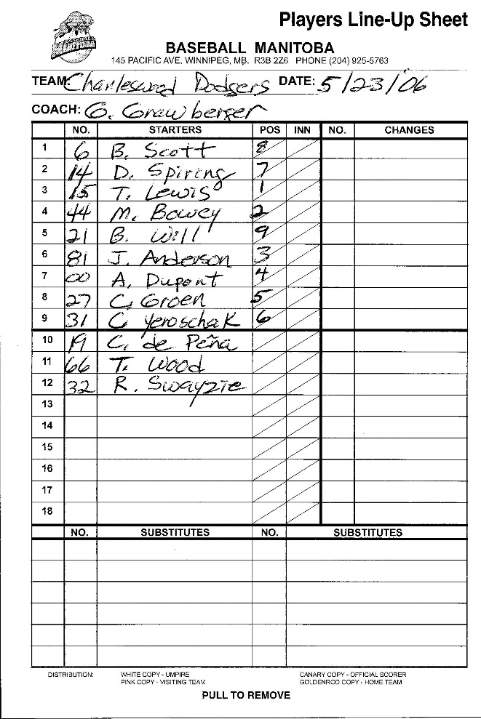
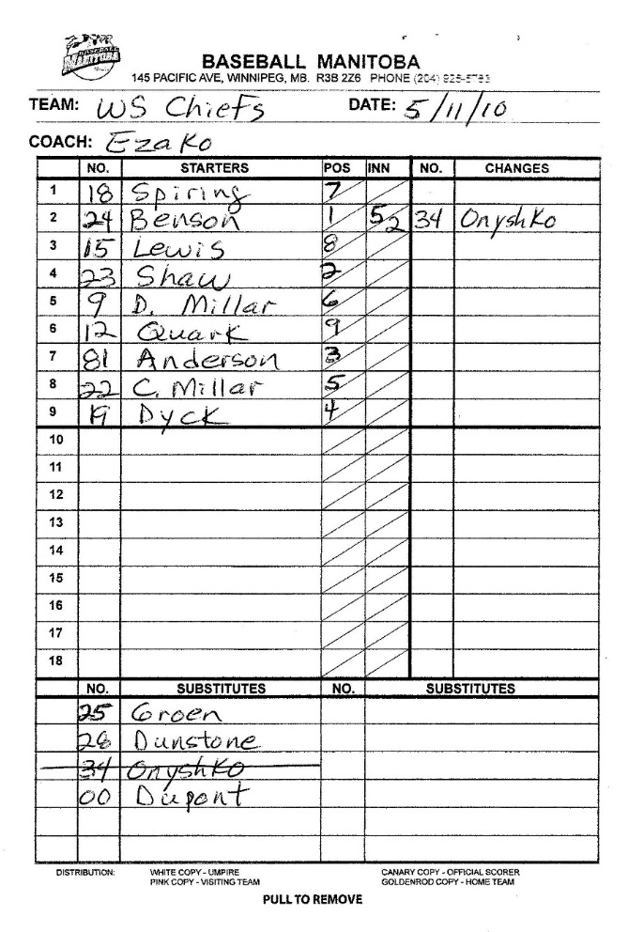

- Lineup cards have four copies – one each for the plate umpire, the other team, your scorekeeper and yourself. After the game begins, any deletions you make to the batting order (injured player, missing player, etc.) must be reported ahead of time to the plate umpire and the other team. Defensive position changes do not have to be reported at this level of baseball, except for pitching changes. Consider posting a copy of your lineup in your own dugout so players can refer to the batting order themselves.
- At younger ages, some coaches find it convenient to set up batting orders ahead of time on a repeatable rotating basis. That eliminates the need to make a bunch of decisions before each game. The only changes you would need to make in that case are when players are absent. One coach we know establishes a batting order for the first game, then whoever would have been next up at the end of that game becomes first up the following game. This ensures that everyone has approximately the same number of bats over the season and creates some sense of a system. It’s also easy for kids to remember who they follow in the order. For older more competitive leagues, you will want to adjust your order as you learn more about the capabilities of your players.
- Have a plan for defensive position rotations too, especially with younger teams and especially early in the season so that everyone gets a crack at a couple of positions during a game. Again, some sort of systematic rotation might be the easiest way to accomplish this. But please don’t be moving everyone around every inning; that is just chaos. Letting players experience different positions is good for morale, you will learn where kids perform best, and you never know at what positions kids may flourish. Please encourage all your players to try pitching and catching as well. Not all will want to do so but encourage them to try if they are willing. For an example system of rotating positions, Tim has posted another short video on the Winnipeg South website’s coaching page (Lineup plan.mp4).
- Have a scorekeeper among your parents who reliably attends games so that you don’t have to keep score yourself. If you don’t know how to fill out a score sheet, have your parent scorekeeper ask someone, or search “how to score” on Google or You Tube. An example scoresheet for one team/two innings is on the next page. There are scoring instructions on the inside front cover of your scorebook. You must keep score for BOTH teams. Although both teams usually keep score, and it’s good to ensure that both scorekeepers agree on the results, the HOME TEAM is the official scorer of record.
- Have a different parent lined up to do pitch counts. This is much simpler than scorekeeping but requires a person to pay close attention to the game. Again, ask for help if you have any doubts about how to do this. As with the scorebook, your team must track pitch counts for BOTH teams. An example pitch-count form follows the scoresheet below. Both teams will have a pitch counter and it’s a good idea for these people to compare their data between each inning so that in the end the numbers agree.

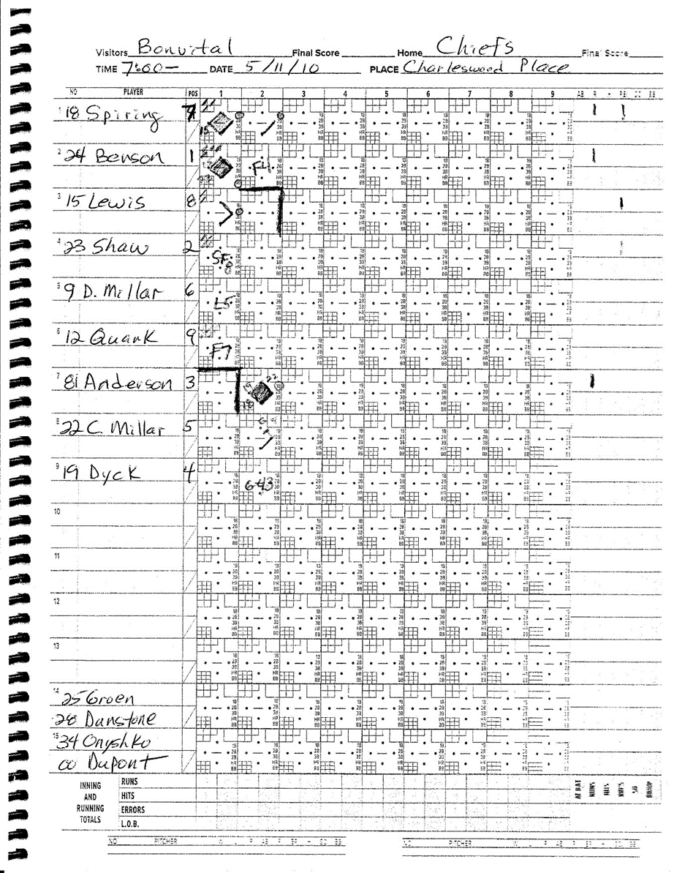

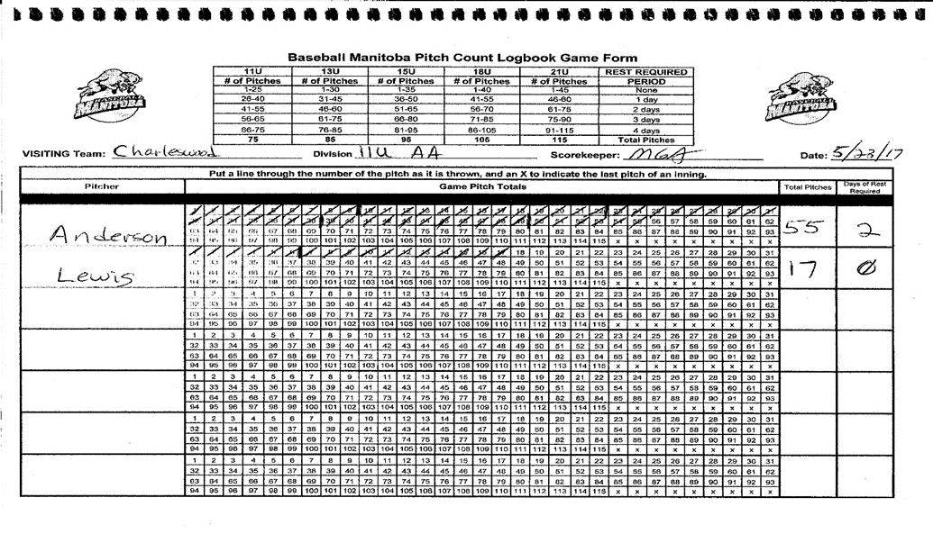
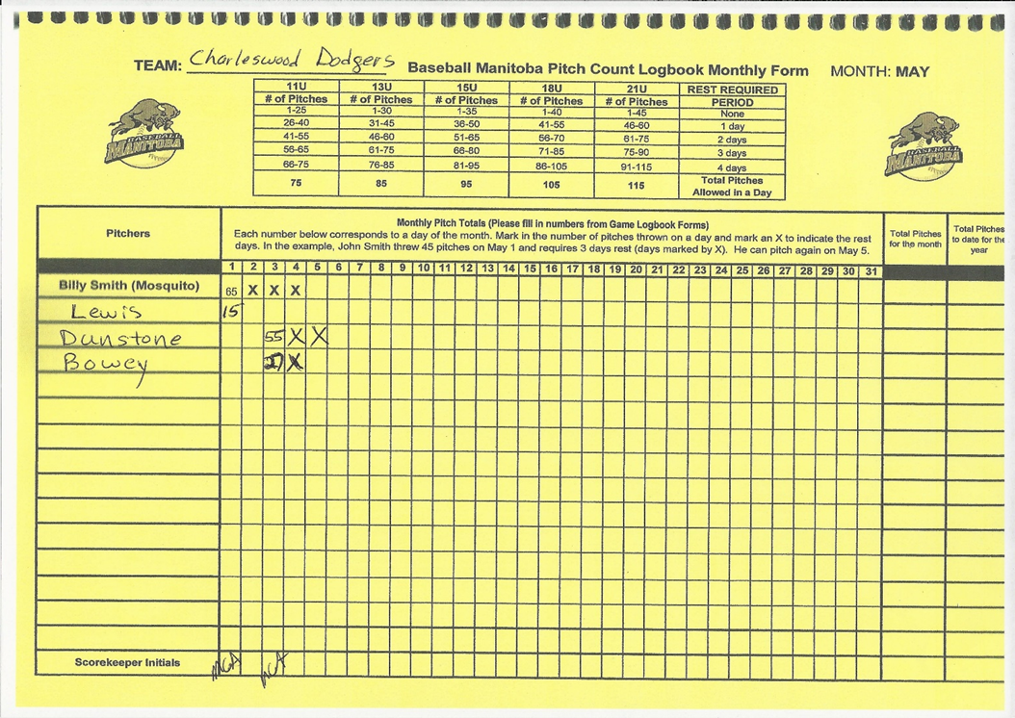
- Fill out your weekly pitch counts (yellow-shaded back pages) and scores right after the game. This will help you avoid violating any pitch-count rules about mandatory days of rest. An example of this is the second image on the page just above.
- Take notes during your game. Coaching is best done in practice, but you can note ideas of things done well or not so well and thus provide ideas for upcoming practices.
- If you play extra tournament games, etc. you may run short of lineup cards or score sheets. If so, you can check with your Club Convenor who might have spares or purchase what you need. In Winnipeg, Home Run Sports, Royal Sports and Pembina Source for Sports usually have these or you can order online.
- While you are doing all this game preparation work, have another coach supervise the kids in their pre-game warm-up. This should start with a light jog just to get blood moving and muscles warm. Follow that with some dynamic movements (not static stretches) and then progressive light throwing. Only do static stretches if the players are thoroughly loose and warm (e.g., at the end of practice). As soon as you can identify a responsible player(s) to lead this routine, let them do it and your coach will be free to do other things. It’s important to supervise the warm-up however, at least until the players are responsible enough to do it themselves, otherwise they are likely to cut corners and be more susceptible to injury. Make sure that players are using good throwing technique, as you have taught them, during all pre-game warm-ups.
- Your pre-game warm-ups should take place on the same half of the field as your dugout. Use the outfield grass or areas outside the foul lines. DO NOT use the groomed infield for your warm-ups except the final infield practice (see below).

- If there is time and space after the initial throwing routine, you might have kids do a little tee work or soft-toss hitting of whiffle balls, but there MUST be close adult supervision of this and everyone MUST be wearing batting helmets.
- After a light jog and basic dynamic movements, have your starting pitcher warm up away from the other players. A catcher (player or coach) that is going to receive warm-up pitches must wear a catcher’s mask. If you have stretch bands, begin with those to prepare the rotator cuff for throwing. Then start by “playing catch” at a short distance, perhaps 65-75% of the distance that he/she will pitch. Next stretch this out to beyond the normal pitching distance. Finally move to a practice mound/rubber and begin pitching from a stretch. Work on all the player’s normal pitches but begin with a fastball at maybe 65% effort. Increase effort through the warm-up but don’t throw more than about 15 pitches or so at younger age levels. The goal is to get loose and warm, not tired. Any pain experienced in throwing should be reported immediately to the head coach and the player must stop throwing. This applies to position players as well during their throwing routines.
And finally,
- If you are the home team you should take your infield warm-up first. Plan to start about 25min before game time and finish in 10min. This is plenty of time if players hustle and coaches hit balls quickly. The Visiting Team will follow and should leave about 5 min for coaches to meet with the umpires before game time.
- Be prompt and ready for the umpire meeting. Give a copy of your lineup to the home plate umpire along with game balls (usually two new and two used but playable balls to start but have more playable balls in reserve if needed). Some umpires might not be familiar with your diamond so let them know if there are unusual ground rules that might not be apparent (e.g., a ball rolling under the shrubs in centerfield is a ground-rule double). Remember you’re the host, but they are in charge as soon as the game begins.
- We suggest that you clarify with the umpires and other coach what rules are in place for end-of-game time. It’s easier to do it at the onset before anyone knows what the effect of that night’s the game-end ruling might be on the final score.
- While you are meeting with the umpires, ask your assistant coach to have the kids equipped, watching and ready to hit the field immediately. Players should hustle on and off the field every inning. No one want to squander daylight and playing time because a team fails to hustle.

During Games
Though certified, remember that many of your umpires will be young people who are also learning and developing in their roles. They will make mistakes every now and then. Remember too that every team in your “A” league will make the playoffs at the end of the season, regardless of your record. The regular season is about developing your players and having fun. Winning is NOT the most important thing, so maintain a mature perspective on what is important and what is not.

As a coach you are a powerful role model for your players. They will take many cues from you as to how you react to bad luck, errors by your own players, an unpleasant opposing coach or an umpire’s mistake. Self-control for coaches is critical if their players are going to comport themselves well too. Focus on cheering on your own players and picking up each other when someone stumbles. Positive reinforcement really is the best approach.

During games, players not in the field should remain on the bench – watching, learning and cheering on their teammates. Having one of the coaches nearby explaining what is happening on the field and things to take note of can help keep bench players engaged. It’s a great opportunity to teach defensive strategies, rules, good baserunning, etc.

Don’t let your kids argue with umpires, opposing players or coaches. If you need to approach an umpire for clarification of a call, ask for time and approach the plate umpire (who is in charge) calmly, respectfully and alone. Being polite and under control is your best chance of a useful interaction. Do NOT carry a rule book with you; no umpire wants to be tutored or confronted with a rule book (unless they request it). Remember if it’s a judgement call, there is virtually no chance of a reversal although you are free to note disagreement. If you believe an umpire who did NOT make a call may have had a better look at the play, you can request that the umpire ask for assistance. Sometimes this can work in your favour, but remember the umpire is NOT required to ask for help or respond to your recommendation. Once a consultation between umpires occurs and they rule on the play, there is no point discussing the call further. If you are certain that an umpire made a mistake concerning a RULE, you may protest the game, but you must do so immediately before another play has occurred and there is a long process you will have to follow through after a protest. Thus, our advice is to use a formal protest very rarely, and we seldom see them except during playoffs. Remember, you cannot protest a judgement call.

If you have substantive concerns regarding an umpire, please let the issue settle overnight, then inform your league’s Umpire-in-Chief (currently Riley Nordman for Winnipeg South) in writing so they can follow up if required. Remember, if you have some good things to say about an umpire, the UIC will really like to hear that as well.

Conversations that involve sharing concerns with coaches of the other team are usually best had after letting a little time pass, so after the end of the game or perhaps even a day or so later.

Above all, in both games and practices, keep the focus for your players on having FUN and LEARNING how to play baseball! Every team makes the WS playoffs, and there are no Major League scouts in the stands!

After Games
After shaking hands graciously with the other team, assemble your kids and coaches for a short team meeting, preferably in the outfield away from anyone else. Your focus should first be on something positive that happened in the game. Encourage your players to contribute to this. Then note briefly some things for the team to work on, usually at the next practice. Conclude with confirming the time and place of your next practice and/or game and assignments for raking and dugout cleanup (see below). Most teams finish with a huddle or short cheer, or something affirming their togetherness as a team.

Next, confer with your scorekeeper and pitch-count recorder, determine the data for both teams, and then seek the concurrence of the other head coach. Usually your numbers will agree or can be readily worked out. If a discrepancy remains, as the home team your pitch count numbers will take precedence but try to find agreement on these. If your team meeting is taking awhile, you might assign your scorekeeper or an assistant coach to have this conversation with the other team.

As soon as possible, but at maximum within 24h, post the scores and pitch counts on the Winnipeg Minor Baseball website. Instructions for doing this were shared with you during the WS coaches’ meeting.

Sometimes a parent may want to talk with you immediately after a game. If it’s a casual remark or a brief neutral inquiry, that’s fine. We suggest, however, if a parent has a concern about something you might have done, fair play, etc. that conversation is best had in private and after a period of reflection and gathering thoughts. A 24-h rule is usually a good idea and you can establish that protocol in your initial parent meeting. The goal is not to avoid a discussion but to have it in a rational, calm manner and away from the rest of the team.

Most clubs will want your team to give the basepaths, mound and home plate area a quick raking to smooth out the deeper tracks and ruts. This is always easiest to do right after a game and will make it much easier for your club to groom the field properly before the next game. If the field is dry, that’s a good place to dump any leftover water too. We suggest that your players do this raking, not the coaches, and that you assign this duty in rotation so that the work doesn’t fall on just a couple of keen kids. And please, teach your players not to dig on the diamonds during a game – players need good footing, but not ruts. A little post-game time with a rake can help that lesson sink in.

Be sure to check the dugout for stray gloves, hats, etc. before the players all leave. Players can also help parents do a quick clean-up of the area around the diamond. And remember, you volunteered to coach, not be a pack mule. Let the players help schlep the gear back to your vehicle. It helps build responsibility and saves your back!

One last suggestion, for enhancing communications within your team, consider using an app like Team Snap or TeamLinkt. These are helpful apps where coaches can list all their games and practices and contact information. They can generate reminders to parents in advance of each event, allows parents to confirm their child’s availability, and lets you contact everyone you need to communicate with in just a few keystrokes. There is generally small charge per month for team use but it may really simplify and enhance your communications. These are multi-sport platforms, so some of your families may already be familiar with the features.

For WSMBA coaches only, thanks to sponsorship by Kahunaverse Sports, you can have free access to the TeamLinkt Premium Package for 2019. For set up information, please email Lori Vassart, AAA Chair, at aaa@winnipegsouth.net.

We hope you have a great 2019 season. If issues arise where you’d like some advice, please contact your local club convener or give one of us a shout.

NCCP Coach Developers Winnipeg South VP Sport Development
Mike Anderson Tony Staruch
Tim Scharer

Coach’s Quick Checklist

Pre-Game
- Know who among your players are coming to play!
- Lineup Cards and Scorebook filled out and ready
- Plan in hand for defensive rotations
- Bases deployed; game balls available
- Field safety inspection
- First aid kit and ice on hand
- Scorekeeper and pitch-counter arranged
- Supervised pre-game warm-up completed
- Home team take infield at least 25 minutes before game time
- Know local ground rules if you’re the home team
- BE READY TO GO AT GAME TIME
- Have fun and encourage your players!

Post-Game
- Shake hands; include thanking the umpires
- Quick team meeting – what’s coming up next?
- Confirm scores and pitch counts with the other team
- Touch-up raking of mound, home plate area and infield
- Final dugout check
- Within 24h, post scores and pitch counts if you were the home team

