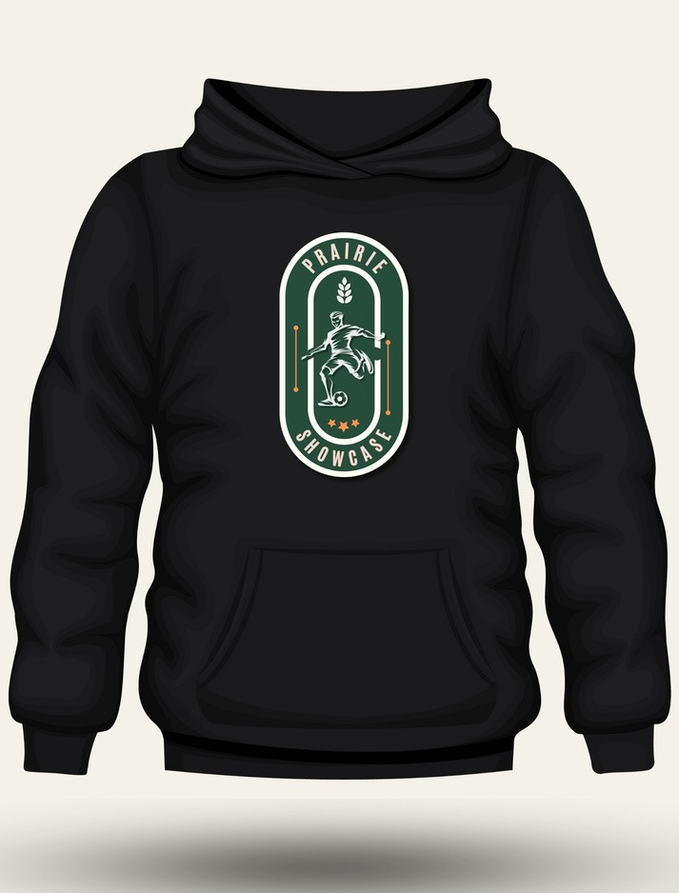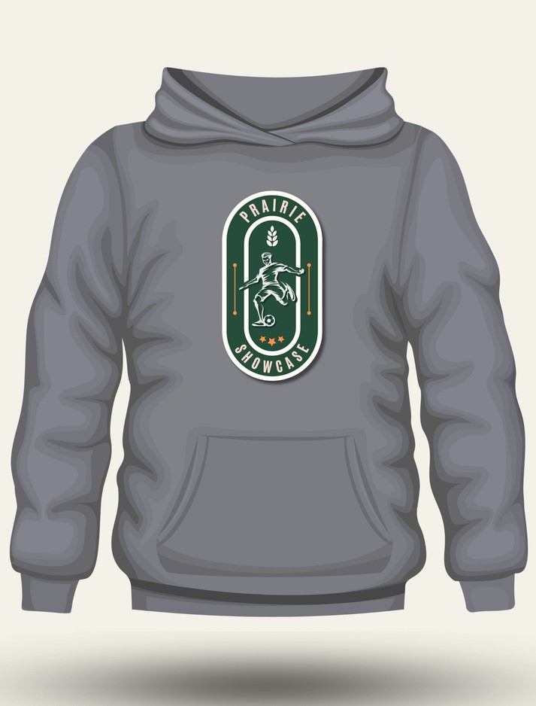

**PULLOVER HOODIE $40.00 PULLOVER HOODIE $40.00**

**WE WILL BE ACCEPTING DEBIT, CREDIT AND CASH FOR MERCHANDISE SALES AT THE TOURNAMENT!**