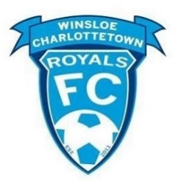
Parents/Players:
Welcome to the 2024 WCRFC Assessment. Please see the enclosed training schedule for times and locations for your age group. Note: please arrive 30 minutes before your session (sign in, receive numbered pinny, session instructions) and be ready to train at the scheduled time (not 5 minutes later).

Process:

We are pleased to announce a new Club Model (developmental philosophy) that has been endorsed by the Board.

“WCRFC strives to provide a competitive but enjoyable learning environment for players and coaches that allows them to develop a strong technical and tactical understanding of the sport of soccer. Using a possession-based approach, the Club will provide an age specific, integrated curriculum teaching the general developmental principles through Conditioned Small-Sided Games allowing our teams to dictate the play through coordinated player movement and speed of play.”

The Club philosophy is important as it allows us to develop our own blueprint to training and playing at each age group to develop quality players at the Club. We know that professional players don’t reach their full potential until their mid to late twenties, so development is very much a process. Thus, it is important to have a building block approach that is integrated into the learning process at the right times under the right training environment.
To create the best possible learning environment, we need to consider three components of the learning process: players, level of competition, and training/learning environment.

Players: (two-year age bracket)
Because of the small size of our clubs on PEI, we use a two-year age category. The amount of development that goes on during a two-year age bracket is huge. If you consider the physical, social, psychological, technical, and tactical levels of maturity within an age group and then consider a late maturing player versus an early maturing player, an ideal learning environment for all players is difficult to create. For example, a player born in December in the first year of an age group is over 700 days younger than a second-year player born in January. The developmental needs can be drastically different. Therefore, I refer to the selection process as an assessment not a tryout. The Club is attempting to place players in an environment that best suits their developmental age not their chronological age. This may be a Division I team for a young player or a move up into an older age division for a very mature player.

Level of Competition:

The same issues arise with the level of competition. The attached diagram shows
that there is limited learning and development go on if individuals or teams are
not close in ability. We continue to work with Soccer PEI on this issue.

Coach (Volunteer)
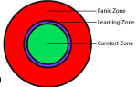
The Club very much appreciates and acknowledges the very important role that our volunteer coaches play in technical development. The Club believes a “Like for Like” assessment process best suits the training environment for players. It also provides the best possible training environment for coaches to teach. The closer the range of abilities within a group, the easier it is to teach and the easier it is to be inclusive.
To create a quality development environment during the assessment process, coaches will be required to organize activities that allow the assessors to evaluate players using the Four Corner Develop Model: Technical, Tactical, Physical, Psychological, and Social.

Click the following link for age group assessment criteria:
https://winsloecharlottetownfc.ca/content/youth-team-assessments-2023
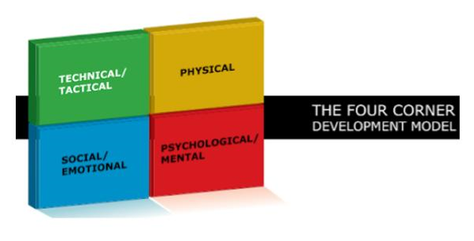

Looking forward to the sessions!

Winsloe Charlottetown Royals FC
