U9 Week 1 Dribbling
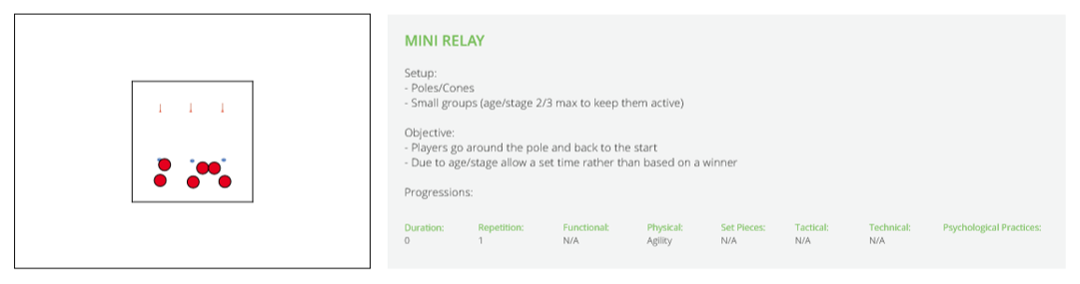

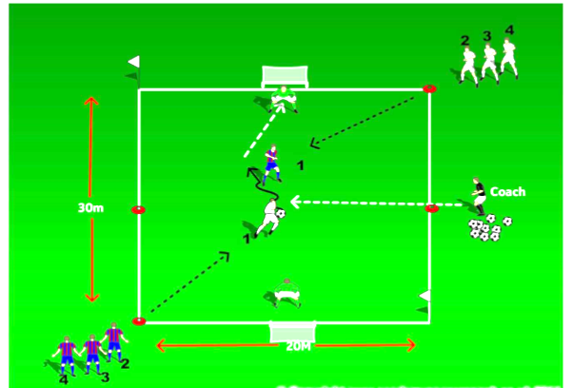
Organization: Players are organized into 2 teams. Each player is given a number. Field is 30 X 25 with a goal at each end. Procedure: The coach calls a specific number and that number runs into the field. These 2 players now play 1 X 1 to goal.

Progression: The coach can call out more than one number to create a 2 X 2 or 3 X 3

