Water Polo Saskatchewan Inc.

Appeal Policy

Appendix D

June4, 2016
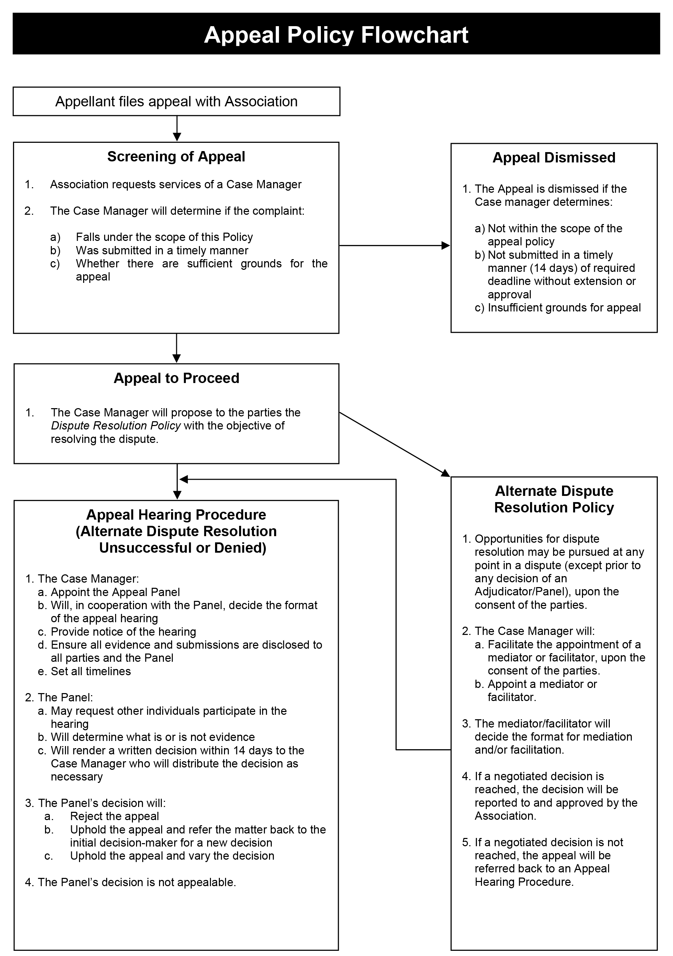
Water Polo Saskatchewan Inc.

Appeal Policy

Definitions
- The following terms have these meanings in this Policy:
  - “Appellant” – The Party appealing a decision
  - “Appeals Panel” – A single person, or in extraordinary circumstances and at the discretion of the Case Manager, three persons, who will hear and decide the appeal.
  - “Association” – Water Polo Saskatchewan
  - “Case Manager” – An individual appointed by the Association, who need not be a member or affiliated with the Association, to administer this Appeal Policy. The Case Manager will comply with the position description described in Appendix “A”.
  - “Days” – Days including weekend and holidays
  - “In writing”- A letter, fax or email sent directly to the Association.
  - “Individuals” – All categories of membership defined in the Association’s Bylaws, including clubs, teams as well as, all individuals engaged in activities with the Association including, but not limited to, athletes, coaches, referees, officials, volunteers, managers, administrators, committee members, and directors and officers of the Association
  - “Respondent” – The body whose decision is being appealed

Purpose
- The Association provides Individuals with this Appeal Policy to appeal certain decisions made by the Association.

Scope and Application of this Policy
- Any Individual who is directly affected by an Association decision will have the right to appeal that decision; provided the appeal falls within the jurisdiction of this Policy and there are sufficient grounds for the appeal under the ‘Grounds for Appeal’ section of this Policy.

- This Policy will not apply to decisions relating to:
- Employment
- Infractions for doping offenses
- The rules of the sport
- Budgeting and budget implementation
- Operational structure and committee appointments
- Volunteer appointments and the withdrawal of termination of those appointments
- Decisions rendered by entities other than Association (appeals of these decisions shall be dealt with pursuant to the policies of those other entities unless requested and accepted by Association at its sole discretion)
- Commercial matters
- Decisions made under this Policy

Timing and Conditions of Appeal
- Individuals who wish to appeal a decision have fourteen (14) days from the date on which they received notice of the decision to submit, in writing to the Association, the following:
  - Notice of the intention to appeal
  - Contact information and status of the Appellant
  - Name of the Respondent and any affected parties, when known to the Appellant
  - Date the Appellant was advised of the decision being appealed
  - A copy of the decision being appealed, or description of decision if written document is not available
  - Grounds for the appeal
  - Detailed reasons for the appeal
  - All evidence that supports the appeal
  - Requested remedy or remedies
  - An appeal fee of five hundred dollars ($500) which will be refunded if the appeal is successful, or forfeited if the appeal is denied. Payment by cheque to the order of Water Polo Sask or by cash can be sent to WPS office at 1860 Lorne Street, Regina, SK, S4P 2L7.

- An Individual who wishes to initiate an appeal beyond the fourteen (14) day period must provide a written request stating the reasons for an exemption. The decision to allow, or not allow, an appeal outside of the fourteen (14) day period will be at the sole discretion of the Case Manager and may not be appealed.

Appeals should be submitted to:
WPS Executive Director or WPS Chair
1860 Lorne Street,
Regina, SK, S4P 2L7
PH: 306-780-9260
e-mail: admin@wpsask.ca
Case Manager

- Upon the receipt of an appeal, the Association will appoint an independent Case Manager to manage and administer appeals submitted in accordance with this Policy and such appointment is not appealable. Case Manager services will be accessible through Sask Sport from an external firm or pool of individuals with knowledge and expertise in dispute resolution.

Grounds for Appeal
- An appeal may only be heard if there are sufficient grounds for appeal, as determined by the Case Manager. Sufficient grounds only include the Respondent:
- Made a decision that it did not have the authority or jurisdiction (as set out in the Respondent’s governing documents)
- Failed to follow its own procedures (as set out in the Respondent’s governing documents)
- Made a decision that was influenced by bias (where bias is defined as a lack of neutrality to such an extent that the decision-maker appears not to have considered other views)
- Made a decision that was grossly unreasonable

- The Appellant must demonstrate, on a balance of probabilities, that the Respondent has made a procedural error as described in the ‘Grounds for Appeal’ section of this Policy.

Alternate Dispute Resolution
- Upon receiving the notice of the appeal, the fee, and all other information (outlined in the ‘Timing of Appeal’ section of this Policy), the Appeal Panel may suggest, and the Parties may consent, the appeal to be heard under the Association’s Alternate Dispute Resolution Policy.

- Appeals resolved by mediation under the Association’s Alternate Dispute Resolution Policy will cause the administration fee to be refunded to the Appellant.

Screening of Appeal
- Should the appeal not be resolved by using the Alternate Dispute Resolution Policy, the Case Manager will have the following responsibilities:
- Determine if the appeal falls under the scope of this Policy
- Determine if the appeal was submitted in a timely manner
- Decide whether there are sufficient grounds for the appeal

- If the appeal is denied on the basis of insufficient grounds, because it was not submitted in a timely manner, or because it did not fall under the scope of this Policy, the Appellant and the Association will be notified, in writing, by the Panel of the reasons for this decision. This decision may not be appealed.

- If there are sufficient grounds for an appeal, the Case Manager will appoint an Appeal Panel (the “Panel”) which shall consist of a single Adjudicator, to hear the appeal. In extraordinary circumstances, and at the discretion of the Case Manager, a Panel of three persons may be appointed to hear the appeal. In this event, the Case Manager will appoint three Panel members and designate one of the appointees to serve as the Chair.

- The Case Manager will establish and adhere to timeframes that ensure procedural fairness and that the matter is heard in a timely fashion.

Procedure for Appeal Hearing
- The Case Manager, in cooperation with the Panel, shall then decide the format under which the appeal will be heard. This decision may not be appealed.

- The format of the hearing may involve an oral in-person hearing, an oral hearing by telephone/telecommunications or other electronic means, a hearing based on a review of documentary evidence submitted in advance of the hearing, or a combination of these methods. The hearing will be governed by the procedures that the Case Manager and the Panel deem appropriate in the circumstances, provided that:
- The hearing will be held within a timeline determined by the Case Manager or the Panel
- The Parties will be given reasonable notice of the day, time and place of the hearing, in the case of an oral in-person hearing, an oral hearing by telephone or other telecommunications
- Copies of any written documents which the parties wish to have the Panel consider will be provided to all Parties in advance of the hearing
- The Parties may be accompanied by a representative, advisor, or legal counsel at their own expense
- The Panel may request that any other individual participate and give evidence at the hearing
- The Panel may allow as evidence at the hearing any oral evidence and document or thing relevant to the subject matter of the appeal, but may exclude such evidence that is unduly repetitious and shall place such weight on the evidence as it deems appropriate
- If a decision in the appeal may affect another party to the extent that the other party would have recourse to an appeal in their own right under this Policy, that party will become a party to the appeal in question and will be bound by its outcome
- The decision to uphold or reject the appeal will be by a majority vote of the Panel

- The hearing will proceed in any event, even if a Party chooses not to participate in the hearing.

- In fulfilling its duties, the Panel may obtain independent advice.

Appeal Decision
- The Panel shall issue its decision, in writing and with reasons, after the hearing’s conclusion. In making its decision, the Panel will have no greater authority than that of the original decision-maker. The Panel may decide to:
- Reject the appeal and confirm the decision being appealed
- Uphold the appeal and refer the matter back to the initial decision-maker for a new decision
- Uphold the appeal and vary the decision

- The Panel's written decision, with reasons, will be distributed to all Parties, the Case Manager, and the Association within 14 days of the hearing’s conclusion. In extraordinary circumstances, the Panel may first issue a verbal or summary decision soon after the hearing’s conclusion, with the full written decision to be issued thereafter. The decision will be considered a matter of public record unless decided otherwise by the Panel.

Confidentiality
- The appeals process is confidential and involves only the Parties, the Case Manager, the Panel, and any independent advisors to the Panel. Once initiated and until a decision is released, none of the Parties will disclose confidential information to any person not involved in the proceedings.

Final and Binding
- The decision of the Panel will be binding on the Parties and on all the Association’s Individuals.

- No action or legal proceeding will be commenced against the Association or Individuals in respect of a dispute, unless the Association has refused or failed to provide or abide by the appeal process as set out in this Policy.

Appendix A

CASE MANAGER POSITION DESCRIPTION
Purpose
    - In some of its policies, the Association requires the appointment of a Case Manager. This Position Description outlines the role, identity, responsibilities and tasks of the Case Manager.

Policies
- The following Policies require the appointment of a Case Manager:
- Discipline and Complaints
- Appeal
- Alternate Dispute Resolution Policy

Identity
- The Case Manager, whether or not appointed by the Association at their sole discretion, should be experienced with the management of disputes in an unbiased manner. The individual should not be connected in any way to the issue being disputed (and/or the outcome of the dispute) but does not necessarily need to be an independent third-party not connected with the Association – though the guaranteed independence and neutrality of a third-party is preferred. The individual does not need to be a Member of the Association.

- The Case Manager’s identity does not need to be approved by any of the parties involved in the dispute, excluding the Association.

Discretion - Complaints
- When a complaint is filed, the Case Manager is required to:
  - Determine whether the complaint is frivolous and within the jurisdiction of the Discipline and Complaints Policy
  - Propose the use of the Association’s Alternate Dispute Resolution Policy
  - Appoint the Panel, if necessary
  - Coordinate all administrative aspects and set timelines
  - Provide administrative assistance and logistical support to the Panel as required
  - Provide any other service or support that may be necessary to ensure a fair and timely proceeding

Discretion - Appeals
- When an appeal is filed, the Case Manager is required to:
  - Propose the use of the Association’s Alternate Dispute Resolution Policy
  - Determine if the appeal falls under the scope of the Appeal Policy
  - Determine if the appeal was submitted in a timely manner
  - Decide whether there are sufficient grounds for the appeal
  - Appoint the Panel, if necessary
  - Coordinate all administrative aspects and set timelines
  - Provide administrative assistance and logistical support to the Panel as required
  - Provide any other service or support that may be necessary to ensure a fair and timely proceeding

- When determining if there are sufficient grounds for appeal, the Case Manager is not acting as the Panel and determining the merits of the appeal, but instead determining whether the Appellant has properly shown that an error, as described in the Appeal Policy, has been properly argued. The Case Manager will need to carefully consult the Association’s policies and procedures, and analyze the process that contributed to the decision, to determine whether there are appropriate grounds.

Discretion – Alternate Dispute Resolution
- When the parties agree to the jurisdiction of the Alternate Dispute Resolution Policy, the Case Manager maybe required to:
- Appoint the mediator or facilitator
- Coordinate all administrative aspects and set timelines
- Provide administrative assistance and logistical support to the mediator or facilitator as required

Hearing Format - Discretion
- If necessary, the Case Manager is required to exercise their discretion to determine the format of the hearing. Hearings typically take the following forms:
- In person
- Conference call
- Written submissions
- Conference call + written submissions

- In determining the format of the hearing the Case Manager should consider:
- The distance between the parties
- The animosity between the parties
- The time commitment and location of the Panel
- The timelines for a decision
- The language barriers between the parties
- The gravity of the complaint/appeal

Panel Appointment
- The Case Manager is required to appoint a Panel of one person, or three in extraordinary circumstances, to decide the issue. The individual(s) should have the following characteristics:
- Experience in dispute resolution
- Experience with sport disputes
- No connection to either party
- Preferably no connection with the Parties
- Decisive

- The Case Manager should remind the Panel to adhere to the powers given to the Panel by the applicable policy. For example, if the policy does not permit the Panel to suspend the respondent indefinitely, then the Panel cannot sanction the respondent in this manner.

Communication
- Especially when the hearing is to be held by written submissions, the Case Manager is required to communicate swiftly, clearly, and decisively with each party. The parties must adhere to the deadlines set by the Case Manager or by the applicable policy and the process must move forward even if a party misses a deadline.

- When coordinating an oral hearing, the Case Manager should first consider the schedule of the Panel, then the schedule of the complainant, and then the schedule of the respondent in an attempt to find a suitable time for everyone.

Suggested Procedure
- The Case Manager may implement the following procedure to facilitate the Discipline and Complaints Policy or the Appeal Policy:
  - Receive the written complaint or appeal
  - Communicate with the Complainant/Appellant that you have been appointed the Case Manager and that their complaint/appeal will be disclosed to the Respondent and Panel. Also determine if there is additional evidence or written submissions to follow, if so, provide a deadline for receipt. (After this step, the Complainant/Appellant may not have another opportunity to make additional submissions or provide evidence, unless determined otherwise by the Panel)
  - Determine whether the complaint is within the jurisdiction of the applicable Policy.
  - Notify the Respondent that you are the Case Manager and are in receipt of a complaint/appeal. Communicate to the Respondent that any submissions will be provided to the Complainant/Appellant and Panel. Provide the Respondent with a reasonable timeframe to submit their response document and any applicable evidence. (After this step, the Respondent may not have another opportunity to make additional submissions or provide evidence, unless determined otherwise by the Panel).
  - The Case Manager may wish to provide the Complainant/Appellant to submit a rebuttal, but the rebuttal must be limited to issues raised by the Respondent and is not an opportunity to provide new evidence. The Panel may exclude such new evidence.
  - Appoint the Panel
  - Conduct a hearing either via written documentation, teleconference, in – person, or a combination of these techniques.
  - Ensure the Panel renders a written decision within a prescribed timeline.

