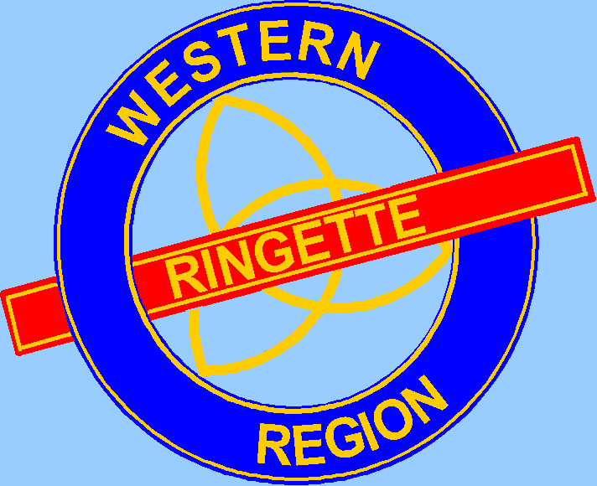
WRRL AGM Meeting Minutes
Thursday, May 12, 2022
7:00pm
Zoom Meeting

Agenda
- Call to Order
- Roll Call-Associations and Executive
Chatham | Margie Vanoirschot/ Eric V
Dorchester | Shelley Handley
Elora/Fergus | Erin Schmid
Forest | Shae Stanbra
Goderich | Graeme Hamilton
Guelph | Nicole Perkins
Hanover | Ian Sizer
Kitchener | Brian Kettles
London | Melinda Suchard
Mitchell | Chris Dowson/Lisa Helmuth
Owen Sound | Absent
St. Mary’s | Mike Richardson
St. Thomas | Brian O
Tillsonburg | Jason Routley
Waterloo | Rachel Gondosch/Neil Henderson
Wellington North | Absent

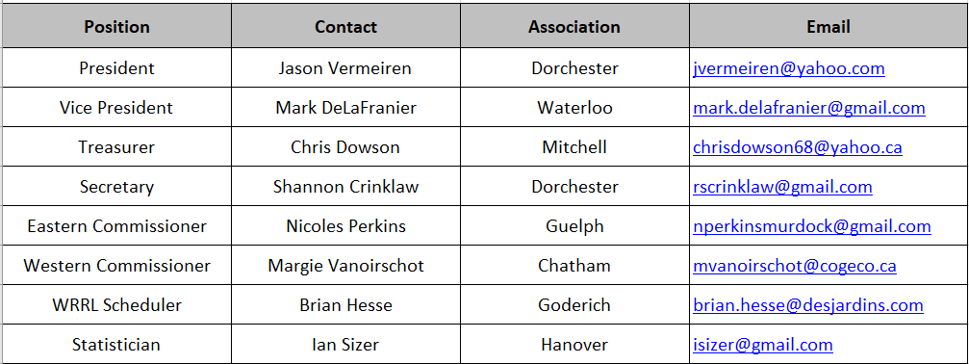
Mark DeLaFranier sent his regrets.
- Approval of Agenda - May 12th, 2022
  - Motion to approve by Hanover
    - First by Guelph
    - Seconded by Elora/Fergus
- Approval of minutes – April 25th, 2021
  - Motion to approve by Elora/Fergus
  - First by St. Thomas
  - Seconded by Dorchester

- Executive Reports
  - Financial Report
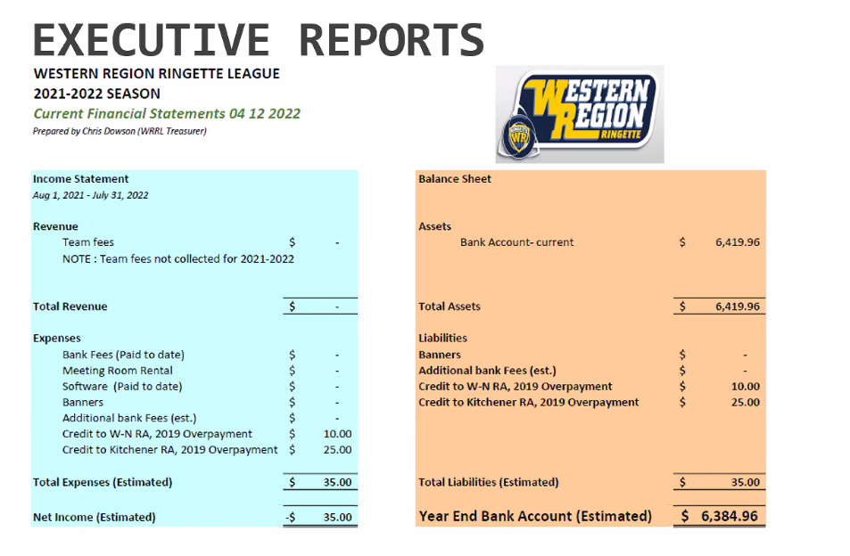
- Looking at setting budget for next year needing to book rooms and have banners created
- Goalie clinics may be possible for next year as well

- Proposed League Schedule for 2021-22 season and Important Dates
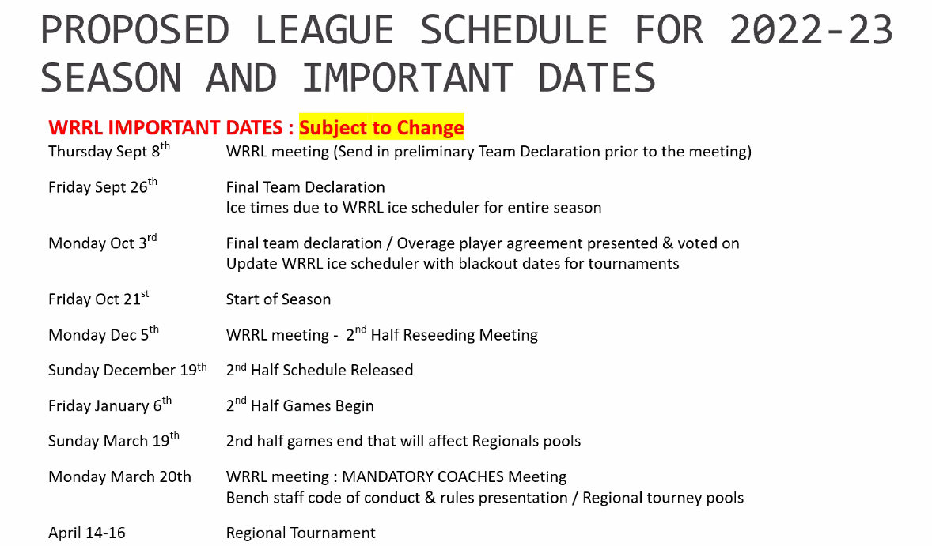
Monday May 15th – AGM
- Season will begin the week of October 14th (after Thanksgiving) not October 21st
- Looking to bring back the reseeding meeting for next year
- Regional Tournament is later next year so games will be allowed to go longer. Regional Tournament to be held in Kitchener/Wilmont.
- Plan to get more than 20 games in this year
- Question addressed: If have 2 teams at the same level, you must have assessment to declare one team as B level then another team as C level as per Ringette Ontario.
- Tillsonburg planning to have two U8 teams and two U10 teams, categorizing teams is not permitted until U12 level and above.
- President to send out requirements for classifying team on BaseCamp

- Elections - Please submit nominations
  - WRRL Treasurer (2-year term)
    - Reviewed job description: busiest time of the year is collecting association fees at the beginning of the year.
    - Nominations for Treasurer: Jason Routley (Tillsonburg)
    - Jason accepted role of Treasurer
    - Next Steps: to meet with Chris at the branch in London to transfer the banking details.
  - Secretary (2-year term)
    - Nominations for Secretary: Brian Kettles (Kitchener)
    - Brian accepted the role of Secretary
  - Ice Scheduler
    - Not up for election this year but will be changing over next year
    - If anyone wants to shadow this position this year, this would be appreciated.

- Children’s Ringette Review
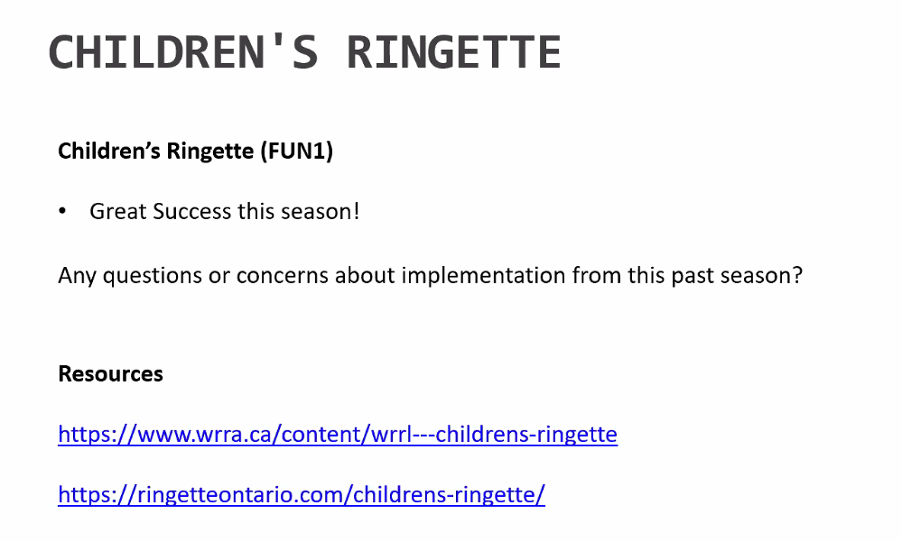
- Sticks were well received

- FUN2 & FUN3 Review
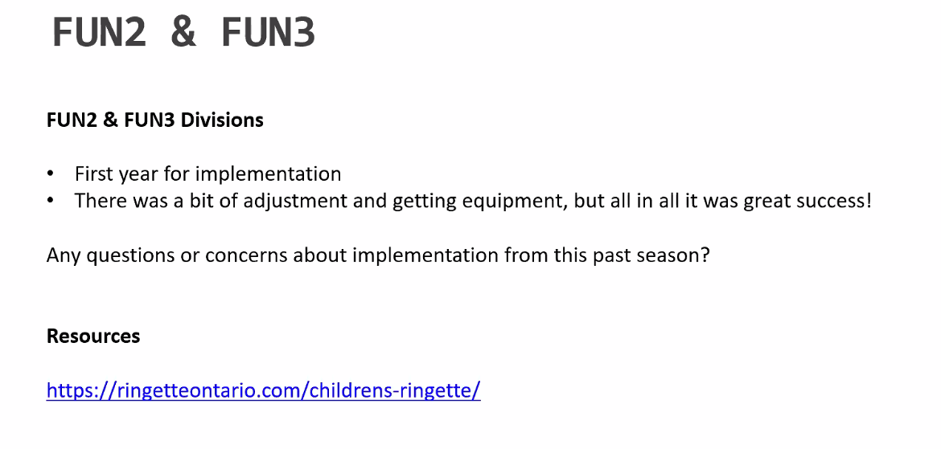
- Ringette Ontario not clear on guidelines
- Not all associations liked the ½ ice concept, hard to teach free pass rules and other rules
- Very confusing program, not the same as hockey program
- Very inconsistent: Refs or no refs, different size nets
- Too many kids on one bench caused issues in Mitchell
- Question: will there be cross over games for FUN3 next year? Next year will have 1st half as close location games then reseeding for 2nd half which will look more like a traditional year

- Regional Tournament
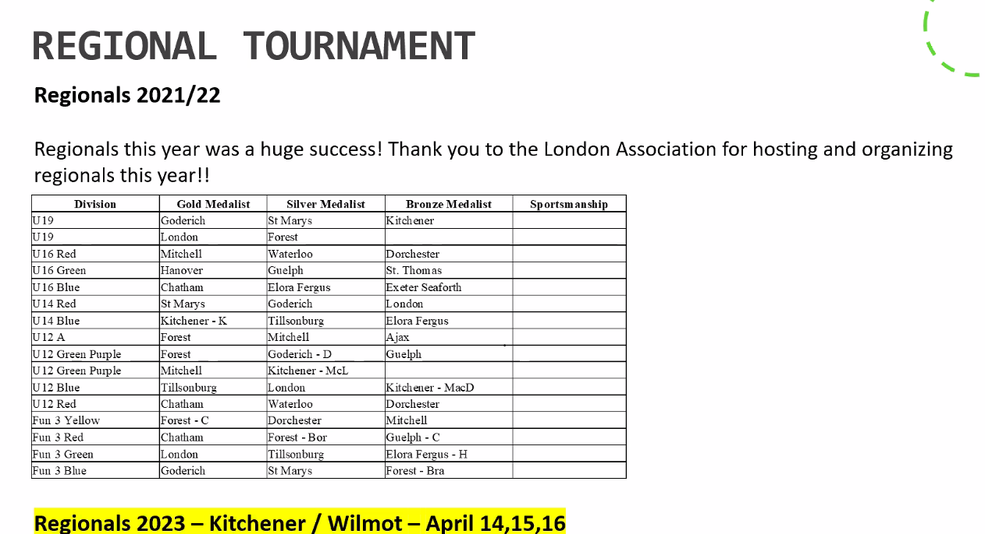
- There was a letter about poorly treated referees at Regional tournaments this year that needs to have awareness. Letter needs to be shared with Coaches.
- B/C WRRL Rep’s & Ice Schedulers
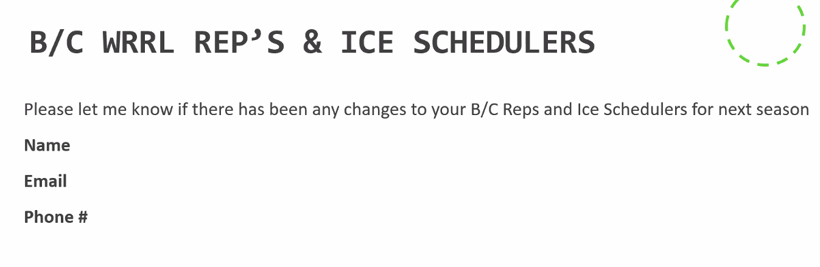
- Updates from RO
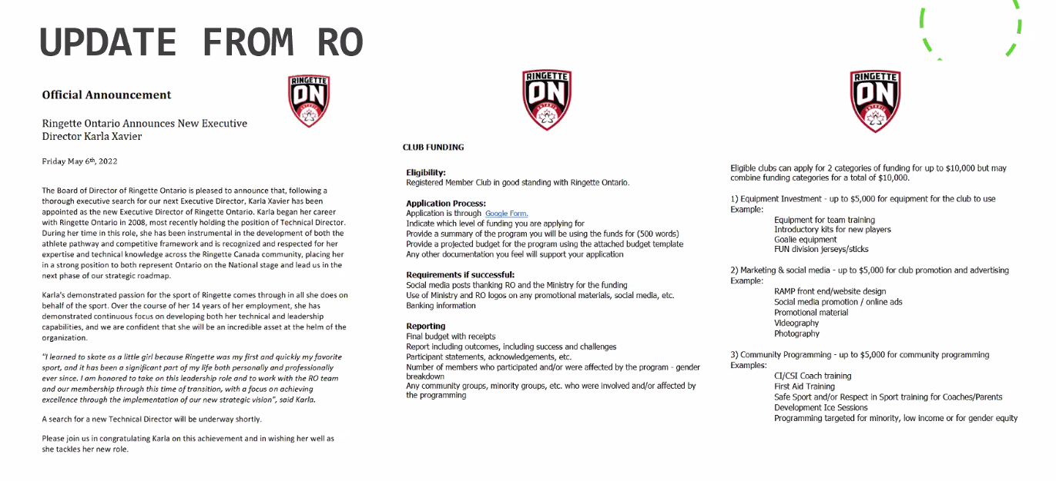
- Karla Xavier named as new Director
- Club Funding available now – looking to allocate $5000 per association

- Mary and Keith Kaiser Scholarship Submissions
- Winner is decided on by sub-committee and will be announced

- Update from WRRL President
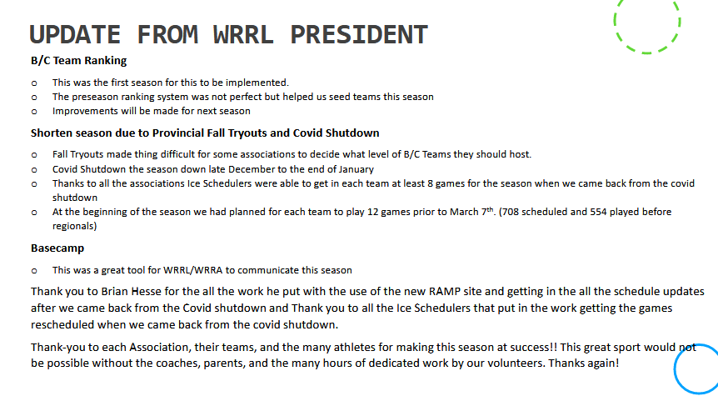
- U12A is only team trying out in Fall starting August 26th. This is earlier than normal to try to avoid impacting regional team formation.
- Reach out Chris Sharpe if other associations want to use BaseCamp as a tool
- Kudos to the league for being able to get the games in and have a great regional tournament with seeding.

- New Business
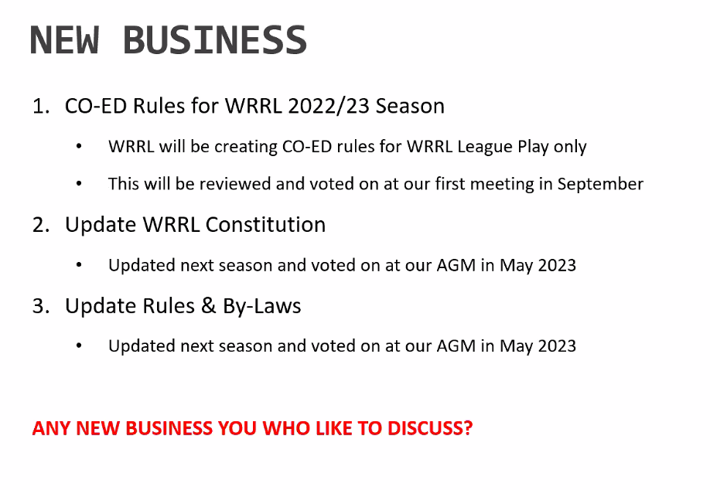
- No new business brought to the meeting
- Next Meeting Date
  - Thursday September 8th, 2022, via Zoom
  - In-person meetings will be AGM and possibly reseeding meeting in December if allowed
  - Meetings are normally Thursdays, but some have been changed to Mondays
- Adjournment
  - Motion to Adjourn by Dorchester
  - First by Mitchell
  - Seconded by Forest

