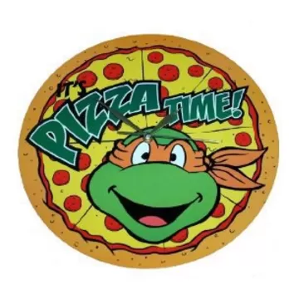
YKGC Pizza Sale,
(Money in the forms of bills would be greatly appreciated as it takes a long time to count and roll coins)

NAME________________________________________

COACH: ______________________________________

HAM & PINEAPPLE 1 2 3 SLICES GLUTEN FREE

PEPPERONI 1 2 3 SLICES GLUTEN FREE

CHEESE 1 2 3 SLICES GLUTEN FREE

EACH SLICE IS $2.50. PLEASE RETURN THIS FORM TO YOUR COACH BY 12:00 PM (NOON). SORRY, NO LATE ORDERS WILL BE ACCEPTED

YKGC Pizza Sale
(Money in the forms of bills would be greatly appreciated as it takes a long time to count and roll coins)

NAME________________________________________

COACH: ______________________________________

HAM & PINEAPPLE 1 2 3 SLICES GLUTEN FREE

PEPPERONI 1 2 3 SLICES GLUTEN FREE

CHEESE 1 2 3 SLICES GLUTEN FREE

EACH SLICE IS $2.50. PLEASE RETURN THIS FORM TO YOUR COACH BY 12:00 PM (NOON). SORRY, NO LATE ORDERS WILL BE ACCEPTED

